MAHARASHTRA COSMOPOLITAN EDUCATION SOCIETY
Azam Campus, Pune – 411 001

E-Content Description
Name of School / College: M A Rangoonwala Institute of Hotel Management and Research
Name and Designation of content creator /Producer | Assoc. Prof Imran Sayyed
Title of E content | Types of Toilets
Theory/practical | Theory
Title and No of Module | Types of Toilets
Title and code of Paper | The Science of Hotel Engineering  Subject Code : HS 206
Broad Subject | Hotel Engineering
Course | BScHS
Class | SY
Semester | Third Semester
University /Board | SPPU
Date of Content Creation | 23 Jan 2020
Name of Reviewer  HOD/Principal | Imran Sayyed

10 Types of Toilets – Different types of Toilet
by Venkat Mani
Types of Toilets listed out below, We will cover all 10 types of toilets available around the world.Like every other inventions on this earth, toilets are also invented and modernized by humans. Human created different types of toilets according to his needs. The types used varied from place to place. Here we listed types of toilets according to the shape and function of the toilets. All type of toilets will have two holes one for Inlet another one for outlet. Inlet will be connected to water line to flush the water to bowl. Outlet will be connected to drainage. Outlet will flush out the waste from the bowl to drainage.
Contents
- 1 WC Health:
- 2 European or Western Water Closet:
  - 2.1 Types of Water Closet Toilets:
- 3 Two piece Toilet:
- 4 One piece toilet:
- 5 Squatting Pan:
- 6 Anglo- Indian Type Toilet
- 7 Kid’s toilet:
- 8 Elderly toilet:
- 9 Smart Toilet – An Intelligent type of toilet:
- 10 Squatty-Potty Toilet:
- 11 Conclusion:

According to the user sitting position we can classify toilets into two types:
- European or Western Waters closet also known as WC/EWC (Toilet designed to sit).
- Squatting pan (Toilet is designed to squat).

WC Health:
WC health is a unique design by guralvit, a turkey sanitaryware manufacturing company. The WC is designed by combining Water closet comfort and Squatting pan health benefit. This design won red dot design award-2012. The weight of this product is around 40 Kgs. The sitting height from ground is around 22CM to 25 CM. It is nearly half of the normal height from the ground when compared to normal European water closet. Normal EWC sitting height will be around 50 CM to 56 CM from the ground. This product is coated with anti bacterial glaze.
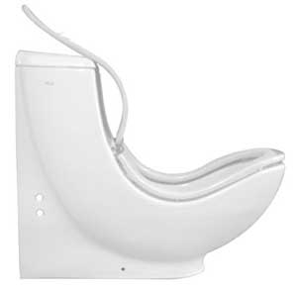types-of-toilets-wc-health
This WC health is a type of water closet but you have to squat in this toilet. And also this is a type of one piece toilet.

European or Western Water Closet:
This WC or EWC are designed to sit in toilet. This kind of toilets comes with seat & cover. When flushing Cover need to be closed. A Western Style toilet will be attached with a flush tank for flushing after usage. Flush Tank may be plastic or ceramic one. Small amount of water will be trapped inside the toilet itself by water seal, normally this water seal height will be 50MM. Normal water closet are open rim because the flushing tanks are high in position so flushing will be effective. The height of European water closets are around 500 to 550 MM. The weight of WC will vary from 12 KG to 20 KG according to the design. All water closet must with stand a minimum of 400 Kgs without breaking.
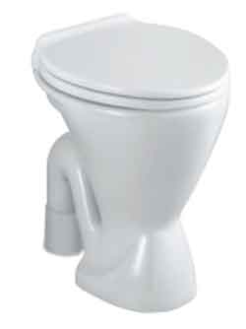
WANT TO KNOW ABOUT VARIOUS TYPES OF WASHBASINS 10 TYPES OF WASH BASINS

Types of Water Closet Toilets:
The Standard Water closet can be classified according to the Trap design (Types of water closet):
- S Trap types of Water Closet (EWC).
- P Trap types of Water Closet (EWC).
Choosing between ‘S’ or ‘P’ trap water closet:
Trap design is important when installing a toilet. Normally S tarp will be used in ground floor installations as piping can be done below ground level. Normally P trap will be installed in top floors because installation of pipe line under the toilet will be difficult.
This water closet can be classified according to the Mounting system (Type of water closet):
- Floor mounts types of toilets.
- Wall Hung Types of toilets.
If the toilet can be installed in floor then it is know as floor mount water closet. Floor fixing hole is provided in this kind of floor mount toilets.
Wall Hung toilets will be fixed in wall by fixing hole in the toilet. Normally floor mount toilet will come in both ‘P’ and ‘S’ Trap, but Wall mount model Toilet will come with ‘P’ Trap.
Seat Cover used in water closet toilet can be classified into two types, one is hard close and another one is soft close.If the falling of seat cover is hard with sound then the seat cover is know as hard close seat cover.If the seat cover falls slow with out any noise then it is know as soft close seat cover.
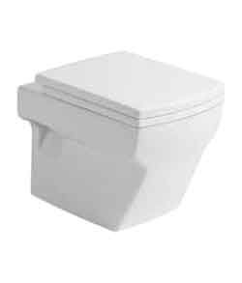
Another way to classify the water closet is the visibility of trap way:
- Concealed trap way type of toilet.
- Visible Trap way types of toilets.
In concealed type of toilets the trap will not be visible it will be covered by the design itself. The cost of concealed trap toilet will be higher cost than the visible Trapway toilet.
According to the bowl design toilets can be classified around 4 types:
- Round bowl toilet.
- Square bowl toilet.
- Elongated Bowl toilet.
- Rectangular bowl toilet.

Two piece Toilet:
Other types of toilets are two piece toilets. Normal EWC toilet is extended to fit a ceramic tank in toilet itself. The name came from the design. Because a piece toilet bowl and a ceramic tank and it are coupled using bolts, so it is called as two piece toilet. Two piece toilets are also called as coupled closet because of design. Weight of the two Piece toilet will be around 25Kgs to 45 Kgs and it depends upon the design of the product. Coupled closet are designed in closed rim method to pressurize the water during flushing. By this closed rim method the required flushing is achieved.
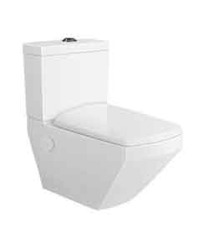two-piece-types-of-toilets
Same like the Normal water closet two piece WC also will be available in ‘S’ & ‘P’ trap and also floor mount as well as wall mount.
The cost of coupled closet or two piece toilets is in between cost of normal water closet and cost of one piece toilet.
Let us see more about Water closet click here:

One piece toilet:
This type of toilets does not need a separate flush tank. Flush tank is attached with the body of EWC itself. The tank and body both are produced by ceramic material and fused together. So the problem of leakage is minimized. This toilet also called as single piece toilet as bowl and tank is one product.
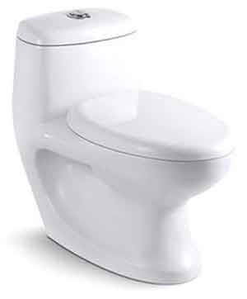one-piece-types-toilet
One piece toilet normally comes in only floor mount type model. AS the weight of toilet will be more so normally single piece toilet will not be made in wall hung methods. The weight of the one piece toilet will be around 38Kgs to 50Kgs.
One piece toilet will be available in ‘S’ and ‘P’ Trap model. One piece toilet will be only designed as closed rim only. The water pressure required to flush out the waste will be created by the closed rim model.
Problem of leakage is very less in one piece toilet. Cost of one piece toilet will be higher than the two piece toilet.
Find 10 types of wash bsains here.

Squatting Pan:
This is the classic type of toilet. Day by day this classic toilet is replaced by modern water closet which gives more comfort and also gives more health complaint. It is proven that squatting pan toilets are much healthier than European water closet.
The squatting pan called in many name as Indian pan, Orissa pan and also Asian pan toilet.
These squatting pans have several designs and varying design country to country.
Squatting pan normally used in Asian countries. Indian, Chinese & Japanese squatting pan greatly difference in design. These types of toilets are comparatively cheaper than the water closet type toilets.
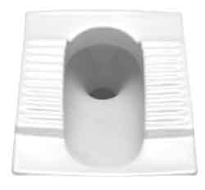
Squatting pan will not be directly connected to the drainage pipe line because the bad order will come in toilets. So squatting pan will be connected to the drain pipe by using an ‘S’ trap or ‘P’ trap. This trap will avoid escape of bad order from drain line by a water seal.
Water seal of the squatting pan will be maintained by the trap. But in water closets the design itself will maintain a water level to seal the bad order escape from the drain pipe line.
Types of squatting Pan Toilets:
- Standard squatting pan.
- Sleek model squatting Pan.
- Squatting Pan without foot rest.
- Squatting pan separate foot rest.
Find more about Squatting Pan here,

Anglo- Indian Type Toilet
Anglo – Indian Type toilet is a combination of squatting pan Indian and western water closet style toilets. You can squat or sit in this toilet as you like. These types of toilets are brought when people get confusion about the type of toilet they want to go with the squatting or western one. This toilet is also called as combination toilet and universal toilet.
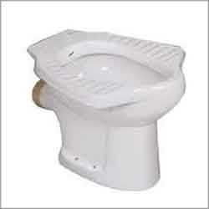

Anglo Indian pans are available in ‘S’ and ’P’ trap as well. This type of toilet only available in Floor mount model. This toilet also will come with an plastic seat cover.
You need to attach a plastic tank or a concealed tank for this model of toilets for flushing.
WANT TO KNOW ABOUT DIFFERENT TYPES OF URINALS 10 TYPES OF URINALS

Kid’s toilet:
Kids Toilet is specially designed toilet for kinds. The size of the toilet is smaller so it can be used for especially under the age of 12. Now a days seat covers are coming such a way that even children can sit on normal Water closet.
Types of Kids Toilet:
- Squatting pan.
- Water closet.

Elderly toilet:
These types of toilets are designed such a way that elder people can easily sit and rise. the pedestal height of the toilet is higher than the normal water closet. the height of the elderly toilet is around 70CM.

Smart Toilet – An Intelligent type of toilet:
These Toilets are latest in this line. What is smart toilet? A specially designed ceramic toilet is attached with the electronic seat cover. All functionally of the smart toilet are depends upon the seat cover.
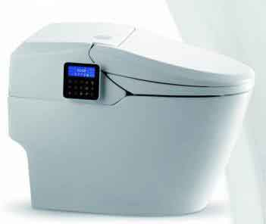
It comes with a remote to set functions and parameters. Some of the features of this smart toilet are listed below,
- Plays pre-set lyrics automatically when someone approaches.
- Automatic seat cover opening by sensors which sense human approaches near to the toilet. It can even disgust between men and women.
- It can also automatically open & close and UV cleaning facility.
- You can set temperature and pressure of the water and position of the water jet.
- User functionality can be saved.
- Inbuilt Warm air drier and temperature can be set as per user input.
- Dual flush option, eco flush or full flush.

Squatty-Potty Toilet:
In general it is not a type of toilet, merely a method of using toilet. Health problem arises when using a European water closet so a ceramic stand will be kept where the leg is placed in water closet. So the angle of sitting will be nearly equal to squatting. So the health problems are reduced.
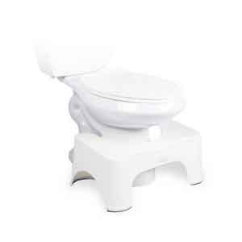

Conclusion:
Even though only two types of toilets (Modern and classic) are there, it is further classified according to its functionality, Usability and designs. Now we have seen 10 Types of toilets and understand how these toilets are classified. Feel free to leave a comment below.
Refferences:
ihmhotelengineeringnotes.blogspot.com
ihmhotelengineeringnotes.blogspot.com
https://lecturenotes.in/m/21160-note-of-hotel-engineering-by-victor-agughasi
ihmkolkata.blogspot.com/2013/04/ihm-kolkata.html
Hotel Engineering - IHM PUSA
ihmpusa.net › wp-content › uploads › 2016/12 › Hotel-Engineering-0
https://www.newtondesk.com/refrigeration-and-air-conditioning-study-notes-hand-written/
en.wikipedia.org/wiki/
encyclopedia2.thefreedictionary.com
www.kopykitab.com/Engineering
www.faadooengineers.com/forums/112-Engineering-Ebooks.
Hotel Engineering Robert F eilliot
Hotel Engineering Tarun Bansal

