MAHARASHTRA COSMOPOLITAN EDUCATION SOCIETY
Azam Campus, Pune – 411 001

E-Content Description
Name of School / College: M A Rangoonwala Institute of Hotel Management and Research
Name and Designation of content creator /Producer | Assoc. Prof Imran Sayyed
Title of E content | Traps - Types
Theory/practical | Theory
Title and No of Module | Traps - Types
Title and code of Paper | The Science of Hotel Engineering  Subject Code : HS 206
Broad Subject | Hotel Engineering
Course | BScHS
Class | SY
Semester | Third Semester
University /Board | SPPU
Date of Content Creation | 22 Jan 2020
Name of Reviewer  HOD/Principal | Imran Sayyed

Traps - Types and Uses
A trap is a device which is used to prevent sewer gases from entering the buildings. The traps are located below or within a plumbing fixture and retains small amount of water. The retaining water creates a water seal which stops foul gases going back to the building from drain pipes. Therefore all plumbing fixtures such as sinks, washbasins, bathtubs and toilets etc. are equipped with traps. This article tells you the features of traps, various types of traps and water seal.
A trap has following features.
- It may be manufactured as an integral trap with the appliance as in some models of European WC, or it may be a separate fitting called an attached trap, which is connected to waste or foul water outlet of appliances.

- The traps should be of a self-cleansing pattern.
- Traps for use in domestic waste should be convenient for cleaning.
- A good trap should maintain an efficient water seal under all conditions of flow.

Various Types of Traps
1. Gully Trap:  These traps are constructed outside the building to carry waste water discharge from washbasin, sinks, bathroom etc. and are connected to the nearest building drain/sewer so that foul gases from sewer do not come to the house. These are deep seal traps, the depth of water seal should be 50 mm minimum. It also prevents the entry of cockroach and other insects from sewer line to waste pipes carrying waste water.  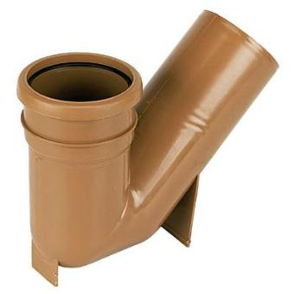  (Gully Trap) | 2. P. Trap:  This trap is used with Indian water closet (ORISSA Pattern). The traps are made from cast iron or UPV sheet. This trap also has water seal and prevents entry of foul gases to the house.  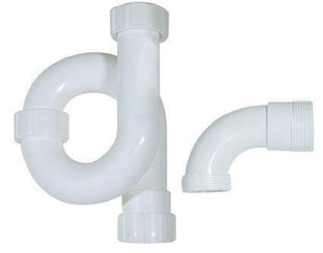  (P Trap)
3. S. Trap:  This trap is similar to P. trap and is used for fixing water closets in toilets. The only difference between P trap and S trap is that P. trap is used for outlet through the wall whereas S. trap is used for outlet through the floor.  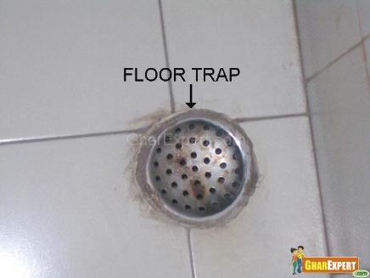 | 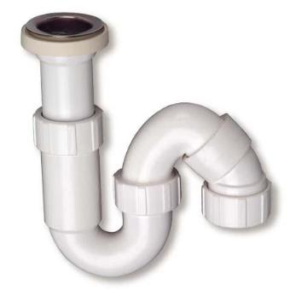(S Trap)  4. Floor Trap or Nahini Trap:  This trap is provided in the floor to collect waste water from washbasin, shower, sink and bathroom etc. These are available in cast iron or UPVC material and have removable grating (JALI) on the top of the trap. The minimum depth of water seal should be 50 mm.

5. Intercepting Trap:
this trap is provided at the last main hole of building sewerage to prevent entry of foul gases from public sewer to building sewer. It has a deep-water seal of 100 mm.

6. Grease Trap:
this trap is a device to collect the grease contents of waste and can be cleaned from the surface. This is generally used in food processing unit.
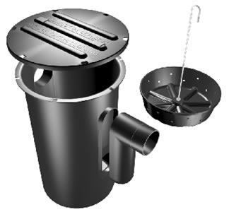
(This picture is contributed by"S.Krishnan")

7. Bottle Trap:
This trap is used below washbasin and sinks to prevent entry of foul gases.

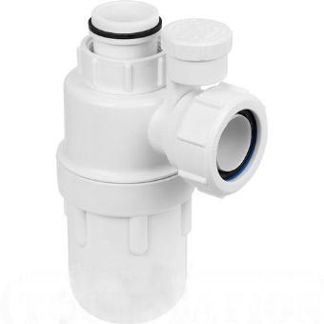

(This picture is contributed by "S.Krishnan")

8. Q Trap:
This trap is used in toilet under water closet. It is almost similar to S trap and is used in upper storey other than ground floor.
Refferences:
ihmhotelengineeringnotes.blogspot.com
ihmhotelengineeringnotes.blogspot.com
https://lecturenotes.in/m/21160-note-of-hotel-engineering-by-victor-agughasi
ihmkolkata.blogspot.com/2013/04/ihm-kolkata.html
Hotel Engineering - IHM PUSA
ihmpusa.net › wp-content › uploads › 2016/12 › Hotel-Engineering-0
https://www.newtondesk.com/refrigeration-and-air-conditioning-study-notes-hand-written/
en.wikipedia.org/wiki/
encyclopedia2.thefreedictionary.com
www.kopykitab.com/Engineering
www.faadooengineers.com/forums/112-Engineering-Ebooks.
Hotel Engineering Robert F eilliot
Hotel Engineering Tarun Bansal

