MAHARASHTRA COSMOPOLITAN EDUCATION SOCIETY
Azam Campus, Pune – 411 001
E-Content Description
Name of School / College: M A Rangoonwala Institute of Hotel Management and Research
Name and Designation of content creator /Producer | Assoc. Prof Imran Sayyed
Title of E content | Salad
Theory/practical | Theory
Title and No of Module | Salad
Title and code of Paper | ADVANCEDFOOD PRODUCTION SYSTEMS  301
Broad Subject | Food Production
Course | BScHS
Class | TY
Semister | Fifth
University /Board | SPPU
Date of Content Creation | 29 March 2020
Name of Reviewer  HOD/Principal | Imran Sayyed

Salad
.
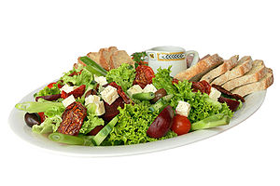
A salad platter.
Salads are a category of dishes whose prototype is raw vegetables served with a sauce or dressing including oil and an acid as a light savory dish. Salads also include a variety of related dishes, including ones with cold cooked vegetables, including grains and pasta; ones which add cold meat or seafood; sweet dishes made of cut-up fruit; and even warm dishes. Though the prototypical salad is light, a dinner salad can constitute a complete meal.
Green salads include leaf lettuce and leafy vegetables with a sauce or dressing. Most salads are served cold, although some, such as south German potato salad, are served warm.
Salads are generally served with a dressing, as well as various garnishes such as nuts or croutons, and sometimes with the addition of meat, fish, pasta, cheese, eggs, or whole grains.
Salads may be served at any point during a meal, such as:
- Appetizer salads, light salads to stimulate the appetite as the first course of the meal.
- Side salads, to accompany the main course as a side dish.
- Main course salads, usually containing a portion of protein, such as chicken breast or slices of beef.
- Palate-cleansing salads, to settle the stomach after the main course.
- Dessert salads, sweet versions usually containing gelatin or whipped cream.

Etymology
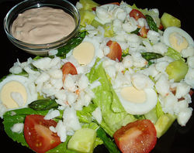
A Crab Louie with peppers on the side.
The word "salad" comes from the French salade of the same meaning, from the Latin salata (salty), from sal (salt). In English, the word first appears as "salad" or "sallet" in the 14th century.
Salt is associated with salad because vegetables were seasoned with brine or salty oil-and-vinegar dressings during Roman times.^{[1]}
The terminology "salad days", meaning a "time of youthful inexperience" (on notion of "green"), is first recorded by Shakespeare in 1606, while the use of salad bar first appeared in American English in 1976.
The term "salad" is commonly mistaken as the term for prepared lettuce.

History
Food historians say the Romans and ancient Greeks ate mixed greens and dressing.^{[2][3]} In his 1699 book, Acetaria: A Discourse on Sallets, John Evelyn attempted with little success to encourage his fellow Britons to eat fresh salad greens.^{[4]} Royalty dabbled in salads: Mary, Queen of Scots, ate boiled celery root over salad covered with creamy mustard dressing, truffles, chervil, and slices of hard-boiled eggs.
The United States popularized salads in the late 19th century and other regions of the world adopted them throughout the second half of the 20th century. From Europe and the Americas to China, Japan, and Australia, premade salads are sold in supermarkets, at restaurants (restaurants will often have a "Salad Bar" laid out with salad-making ingredients, which the customers will use to put together their salad) and at fast food chains. In the US market, fast food chains such as McDonald's and KFC, that typically sold hamburgers, fries, and fried chicken, now also sell packaged salads to appeal to the health-conscious customers.

Types of salads

Green salad
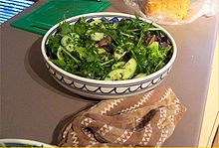
A Green Salad
The "green salad" or "garden salad" is most often composed of leafy vegetables such as lettuce varieties, spinach, or rocket (arugula). Due to their low caloric density, green salads are a common diet food. The salad leaves may be cut or torn into bite-sized fragments and tossed together (called a tossed salad), or may be placed in a predetermined arrangement (a composed salad).

Vegetable salad
Vegetables other than greens may be used in a salad. Common vegetables used in a salad include cucumbers, peppers, tomatoes, mushrooms, onions, spring onions, red onions, avocado, carrots, celery, and radishes. Other ingredients, such as olives, hard boiled egg, artichoke hearts, heart of palm, roasted red bell peppers, green beans, croutons, cheeses, meat (e.g. bacon, chicken), or seafood (e.g. tuna, shrimp), are sometimes added to salads.

Bound salad
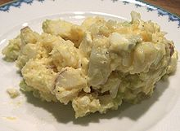
American-style potato salad with egg and mayonnaise
A "bound" salad can be composed (arranged) or tossed (put in a bowl and mixed with a thick dressing). They are assembled with thick sauces such as mayonnaise. One portion of a true bound salad will hold its shape when placed on a plate with an ice-cream scoop. Examples of bound salad include tuna salad, pasta salad, chicken salad, egg salad, and potato salad.
Bound salads are often used as sandwich fillings. They are also popular at picnics and barbecues, because they can be made ahead of time and refrigerated.

Main course salads
Main course salads (also known as "dinner salads" and commonly known as "entrée salads" in North America) may contain grilled or fried chicken pieces, seafood such as grilled or fried shrimp or a fish steak such as tuna, mahi-mahi, or salmon. Sliced steak, such as sirloin or skirt, can be placed upon the salad. Caesar salad, Chef salad, Cobb salad, Greek salad, and Michigan salad are types of dinner salad.

Fruit salads
Fruit salads are made of fruit, and include the fruit cocktail that can be made fresh or from canned fruit.

Dessert salads
Dessert salads rarely include leafy greens and are often sweet. Common variants are made with gelatin or whipped cream; e.g. jello salad, pistachio salad, and ambrosia. Other forms of dessert salads include snickers salad, glorified rice, and cookie salad popular in parts of the Midwestern United States.

Examples of salads
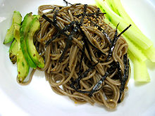

noodle salad
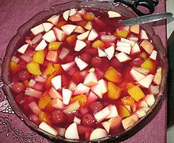

Fruit salad

World salads
Main article: List of salads

Other salads
The following is a list of additional salads:
- Bean saladBroccoli slawCaesar salad
- Candle saladCaprese saladChef saladChicken salad
- Chinese chicken saladColeslawCongealed salad
- Cookie saladCrab Louie saladÇoban Salatası (Turkish Salad)Egg salad
- Eggplant saladFattoushFruit saladGado-gadoGỏi ngó sen - a Vietnamese salad
- Greek saladHam saladIsraeli saladLarbMacaroni salad
- Niçoise saladPanzanellaPasta saladPotato saladSalad OlivierSalmagundiSeven-layer saladShopska saladSomen saladSom tamTabouliTaco salad
- Thai saladsTuna saladWaldorf saladWatergate salad

Dressings
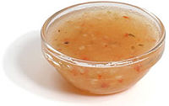
A dish of American-style Italian dressing.
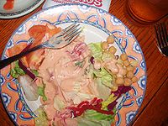

Thousand Island dressing on a salad
Sauces for salads are often called "dressings". The concept of salad dressing varies across cultures.
In Western culture, there are three basic types of salad dressing:
- Vinaigrette
- Creamy dressings, usually mayonnaise-based, but which may also contain yogurt, sour cream, buttermilk, milk, or crème fraiche
- Cooked dressings, which resemble creamy dressings, but are usually thickened by adding egg yolks and gently heating.
Vinaigrette /vɪnəˈɡrɛt/ is a mixture (emulsion) of salad oil and vinegar, often flavored with herbs, spices, salt, pepper, sugar, and other ingredients. It is used most commonly as a salad dressing, but also as a sauce or marinade.
In North America, mayonnaise-based Ranch dressing is most popular, with vinaigrettes and Caesar-style dressing following close behind.^{[7]} Traditional dressings in France are vinaigrettes, typically mustard-based, while mayonnaise is predominant in eastern European countries and Russia. In Denmark, dressings are often based on crème fraîche. In southern Europe, salad is generally dressed by the diner with oil and vinegar.
In Asia, it is common to add sesame oil, fish sauce, citrus juice, or soy sauce to salad dressings.[
The following are examples of common salad dressings:
- Blue cheese dressing
- Caesar dressing
- Extra virgin olive oil
- French dressing
- Ginger dressing
- Honey Dijon
- Hummus
- Italian dressing
- Louis dressing
- Ranch dressing
- Russian dressing
- Tahini
- Thousand Island dressing
- Vinaigrette
- Wafu dressing

Toppings and garnishes
Popular salad garnishes are nuts, croutons, anchovies, bacon bits (real or imitation), garden beet, bell peppers, shredded carrots, diced celery, watercress, sliced cucumber, parsley, sliced mushrooms, sliced red onion, radish, french fries, sunflower seeds (shelled), real or artificial crab meat (surimi) and cherry tomatoes. Various cheeses, berries, seeds and other ingredients can also be added to green salads. Cheeses, in the form of cubes, crumbles, or grated, are often used, including blue cheese, Parmesan cheese, and feta cheese. Color considerations are sometimes addressed by using edible flowers, red radishes, carrots, various colors of peppers, and other colorful ingredients.

Salad records
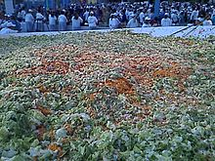

Largest lettuce salad in the world.
The moshav (agricultural village) of Sde Warburg, Israel, holds the Guinness World Record for the largest lettuce salad, weighing 10,260 kg. The event, held on 10 November 2007, was part of the 70th anniversary celebration of the founding of the moshav. The salad was sold to participants and onlookers alike for 10 NIS per bowl, raising 100,000 NIS (over $25,000) to benefit Aleh Negev, a rehabilitative village for young adults suffering from severe physical and cognitive disabilities. Major General (Res.) Doron Almog, Chairman of Aleh Negev was present to accept the donation and commended the residents, who had grown the lettuce and prepared the salad on the moshav. The volunteer effort to prepare the salad itself took all day and most of the residents, ranging from many of the original founders of the moshav to young children, participated
Ref:
1) Wikipedia.org
2) Ww.thespuceeats.com
3) theculinary.pro.com
4) ihmnotessite.net
5) slideshare.net
6) escoffieronline.com
7) tutorialpoint.com
8) coursehero.com

