MAHARASHTRA COSMOPOLITAN EDUCATION SOCIETY
Azam Campus, Pune – 411 001

E-Content Description
Name of School / College: M A Rangoonwala Institute of Hotel Management and Research
Name and Designation of content creator /Producer | Assoc. Prof Imran Sayyed
Title of E content | Refrigerator
Theory/practical | Theory
Title and No of Module | Refrigerator
Title and code of Paper | The Science of Hotel Engineering  Subject Code : HS 206
Broad Subject | Hotel Engineering
Course | BScHS
Class | SY
Semester | Third Semester
University /Board | SPPU
Date of Content Creation | 19 Jan 2020
Name of Reviewer  HOD/Principal | Imran Sayyed

Refrigerator

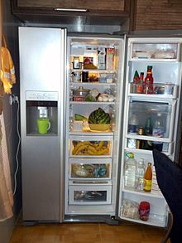
A side-by side refrigerator with an icemaker
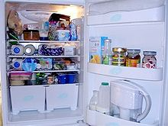
A typical refrigerator with its door open
A refrigerator (colloquially fridge) is a common household appliance that consists of a thermally insulated compartment and a heat pump (mechanical, electronic, or chemical) that transfers heat from the inside of the fridge to its external environment so that the inside of the fridge is cooled to a temperature below the ambient temperature of the room. Refrigeration is an essential food storage technique in developed countries. Lower temperatures in a confined volume lowers the reproduction rate of bacteria, so the refrigerator reduces the rate of spoilage.
A refrigerator maintains a temperature a few degrees above the freezing point of water. Optimum temperature range for perishable food storage is 3 to 5 °C (37 to 41 °F).^{[1]} A similar device that maintains a temperature below the freezing point of water is called a freezer. The refrigerator replaced the icebox, which was a common household appliance for almost a century and a half prior. For this reason, a refrigerator is sometimes referred to as an icebox.

Freezer
Freezer units are used in households and in industry and commerce. Food stored at or below −18 °C (−0 °F) is safe indefinitely.^{[2]} Most household freezers maintain temperatures from -23 to -18 °C (-9 to -0 °F), although some freezer-only units can achieve −34 °C (−29 °F) and lower. Refrigerators generally do not achieve lower than −23 °C (−9 °F), since the same coolant loop serves both compartments: Lowering the freezer compartment temperature excessively causes difficulties in maintaining above-freezing temperature in the refrigerator compartment. Domestic freezers can be included as a separate compartment in a refrigerator, or can be a separate appliance. Domestic freezers are generally upright units resembling refrigerators, or chests (resembling upright units laid on their backs). Many upright modern freezers come with an ice dispenser built into their door. Some even more upright and new models include exact temperature changing devices and even a built in clock.

Commercial and domestic refrigerators
Commercial refrigerator and freezer units, which go by many other names, were in use for almost 40 years prior to the common home models. They used gas systems such as anhydrous ammonia (R-717) or sulfur dioxide (R-764), which occasionally leaked, making them unsafe for home use and industrial purposes. Practical household refrigerators were introduced in 1915 and gained wider acceptance in the United States in the 1930s as prices fell and non-toxic, non-flammable synthetic refrigerants such as Freon-12® (R-12) were introduced. However, R-12 damaged the ozone layer, causing governments to issue a ban on its use in new refrigerators and air-conditioning systems in 1994. The less harmful replacement for R-12, R-134a (tetrafluoroethane), has been in common use since 1990, but R-12 is still found in many old systems today.

Styles of refrigerators
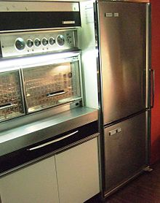
Frigidaire Imperial "Frost Proof" model FPI-16BC-63, top refrigerator/bottom freezer with brushed chrome door finish made by General Motors Canada in 1963
Most households use the freezer-on-top-and-refrigerator-on-bottom style, which has been the basic style since the 1940s.
- Traditional style — 1940s to present. Freezer top/refrigerator bottom (although most of the earlier models, some of the cheaper later models, and still some mini-fridges use the freezer chest, or what is known as the freezer-in-the-fridge). A separate freezer compartment — not located within the larger refrigerator compartment — became the industry standard during the early- to mid-1960s.
- Side-by-side style — introduced by Amana in 1949 but not popular until 1965–present; left side is freezer and the right is refrigerator.
- Top-refrigerator/bottom-freezer style — mid-1950s to present.
- French-door style — late 1990s-present. Two French doors for refrigerator and bottom freezer.
- Four-door French-door style - mid-2000s-present. Two French doors for refrigerator and bottom freezer plus an extra door above the freezer which can function as a refrigerator or freezer.
- Door and drawer, similar in concept to drawer style ovens, whereby the entire contents of the freezer are pulled out on gliders.
In the early 1950s most refrigerators were white, but from the mid-1950s through present day designers and manufacturers put color onto refrigerators. In the late-1950s/early-1960s, pastel colors like turquoise and pink became popular, brushed chrome-plating (similar to stainless finish) was available on some models from different brands. In the late 1960s and throughout the 1970s, earth toned colors were popular, including Harvest Gold, Avocado Green and almond. In the 1980s, black was viewed as luxurious. In the late 1990s stainless steel became stylish, and in 2009, one manufacturer introduced multi-color designs.
Most home refrigerators weigh between 200 pounds (91 kg) and 450 pounds (200 kg), with some models weighing up to 875 pounds (397 kg).

History
Before the invention of the refrigerator, icehouses were used to provide cool storage for most of the year. Placed near freshwater lakes or packed with snow and ice during the winter, they were once very common. Natural means are still used to cool foods today. On mountainsides, runoff from melting snow is a convenient way to cool drinks, and during the winter one can keep milk fresh much longer just by keeping it outdoors.
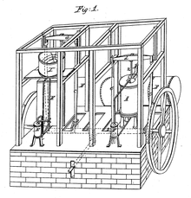

Schematic of Dr. John Gorrie's 1841 mechanical ice machine.
In the 11th century, Persian physicist and chemist Ibn Sina (Latinized name: Avicenna) invented the refrigerated coil, which condenses aromatic vapours. This was a breakthrough in distillation technology and he made use of it in his steam distillation process, which requires refrigerated tubing, to produce essential oils.

Collective refrigerators in the Alblasserwaard, Dutch newsreel 1956
The first known artificial refrigeration was demonstrated by William Cullen at the University of Glasgow in 1748.^{[7]} The American inventor Oliver Evans, acclaimed as the "father of refrigeration," invented the vapor-compression refrigeration machine in 1805. Heat was removed from the environment by recycling vaporized refrigerant, where it moved through a compressor and condenser, where it eventually reverted to a liquid form to repeat the process. However, Evans built no such refrigeration unit.^{[8]} In 1834, Jacob Perkins modified Evans' original design, building the world's first refrigerator and filing the first legal patent for refrigeration using vapor-compression.^{[9]} John Gorrie, an American doctor from Florida, invented the first mechanical refrigeration unit in 1841—based on Evans' original invention to make ice in—to cool air for yellow fever patients. Gorrie's mechanical refrigeration unit received a patent in 1851.^{[10]} American professor Alexander C. Twining of Cleveland, Ohio patented an early vapor-compression refrigerator in 1853 that was fully capable of producing a ton of ice per day.^{[11]}
In 1856, James Harrison, an immigrant from Scotland living in Australia, developed an ice making machine using ammonia and an ether compressor.^{[12]} It was used in the brewing and meat packing industries of Geelong, Victoria. Ferdinand Carré of France developed a somewhat more complex system in 1859. Unlike earlier compression-compression machines, which used air as a coolant, Carré's equipment contained rapidly expanding ammonia. In 1867, Andrew Muhl, an immigrant from France, built an ice-making machine in San Antonio, Texas, to help service the expanding beef industry before moving it to Waco in 1871.^{[13]} In 1873, the patent for this machine was contracted by the Columbus Iron Works,^{[14]} a company acquired by the W. C. Bradley Co., which produced the world's first commercial ice-makers.^{[15]}
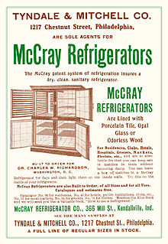
1905 McCray refrigerator ad
Carl Paul Gottfried Linde, ennobled in 1897 as Ritter von Linde, was a German engineer who developed refrigeration and gas separation technologies. In 1890, Carl von Linde moved back to Munich where he took up his professorship once more, but was soon back at work developing new refrigeration cycles. In 1892, an order from the Guinness brewery in Dublin for a Carbon Dioxide liquefaction plant drove Linde's research into the area of low temperature refrigeration, and in 1894 he started work on a process for the liquefaction of air. In 1895, Linde first achieved success, and filed for patent protection of his process (not approved in the US until 1903). In 1901, Linde began work on a technique to obtain pure oxygen and nitrogen based on the fractional distillation of liquefied air. By 1910 coworkers including Carl's son Friedrich had developed the Linde double-column process, variants of which are still in common use today.
In 1913, refrigerators for home and domestic use were invented by Fred W. Wolf of Fort Wayne, Indiana with models consisting of a unit that was mounted on top of an ice box.^{[16]} In 1914, engineer Nathaniel B. Wales of Detroit, Michigan, introduced an idea for a practical electric refrigeration unit, which later became the basis for the Kelvinator. A self-contained refrigerator, with a compressor on the bottom of the cabinet was invented by Alfred Mellowes in 1916. Mellowes produced this refrigerator commercially but was bought out by William C. Durant in 1918, who started the Frigidaire Company to mass-produce refrigerators.^{[17]} In 1918, Kelvinator Company introduced the first refrigerator with any type of automatic control. The absorption refrigerator was invented by Baltzar von Platen and Carl Munters from Sweden in 1922, while they were still students at the Royal Institute of Technology in Stockholm. It became a worldwide success and was commercialized by Electrolux. Other pioneers included Charles Tellier, David Boyle, and Raoul Pictet. Carl von Linde was the first to patent and make a practical and compact refrigerator.
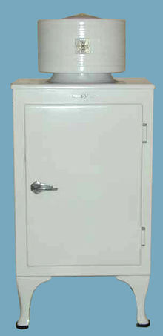
General Electric "Monitor-Top" refrigerator, introduced in 1927.
Refferences:
ihmhotelengineeringnotes.blogspot.com
ihmhotelengineeringnotes.blogspot.com
https://lecturenotes.in/m/21160-note-of-hotel-engineering-by-victor-agughasi
ihmkolkata.blogspot.com/2013/04/ihm-kolkata.html
Hotel Engineering - IHM PUSA
ihmpusa.net › wp-content › uploads › 2016/12 › Hotel-Engineering-0
https://www.newtondesk.com/refrigeration-and-air-conditioning-study-notes-hand-written/
en.wikipedia.org/wiki/
encyclopedia2.thefreedictionary.com
www.kopykitab.com/Engineering
www.faadooengineers.com/forums/112-Engineering-Ebooks.
Hotel Engineering Robert F eilliot
Hotel Engineering Tarun Bansal

