MAHARASHTRA COSMOPOLITAN EDUCATION SOCIETY
Azam Campus, Pune – 411 001

E-Content Description
Name of School / College: M A Rangoonwala Institute of Hotel Management and Research
Name and Designation of content creator /Producer | Assoc. Prof Imran Sayyed
Title of E content | Mousseline
Theory/practical | Theory
Title and No of Module | Mousseline
Title and code of Paper | ADVANCEDFOOD PRODUCTION SYSTEMS  301
Broad Subject | Food Production
Course | BScHS
Class | TY
Semister | Fifth
University /Board | SPPU
Date of Content Creation | 26 March 2020
Name of Reviewer  HOD/Principal | Imran Sayyed

A mousse is a prepared food that incorporates air bubbles to give it a light and airy texture. It can range from light and fluffy to creamy and thick, depending on preparation techniques.^{[1]} A mousse may be sweet or savory.Dessert mousses are typically made with whipped egg whites or whipped cream, and generally flavored with chocolate or puréed fruit.For savory mousse fish or liver may be used.
Mango Mousse
Chocolate Mousse
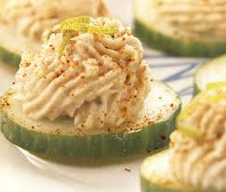
Easter Trout Mousse
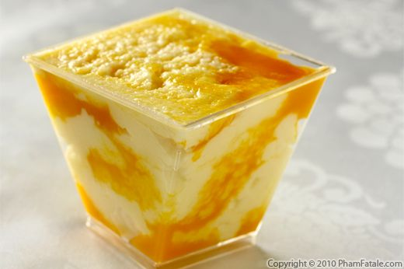
Mango Cream Cheese Mousse

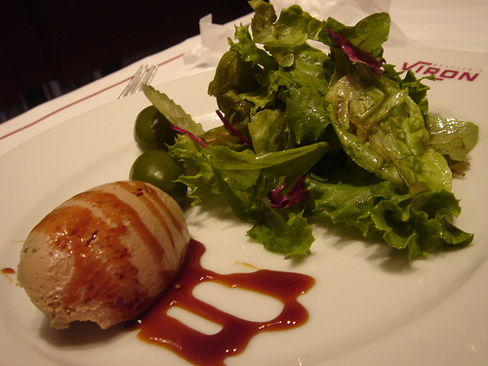
Chicken & Duck Liver Mousse with Truffles
Avocado Mousse
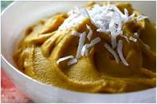
Pumpkin Mousse
Salmon Mousse
Mousseline may refer to:
Mousseline, is food preparation similar to a mousse, served hot or cold, that includes whipped cream as an ingredient, including:
Mousseline, a hollandaise sauce or mayonnaise to which stiffly whipped cream has been added
Mousseline, an aspic or paste containing whipped cream,^{[7]} or, less frequently beaten egg whites, with meat, fish, shellfish or foie gras, usually puréed, and prepared in a mould
[Mousseline, a confectioner's term to describe certain pastries and cakes containing delicate mixtures with cream or butter
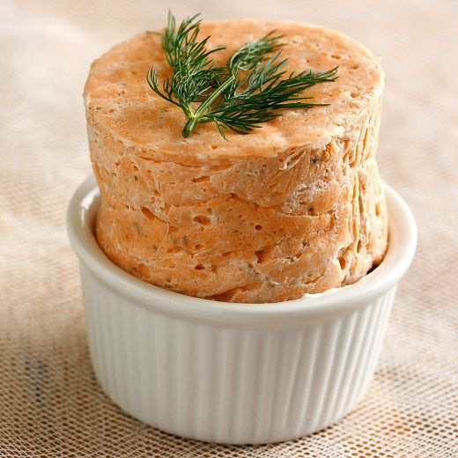
Ref:
1) Wikipedia.org
2) Ww.thespuceeats.com
3) theculinary.pro.com
4) ihmnotessite.net
5) slideshare.net

