MAHARASHTRA COSMOPOLITAN EDUCATION SOCIETY
Azam Campus, Pune – 411 001
E-Content Description
Name of School / College: M A Rangoonwala Institute of Hotel Management and Research
Name and Designation of content creator /Producer | Assoc. Prof Imran Sayyed
Title of E content | Icing (food)
Theory/practical | Theory
Title and No of Module | Icing (food)
Title and code of Paper | Principles of International Cuisine 401
Broad Subject | Food Production
Course | BScHS
Class | TY
Semester | Sixth
University /Board | SPPU
Date of Content Creation | 3 Jan 2020
Name of Reviewer  HOD/Principal | Imran Sayyed

Icing (food)
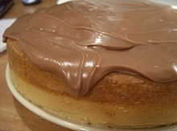

This cake has an icing made with chocolate and sour cream.
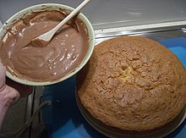

Icing in a bowl before being spread on a cake.
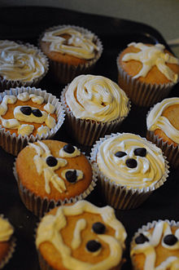

Cupcakes decorated by children using a butter cream icing
Icing, also called frosting in the United States, is a sweet often creamy glaze made of sugar with a liquid such as water or milk, that is often enriched with ingredients such as butter, egg whites, cream cheese, or flavorings and is used to cover or decorate baked goods, such as cakes or cookies. Elizabeth Raffald documented the first recipe for icing in 1769 in the Experienced English Housekeeper, according to the Food Timeline. However, it was not until 1915 that Mrs. Fred W. Gurney created the first buttercream recipe, and Fannie Farmer followed suit with several more recipes in 1918 and 1923.
Icing can be formed into shapes such as flowers and leaves using a pastry bag. Such decorations are common place on birthday and wedding cakes. Chef's color dye (food coloring) is commonly added to icing mixtures to achieve the desired color. Sprinkles, coloring mist, edible images or other decorations are often used on top of icing.
The simplest icing is a glacé icing, containing icing sugar and water. This can be flavored and colored as desired, for example by using lemon juice in place of the water. More complicated icings can be made by beating fat into icing sugar (as in butter cream), by melting fat and sugar together, by using egg whites (as in royal icing), and by adding other ingredients such as glycerin (as in fondant). Some icings can be made from combinations of sugar and cream cheese or sour cream, or by using ground almonds (as in marzipan).
Icing can be applied with a utensil such as a knife or spatula, or it can be applied by drizzling or dipping (see glaze) or by rolling the icing out and draping it over the cake. The method of application largely depends on the type and texture of icing being used. Icing may be used between layers in a cake as a filling, or it may be used to completely or partially cover the outside of a cake or other baked product.
A glaze in cooking is a coating of a glossy, often sweet, sometimes savoury, substance applied to food typically by dipping, dripping, or with a brush. Egg whites and basic icings are both used as glazes. For example, doughnut glaze is made from a simple mixture of powdered or confectioner's sugar and water that the doughnuts are dipped in, or some pastry doughs have a brushed on coating of egg whites. Glazes can also be made from fruit and are often applied to pastries. A type of savory glaze can be made from reduced stock that is put on meat or vegetables. Some candies or confections may be coated in edible wax glazes.
Cream cheese is a soft, mild-tasting, white cheese with a high fat content. Traditionally, it is made from unskimmed milk enriched with additional cream.
In the United States of America it is defined by the US Department of Agriculture as containing at least 33% milk fat (as marketed) with a moisture content of not more than 55%, and a pH range of 4.4 to 4.9. In other countries it is defined differently and may need a considerably higher fat content.
Cream cheese is not naturally matured and is meant to be consumed fresh, and so it differs from other soft cheeses such as Brie and Neufchâtel. It is more comparable in taste, texture, and production methods to Boursin and Mascarpone.
Cream cheese is typically used in savory snacks of various types (for example, as a spread on bread, bagels, crackers, various types of raw vegetables, etc.), and can be used in cheesecakes and salads. It can also be used to make cheese sauces. It can be a base to some spreads, such as yogurt-cream cheese topping for graham crackers, (1.25 parts cream cheese, 1 part yogurt, whipped.). It is sometimes used in place of butter (or alongside butter in a ratio of two parts cream cheese to one part butter) when making cakes or cookies, and it is also used to make cream cheese frosting, which is similar to buttercream frosting (using a ratio of two parts cream cheese to one part butter) which is used to frost carrot cake. It is the main ingredient in crab rangoon, an appetizer commonly served at American Chinese restaurants. It can also be used instead of butter or olive oil in mashed potatoes to create a creamy taste. It is also commonly used in some western-style sushi rolls.
Buttercream (also known as butter cream, butter icing or mock cream) is a type of icing or filling, used inside cakes, as a coating, and as decoration. In its simplest form, it is made by creaming butter with powdered sugar, although other fats can be used, such as margarine or lard. Colorings and flavorings are often added, such as chocolate, fruit purees or various extract. Buttercream is a common and popular topping for cupcakes, sponge cakes, butter cakes and other desserts.
Whether buttercream with no butter or a butter equivalent can rightly be called buttercream is debated among bakers, pastry chefs, and cake decorators.

Types

Simple buttercream
Simple buttercream (also known as American buttercream, decorator's buttercream or decorator's frosting) is made by creaming together butter, margarine or vegetable shortening, and powdered sugar to the desired consistency and lightness. Typically twice as much sugar (by weight) as butter is used. Flavorings, in the form of extracts or oils, may also be added. Some recipes call for non-fat milk solids, these add a creamy texture without the addition of water content of regular milk.
The frosting can form a thin crust after prolonged time at a cool temperature, which prevents sticking. This is due to the high sugar content and may be prevented with the addition of invert sugars such as glucose or fructose. Compared to other types of buttercreams, simple buttercream has a high proportion of sugar content, making it the sweetest of all the buttercreams.

Meringue-based buttercream
There are three types of meringue-based buttercreams. Each is called after the type of meringue used. There are two cooked versions, Italian meringue and Swiss meringue, and one uncooked, or French version. The 2 cooked meringues must be cooled to room temperature in order not to melt the butter, which has a variable melting point although below 40C/104F,^{[1]} which is subsequently beaten in.
Italian meringue is prepared by the addition of sugar syrup made by heating sugar and water (and sometimes the addition of glucose or corn syrup to stabilize the crystal structure) heated to the soft-ball stage (118°C, 240 °F) to egg whites whipped to soft peaks. The sugar syrup cooks the egg whites, heating them well past the 60°C (140°F) recommended in the USA to kill salmonella and any other potentially harmful bacteria. The syrup and egg white mixture is then whipped and cooled until it reaches room temperature.
Swiss Meringue is prepared by cooking the egg whites and sugar together in a bowl placed on a pot of boiling water. The mixture is whisked while it cooks until the temperature of the mix reaches 60°C. The mixture is then removed from the heat and whipped at high speed until it forms stiff peaks and has cooled
French meringue is prepared by whipping egg whites, cream of tartar, and caster sugar until stiff, glossy peaks are formed. French Meringue is usually used in recipes in which the prepared meringue is piped or spread onto a sheet pan and then cooked in a slow (low temp.) oven. When used as a base for buttercream, it remains uncooked. Because of the health concerns in the USA surrounding the consumption of raw eggs, the use of French meringue as the base for buttercream is rare there. In other countries, uncooked meringue is more common.
No matter which of the three types of meringue are used as the base, once it is prepared, butter and flavorings (extracts or oils) are then beaten into the meringue to transform the meringue into buttercream. Meringue-based buttercreams are light and creamy in texture and balanced between sweetness and richness. They are also the easiest to work with when icing and decorating cakes.

French buttercream
French buttercream is prepared in the same way as Italian meringue-based buttercream, except egg yolks (some versions use whole eggs) are used in place of the egg whites--a hot sugar syrup which has reached the soft-ball stage is beaten into the egg yolks which have been beaten until they are thick and pale yellow. The syrup and egg yolk mixture is further whipped until it has formed a light foam and has cooled. Butter and flavorings (extracts or oils) are then whipped in. This icing is very rich, smooth, and light. French buttercream tends to melt faster than other buttercreams due to the high content of fat from the egg yolks and butter. This type of buttercream is best suited for use as a filling or an icing, but not for decorations.

Custard-based buttercream
Custard-based buttercream (also known as German or Bavarian buttercream) is prepared by beating together a thick type of custard called pastry cream and softened butter, and may be additionally sweetened with extra confectioners' sugar. Like French buttercream, this icing is very rich and smooth and is best suited for use as a filling or an icing, but not for decorations.

Rolled buttercream
Most often used for icing sugar cookies, rolled buttercream is prepared by mixing together a large amount of powdered sugar with vegetable shortening, glucose or corn syrup, and flavorings (extracts or oils). So much powdered sugar is needed that it cannot all be incorporated using a spoon or mixer and must be kneaded in. Once all of the ingredients are combined, an icing dough is formed that can be rolled out and cut into shapes. Rolled buttercream is similar to fondant, but with a softer texture and less elasticity, it cannot be rolled as thin and so is not good for covering cakes or molding flowers or figures.

Choice of fat
The choice of fat in a buttercream frosting relates closely to the stability. Often, some amount of vegetable shortening is combined with butter for better consistency and resistance to heat.

Butter
Sweet cream unsalted butter is traditionally the fat of choice for buttercreams, as evidenced by the name. Butter provides a more delicate texture and superior flavor and mouthfeel (texture) when compared to vegetable shortening. Butter melts at a lower temperature, though, making it more difficult to use. The coloring provided by the butter is slightly off-white in the final frosting.

Margarine and shortening
Hydrogenated vegetable shortenings and margarine have become popular ingredients in commercial icings during the 20th century because they are cheaper and more stable at room temperature, and therefore easier to work with than butter. The whiter color is also favored, especially for wedding cakes. However, shortening does not dissolve in the mouth like butter, leading to a heavy, greasy feel inside of the mouth. The flavor of the buttercream is also not as intense. The resulting product raises health concerns due to the presence of trans fats in hydrogenated vegetable oils. Many margarines are virtually free of trans fats but in the US partially hydrogenated margarine is common.

Additions
Flavorings are commonly present in a buttercream frosting. Vanilla and chocolate are the most common additions, with coffee also a popular flavoring. Clear vanilla extract can be used to create a lighter-colored frosting. For chocolate buttercreams, cocoa powder or melted chocolate is added during the creaming stage or towards the end. Liqueurs or extracts, such as almond or peppermint, can also be added. For meringue-type and French buttercreams, the sugar syrup can be prepared with finely grated citrus zest or liquids such as juice for increased flavor. Food coloring can be added easily to any buttercream.

Handling
Most buttercreams can be left at room temperature without melting. Buttercreams made with shortening and a higher sugar content withstand warmer temperatures better than those made solely with butter. Cooling buttercream will cause it to harden. If a frosted cake is cooled, the buttercream may crack.
For French buttercream, it is better to leave the cakes with butter cream covered in plastic wrap in the refrigerator. Remove them 10 or 15 minutes before serving or longer to mitigate the chill.
When using buttercream to frost a cake, it is best to work with it when it is soft and spreadable. Icings may be stored, covered, in the refrigerator for several days. Before use, the icing needs to sit outside the fridge so it can come up to room temperature. If it must be warmed quickly or if it curdles, it can be heated over warm water (such as a bain marie or double boiler) and beaten until it becomes smooth again. Avoid directly heating the buttercream.
Royal icing is a hard white icing, made from softly beaten egg whites, icing sugar (powdered sugar), and sometimes lemon or lime juice. It is used on Christmas cakes, wedding cakes, gingerbread houses and many other cakes and biscuits, either as a smooth covering, or in sharp peaks. Glycerine is often added to prevent the icing from setting too hard. When Icing cakes Marzipan is usually used under the Royal Icing to prevent discoloration of the icing.
Usual proportions are 2 egg whites to 1 teaspoon of lemon juice, 1 teaspoon of glycerine and 1 Pound of sugar. The amount of sugar however must be altered to get the right consistency for application.
As well as coating cakes and biscuits, royal icing is used to make decorations such as flowers and figures for putting on the cake. The Royal Icing is piped into shapes which are allowed to harden on a non-stick surface. These can then be arranged to create edible decorative effects on a variety of sweet foods. The Glycerine must be omitted for this purpose.

Health risk
Although royal icing has traditionally been prepared with fresh egg whites, many people substitute meringue powder, given the risk of salmonella that using raw egg whites presents.^{[1]} Alternatively, ready-to-use, pasteurized, refrigerated egg whites can be purchased in most grocery stores which should also provide a safe alternative to fresh egg whites
Marzipan is a confection consisting primarily of sugar and almond meal. It is often made into sweets: common uses are marzipan-filled chocolate and small marzipan imitations of fruits and vegetables. It is also rolled into thin sheets and glazed for icing cakes, primarily birthday and wedding cakes and Christmas cakes. This use is particularly common in England, on large fruitcakes. Marzipan (or almond paste) may also be used as a cake ingredient, as in stollen. In some countries, it is shaped into small figures of animals as a traditional treat for New Year's Day. Marzipan is also used in Tortell, and in some versions of king cake eaten during the Carnival season. Traditional Swedish Princess Cake is typically covered with a layer of marzipan that has been tinted pale green
Meringue, ( /məˈræŋ/) is a type of dessert, often associated with Swiss and French cuisine, made from whipped egg whites and sugar, and occasionally an acid such as cream of tartar or a small amount of vinegar. A binding agent such as cornstarch or gelatin may also be added. The addition of powdered sugar, which usually contains corn starch, to the uncooked meringue produces a pavlova, a national dish of Australia and New Zealand. The key to the formation of a good meringue is the formation of stiff peaks formed by denaturing the protein ovalbumin (a protein in the egg whites) via mechanical shear. Meringues are often flavoured with vanilla and a small amount of almond or coconut extract although if these extracts are based on an oil infusion then this, if used in excess, may inhibit the egg whites into forming a foam due to the fat from the oil. They are light, airy and sweet confections. Homemade meringues are often chewy and soft with a crisp exterior, although a uniform crisp texture may be achieved at home, whilst commercial meringues are crisp throughout.

History
The notion that meringue was invented in the Swiss town of Meiringen by an Italian chef named Gasparini is contested. It is more probable that the name meringue for this confection first appeared in print in François Massialot's cookbook of 1692. The word meringue first appeared in English in 1706 in an English translation of Massialot's book. Two considerably earlier seventeenth-century English manuscript books of recipes give instructions for confections that are recognizable as meringue, though called "white biskit bread" in the book of recipes started in 1604 by Lady Elinor Fettiplace (c. 1570 - c. 1647) of Appleton in Berkshire (now in Oxfordshire),^{[4]} or called "pets" in the manuscript of collected recipes written by Lady Rachel Fane (1612/13 - 1680), of Knole, Kent. Slowly baked meringues are still referred to as "pets" (meaning farts in French) in the Loire region in France due to their light and fluffy texture.
Meringues were traditionally shaped between two large spoons, as they are generally at home today. Meringue piped through a pastry bag with a gored tip (illustration above) was introduced by Antonin Carême.

Type of meringue
There are several types of meringue, the sweetened, uncooked beaten egg whites that form the "islands" of Floating Island (also known in French as île flottante), the partly cooked toppings of lemon meringue pie and other meringue-topped desserts, and the classic dry featherweight meringue. Different preparation techniques produce these results.
- French meringue is the method best known to home cooks. Fine white sugar is beaten into egg whites.
- Italian meringue is made with boiling sugar syrup, instead of caster sugar. This leads to a much more stable soft meringue which can be used in various pastries without collapsing. In an Italian meringue, a hot sugar syrup is whipped into softly whipped egg whites till stiff. This type of meringue is safe to use without cooking. It will not deflate for a long while and can be either used on pies and Baked Alaska, or spread on a sheet and baked for meringues.
- Swiss meringue is whisked over a bain-marie to warm the egg whites, and then whisked steadily until it cools. This forms a dense, glossy marshmallow-like meringue. It is usually then baked.
Sour cream is a dairy product rich in fats obtained by fermenting a regular cream by certain kinds of lactic acid bacteria The bacterial culture, which is introduced either deliberately or naturally, sours and thickens the cream. Its name stems from the production of lactic acid by bacterial fermentation, which is called souring
Ganache ( /ɡəˈnɑːʃ/; from the French word for "jowl") is a glaze, icing, sauce, or filling for pastries made from chocolate and cream.
Ganache is normally made by heating cream, then pouring it over chopped dark semi-sweet chocolate. The mixture is stirred or blended until smooth, with liqueurs or extracts added if desired.
Depending on the kind of chocolate used, for what purpose the ganache is intended, and the temperature at which it will be served, the ratio of chocolate to cream is varied to obtain the desired consistency. Typically, two parts chocolate to one part cream are used for filling cakes or as a base for making chocolate truffles, while one to one is commonly used as a glaze. Cooled ganache can be whipped to increase volume and spread to cover a cake. However, if left to cool too much it can become too thick and unspreadable
Poured fondant is a creamy confection used as a filling or coating for cakes, pastries, and candies or sweets. In its simplest form, it is sugar and water cooked to the soft-ball stage, cooled slightly, and stirred or beaten until it is an opaque mass of creamy consistency. Sometimes lemon is added to the mixture, mainly for taste. Other flavorings are used as well, as are various colorings. For example, the main filling of a Cadbury Creme Egg is poured fondant.
Rolled fondant or fondant icing, which is not the same material as poured fondant, is commonly used to decorate wedding cakes. It includes gelatin (or agar in vegetarian recipes) and food-grade glycerine, which keeps the sugar pliable and creates a dough-like consistency. It can also be made using powdered sugar and melted marshmallows. Rolled fondant is rolled out like a pie crust and used to cover the cake.
Couverture chocolate is a very high quality chocolate that contains extra cocoa butter (32-39%). The higher percentage of cocoa butter, combined with proper tempering, gives the chocolate more sheen, firmer "snap" when broken, and a creamy mellow flavor.
The total "percentage" cited on many brands of chocolate is based on some combination of cocoa butter in relation to cocoa solids (cacao). In order to be properly labeled as "couverture", the percentage of cocoa butter must be between 32% and 39%, and the total percentage of the combined cocoa butter plus cocoa solids must be at least 54%. Sugar makes up the remainder, and up to 1% may be made up of vanilla, and sometimes soy lecithin.
Couverture is used by professionals for dipping, coating, molding and garnishing.
The term "couverture chocolate" should not be confused with "confectionery chocolate", "compound chocolate" or "summer coating": these products have a lower percentage of solids, and they may also contain vegetable oil, hydrogenated fats ("trans fats"), coconut and/or palm oil, and sometimes artificial chocolate flavoring.
Some brands of couverture chocolate are packaged tempered, and others are packaged untempered. Subsequent tempering may or may not be required, depending on the usage and the desired characteristics of the final product.
Couverture chocolate should not be substituted when semi-sweet, bittersweet, or unsweetened chocolate is called for in a recipe, as the increased cocoa butter content and the sugar content may alter the finished product.
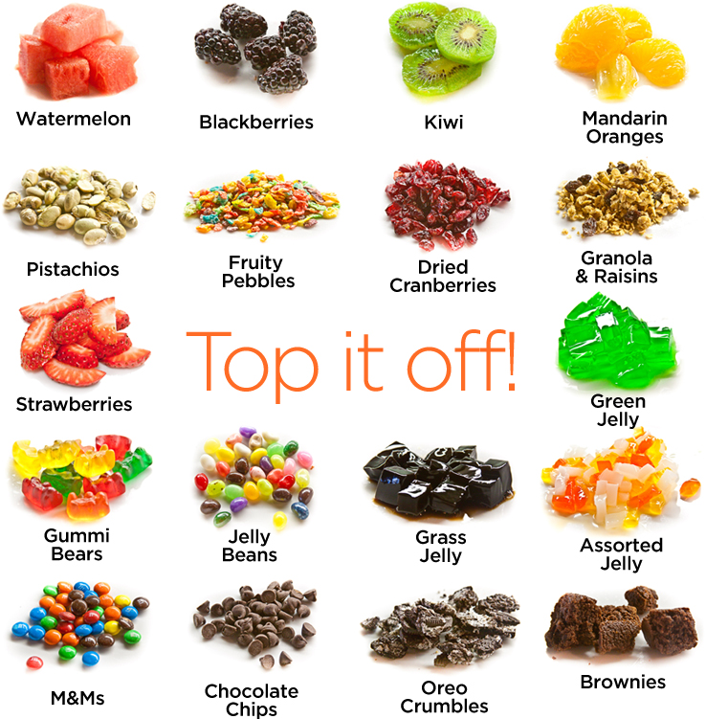
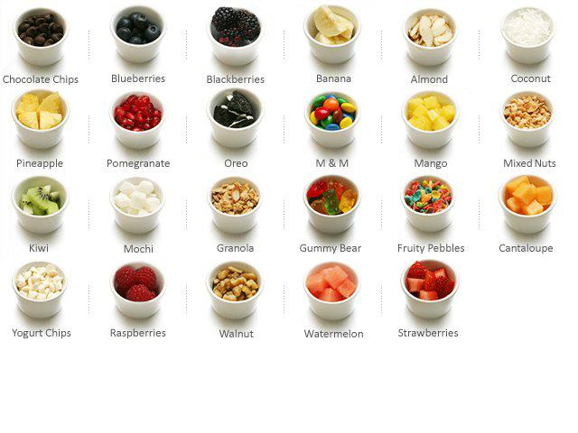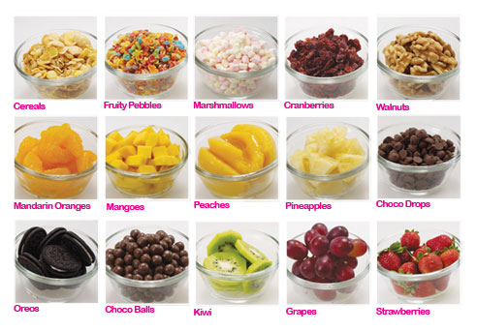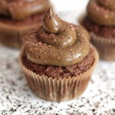
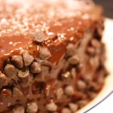
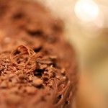
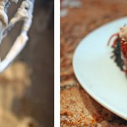
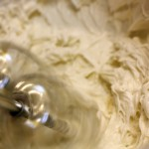
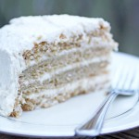
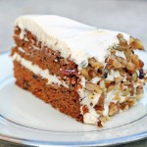
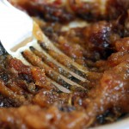
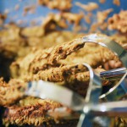
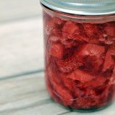
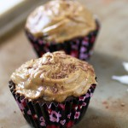
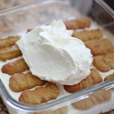
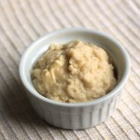
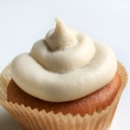
Avocado Mocha Frosting | Chocolate Frosting
Chocolate Ganache | Cinnamon Frosting
Coconut Buttercream Frosting | Coconut Cream Cheese Frosting
Cream Cheese Frosting | Date Mixture
Hazelnut Frosting | Strawberry Preserves
Sunbutter Frosting | Tiramisu Cream Cheese Filling
Vanilla Custard | Vanilla Frosting

Pudding Types
.
There are four major types and ways to prepare puddings: boiled, baked, steamed and chilled in the refrigerator until it gels. Some recipes can be prepared by either one method or another or through a combination of methods.
Betty: Dating back to colonial America, Betties are baked puddings made of layers of sugared and spiced fruit and buttered bread crumbs. Though many fruits can be used, the most popular is Apple Brown Betty, made with sliced apples and brown sugar.
Blancmange (bluh-MAHNZH): A simple cooked pudding made of milk, cornstarch, sugar and vanilla. Gelatin may be substituted for the cornstarch. The hot mixture is poured into a mold, chilled, unmolded and served with a sweet sauce or fresh fruit. The original blancmange used pulverized almonds in lieu of cornstarch.
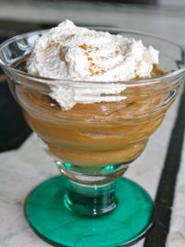Boiled Pudding: Boiled puddings are the easiest and quickest to prepare. They are constantly stirred on the stovetop until thickened and can be made in such favorite flavors as vanilla, chocolate and butterscotch.
SARAH SAYS: Chocolate pudding can be called the chocolate version of classic stirred custard thickened with cornstarch. Typically, cornstarch custard is made the same way by cooking a mixture of sugar, cornstarch, eggs (or egg yolks), a bit of salt, and a dairy liquid in a saucepan on the stovetop until thickened. If a boiled pudding recipe calls for unsweetened chocolate, try substituting it with bittersweet, which will give a smoother texture. The reasons? First, unsweetened chocolate has a lower percentage of cocoa butter than bittersweet, resulting in less of a smooth texture. Second, bittersweet contains some milk solids and lecithin (an emulsifier), both of which create a smoother, creamier texture and mouthfeel.
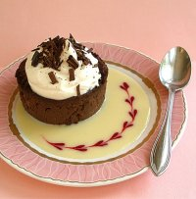Bread Pudding: Bread pudding consists of bread, milk (or cream), sugar, eggs, and (sometimes) flavorings, and typically baked. But they could be put together in any number of different ways, yielding very different results, from baked custard with slices of French bread on top to a rich, treacle pudding with sauce--really more of a pudding cake. In all, bread pudding should have a rich and silky a not-too-sweet pudding/custard, with some of the bread having been soaked and dissolved in it. Its golden brown top should be made up of pieces of bread with great chew or be crispy. Bread pudding should wobble like a Jell-O mold when removed from the oven, as continues to cook after removal. Remove the pudding from the oven just as it begins to inflate and rise up high in the pan. A knife inserted into the custard should not come out clean but be partially coated with half-set custard.
Diplomat Pudding: This cold, molded dessert consists of alternating layers of liqueur-soaked ladyfingers (or sponge cake), jam, chopped candied fruit and custard (sometimes combined with whipped cream). Diplomat pudding is usually garnished with whipped-cream rosettes and candied fruit.
Hasty Pudding: This easy, versatile dish was enjoyed by our Colonial ancestors both in the morning for breakfast and after dinner for dessert. It's a simple cornmeal mush made with water or milk and sometimes sweetened with molasses, maple syrup or honey. If the dish isn't sweetened during cooking, a syrup or sweet sauce usually accompanies a hasty pudding. It's served hot, sometimes with milk or cream.
Indian Pudding: This hearty, old-fashioned dessert originated in New England. It's a spicy, cornmeal-molasses baked pudding that can sometimes include sliced apples. Indian pudding is usually served with whipped cream, hard sauce or ice cream.
Mixes: Dry pudding mixes take on two forms — cooked and instant — which indicate whether the formula requires a pre-gelatinized or cook-up starch. They are made on the stovetop.
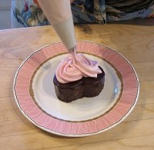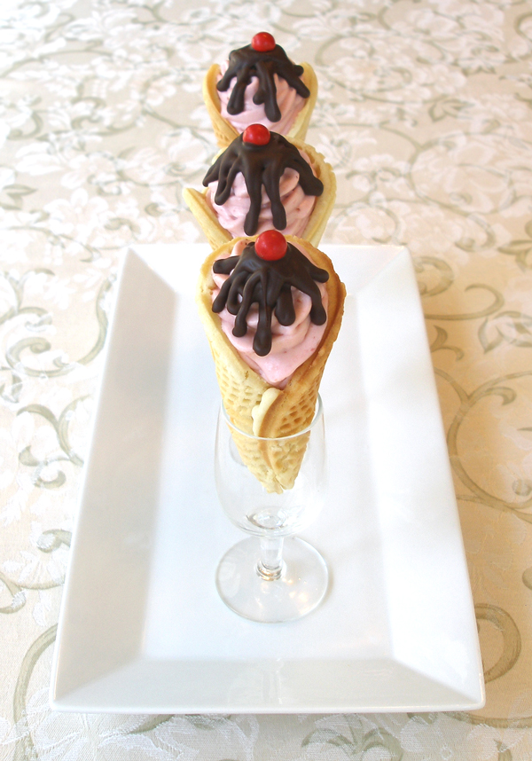Mousse: is the modern day version of pudding, with a smooth and creamy texture. Originally, the word mousse came from the French term meaning "foam" or "froth". It is a rich, airy dish that can be either sweet or savory and hot or cold. Cold dessert mousses are usually made with fruit puree or a flavoring such as chocolate or lemon. A mousse is similar to a Bavarian crème, which is a custard or a chiffon, in that it is light and airy due to the addition of whipped egg whites, whipped cream or both. They are usually fortified with gelatin (not as much in chocolate mousse recipes) because they are generally softer than the Bavarian or chiffon. Mousses tend to be too soft to mold into a semi-rigid form, i.e. a gelatin dessert, so they are usually piped into the final dessert presentation and garnished with additional whipped cream just prior to serving. HOW TO EGGS - COOKING TECHNIQUES FOR SAFE EGGS IN RECIPES
Unbaked flourless cakes include Mousse cakes, which are typically molded in a dessert ring or springform pan then simply chilled before unmolding. The cakes often have a crust or bottom layer that's baked before the mousse is added. Bottom layers can include baked genoise or biscuit cake layer, which can also be layered alternately with the mousse.
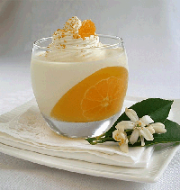Panna Cotta or Pannacotta: Panna cotta is a traditional Piemontese recipe -- the name means "cooked cream" in Italian. There are numerous variations on this wonderful light and delicious recipe, but I find that this recipe turns out especially creamy and smooth, as well as flavorful. Panna Cotta is typically made by boiling together milk or buttermilk, cream and sugar, and then mixing it with gelatin and flavoring it, often with vanilla. A perfect panna cotta should have just enough gelatin that it seems the dairy is barely holding together.
Plum Pudding: The name of this specialty comes from the fact that it originally contained plums, which it no longer does. Instead, this traditional Christmas dessert is made with suet, dried currants, raisins, almonds and spices. It's either steamed or boiled and is often served warm, flamed with brandy or rum, and accompanied by hard sauce. Steamed puddings are made by mixing the ingredients and then pouring into a tightly covered mold. It then goes into a waterbath which is fashioned from a pot where the water only comes up 2/3 of the sides of the mold. The pudding is then steamed on the stovetop for hours with the heat on low until done.
Rice Pudding: At its best, rice pudding is simple, lightly sweet, and tastes of its primary component: rice. Medium or long-grained rice works best. Some recipe cook the rice and water in a covered pot first, followed by simmering the cooked rice uncovered in the dairy mixture. Others have you bake the recipe.
Saxon Pudding: An English steamed brown bread pudding, uses dark rye bread, chocolate, almonds and crystallized fruit. Yorkshire pudding, made from cooked beef drippings, commonly accompanies a Sunday lunch of roast beef, lamb or pork. It is served with gravy, mint sauce or applesauce
Steamed Pudding: A sweet or savory pudding that is cooked (usually in a special steamed-pudding mold) on a rack over boiling water in a covered pot on a stovetop, taking hours to cook. Although steamed pudding can be cooked in a variety of containers, there are special steamed-pudding molds with decorative sides and bottom, as well as a lid that clamps tightly shut. Many molds also have a central tube (like an angel-food cake pan) that provides more even heat distribution, thereby cooking the pudding more evenly. When it is unmolded the pudding retains its decorative shape. They're customarily served with a sauce.
Summer Pudding: This classic English dessert consists of sweetened fresh berries and often red currants that are briefly cooked, then cooled before being placed in a bread-lined casserole dish. The fruit is topped with additional slices of bread, covered with a plate and weighted overnight in the refrigerator. The cold dessert is unmolded and served with whipped cream.
Yorkshire Pudding: British roast beef wouldn't be complete without Yorkshire pudding, which is like a cross between a popover and a soufflé and not at all like a pudding. It's made with a batter of eggs, milk and flour, baked in beef drippings until puffy, crisp and golden brown. It may be prepared in a shallow baking dish, muffin tins or other small containers, or in the same pan as the roast. Like a hot soufflé, Yorkshire pudding will deflate shortly after it's removed from the oven. This specialty takes its name from England's northern county of Yorkshire.
FROM AROUND THE WORLD
Mediterranean cooks make sweet, rich rice puddings using whole or ground rice flavored with cinnamon stick, lemon peel, orange blossom, honey, pistachio, almonds or hazelnuts.
Turkish fried semolina pudding, a pale brown, rich, soft pudding with pine nuts and vanilla; and Tunisian couscous pudding made from semolina, nuts, dates, rose water, seasonal fruits, pomegranate seeds and black raisins.
Indian sweet, rich, creamy puddings may be chilled or hot — cream, rice, tapioca, milk, vermicelli and carrot bases are flavored with ghee, nuts, rose petals, kewra essence, golden raisins and green cardamom. Halwa pudding contains grated carrots cooked in milk until tender, with ghee, cashews, golden raisins, sweetened condensed milk, cardamom and nutmeg. Milk-based payasams contain semolina, green split peas or vermicelli, flavored with spices and nuts and thickened with tapioca flour or almond paste.
In Southeast Asia, puddings include: bubur pulot hitam, a sweet, chewy, sticky, black rice pudding from Malaysia; Cambodia’s corn pudding; Indonesia’s steamed green-colored coconut and egg pudding; Burma’s creamy sago pudding; and Philippines’ sweet fruit and yam pudding. Latin American flan, a caramel pudding, varies regionally, and may include cinnamon, grated lemon rind and coconut, blanched almonds, cocoa or dark rum. Sweet, caramelized milk pudding, or dulce de leche, is made with simmered milk, sugar and vanilla and/or condensed milk. Mexican capirotada, a hot, baked bread pudding has repeated layers of toasted, cubed white bread, butter and a layer of sliced apples, almonds, raisins and coarsely chopped cheese, topped with piloncillo syrup (brown sugar) and spices.
Caribbean puddings include: carrot with raisins, allspice and dark rum served warm with hot rum sauce; banana and breadfuit; chipolata made with cream, vanilla and candied fruit topped with maraschino cherries; and Christmas steamed pudding served with brandy butter or brandy sauce..
Ref:
1) Wikipedia.org
2) Ww.thespuceeats.com
3) theculinary.pro.com
4) ihmnotessite.net
5) slideshare.net
6) escoffieronline.com
7) tutorialpoint.com
8) coursehero.com
9) hmhub.net
10) hospitalitytourism.blogspot.com

