MAHARASHTRA COSMOPOLITAN EDUCATION SOCIETY
Azam Campus, Pune – 411 001

E-Content Description
Name of School / College: M A Rangoonwala Institute of Hotel Management and Research
Name and Designation of content creator /Producer | Assoc. Prof Imran Sayyed
Title of E content | Question
Theory/practical | Theory
Title and No of Module | Question
Title and code of Paper | The Science of Hotel Engineering  Subject Code : HS 206
Broad Subject | Hotel Engineering
Course | BScHS
Class | SY
Semester | Third Semester
University /Board | SPPU
Date of Content Creation | 16 Jan 2020
Name of Reviewer  HOD/Principal | Imran Sayyed

Ans 1) In electricity supply systems, an earthing system or grounding system is circuitry which connects parts of the electric circuit with the ground, thus defining the electric potential of the conductors relative to the Earth's conductive surface. The choice of earthing system can affect the safety and electromagnetic compatibility of the power supply.
People use an earthing system mainly for these applications:
To protect a structure from lightning strike, directing the lightning through the earthing system and into the ground rod rather than passing through the structure.
Part of the safety system of mains electricity, preventing problems associated with floating ground and sky voltage.
The most common ground plane for large monopole antenna and some other kinds of radio antenna.
Other, less common applications of earthing systems include:
single-wire earth return.
part of a system that powers small devices from sky voltage.
one at each end of a ground dipole ELF antenna.
What is the Earthing System?
TT system
This system normally used for consumer power supply.No earthing system provided by power distributor.The owner must install the earthing protection by their own connection to the earth.They must installing a suitable electrode and safe arrangement for which they are responsibility to their installation.
The neutral and earthing conductor must be separately through the installation because power distributor only provide the supply neutral or protective conductor for the connection to consumer.
The advantage of this system is it clear from the noise of high or low frequency,not have risk of neutral broken or failure and suitable for special application like telecommunication.TT system is suitable for premises where all AC power circuits are residual current device (RCD) protected.

IT system
This system is similar with TT system but totally different in earthing supply.The distributor system not have any connection to earth or it have only a high impedance connection.It mean the usual protection is not effective for this system.
This type is not for consumer power supply.It special for power distributor such as substation or generator area.
TN-S system
This system has the neutral of power supply with connection of earth only at one point to the source.the consumer’s earthing terminal is usually connected to the metallic Armour of the distributor’s cable into the HV / LV transformer.
It is commonly used for underground power supply to the premise or factory from the distributor substation to customer substation.This earth terminal is connected by the supply protective conductor (PE) back to the star point (neutral) of the secondary winding of the supply transformer, which is also connected at that point to an earth electrode.
TN-C-S system
This system has the supply neutral conductor of a distribution main connected with earth at source as protective multiple earthing (PME).The supply distributor neutral conductor is also used to return earth fault currents from the consumer installation back to the source with a safely manner.
The power supply distributor will provide a consumer’s earthing terminal which is linked to the incoming neutral conductor.This combined earth and neutral system called the ‘protective and neutral conductor’ (PEN) or the ‘combined neutral and earth’ conductor (CNE).
TN-C system
This system is not familiar or unusual for earthing system.It a combined PEN conductor fulfills the functions of both a PE and an N conductor.The PEN conductor is the sheath of a cable and therefore is concentric with (totally surrounds) the phase conductor(s).
For wiring or cabling purpose,the suitable material is uses mineral insulated cable, the metallic copper sheath being the combined neutral and earth conductor.Normally this system used for ships or offshore platform earthing system.RCD protected is not function properly for this system.
Ans2)The door to door system. The bins or containers are located at each door, courtyard or
other area accessible from the home or building. The distance that the citizen has to
travel to deposit the waste is minimal.
• The kerbside system. The deposit points are no longer located at the door, but every 50-60
m on kerbsides. Citizens do not have to travel very far and acceptance is good. This
system is applied in cities with high population densities.
• The drop-off points system. Collection points are located at greater distances in order to
reduce management costs. The areas may have a range of between 100 and 300 m. The
system relies on citizens' willingness to travel longer distances on foot. Figure 3 shows
two drop-off points for dropping off paper-cardboard, glass and lightweight packaging
(plastic, metal and liquid packaging board) separately.
• Deposit at establishment level. Some establishments (shops, public institutions, etc.)
collaborate in the separate collection of some types of waste, particularly hazardous
waste such as batteries, fluorescent lamps and drugs.
• Deposit at facility level. Deposit points are located in facilities away from the residential
area. These facilities are called "Clean points", "Ecoparks" and "Recovery and Recycling
Centres" (Household Waste Recycling Centres in the United Kingdom). They are able to
selectively collect all types of waste, especially those that are not collected at other
levels
Defrosting (or thawing) is a procedure, performed periodically on refrigerators and freezers to maintain their operating efficiency. Over time, as the door is opened and closed, letting in new air, water vapour from the air condenses on the cooling elements within the cabinet. It also refers to leaving frozen food at a higher temperature prior to cooking.
Ans4)Defrosting a freezer
The resulting ice inhibits heat transfer out of the cabinet increasing running costs. Furthermore as the ice builds up it takes increasing space from within the cabinet - reducing the space available for food storage. Defrosting the unit is achieved by:-
Temporarily removing all food from the cabinet.
Turning off power to the unit.
Leaving the doors to the unit open
Waiting for the ice to melt and draining it appropriately. Using a towel is advisable when completing this step.
The process may be sped up by mechanical removal of ice, or the introduction of gentle heat into the cabinet. Placing a pan of hot water in the cabinet and closing it is an effective method. Using a fan to blow in room temperature air will also greatly speed up the melting process as well as help to evaporate the damp surfaces. Note that the fastest manual way is to use a vacuum cleaner: simply insert the hose into the exhaust port (nearly all are designed for this), and use the wand to blow on the coils; this method is much faster than any other.
Tips for Defrosting Your Freezer Without Hassle
An easy and less-stress way to thaw your freezer is first to use up the contents before unplugging. Eating down the freezer can save you money because you won't be buying more. Remember, you'll be using up what you have, that stuff you already paid for, before it loses quality in a freezer with fluctuating temperatures.
Once you've eaten down the freezer, unplug the machine, open it up, and let the ice melt. Beach towels can help soak up the water that melts off the sides. Wipe down the sides of the machine before plugging it back in and commencing the big refill.
If you're not in a place to eat up everything, you can place the frozen items in a cooler or in a cool space wrapped with blankets to keep them frozen. A pan of hot water placed in the unplugged, empty freezer can help speed up the thawing process.
It's so refreshing to have a clean slate: an empty freezer with frostless sides is a great project for refilling. Plus, you'll have a freezer that runs more efficiently, saving you money in more ways than one.
Ans 5)Ion-exchange is used extensively in small water systems and individual homes. Ion-exchange resin, (zeolite) exchanges one ion from the water being treated for another ion that is in the resin (sodium is one component of softening salt, with chlorine being the other). Zeolite resin exchanges sodium for calcium and magnesium. These reactions represent cation exchange, the exchange of positive ions. To replenish the sodium ions used, units need to be regenerated with material containing high amounts of sodium, normally salt brine. This allows the resin to be reused many times. Ion-exchange does not alter the water’s pH or alkalinity. However, the stability of the water is altered due to the removal of calcium and magnesium and an increase in dissolved solids. For each ppm of calcium removed and replaced by sodium, total dissolved solids increase by 0.15 ppm. For each ppm of magnesium removed and replaced by sodium, total dissolved solids increase by 0.88 ppm. Measurements used to express water hardness in ion-exchange differ from units used in limesoda softening. Hardness is expressed as grains per gallon rather than mg/l of calcium carbonate. 2 ADVANTAGES OF ION-EXCHANGE SOFTENING Compared with lime-soda ash softening, ion-exchange has certain advantages. It is compact and has a low capital cost. The chemicals used are safer for the operator to handle and operation is much easier. It can be almost totally automated. Because resins have the ability to remove all hardness from the water, treated water must be blended with water that has been by-passed around the softener (or adjustments made) to obtain a hardness level the operator needs to maintain. Many systems have found ion-exchange to be the most cost effective way to produce quality water for their customers. If zeolite units are used to soften surface water, it must be preceded by surface water treatment.
Ans 6) Plain Break Oil Circuit Breakers
Oil Circuit Breaker
a high-voltage AC electrical switch whose main contacts are located in a space filled with mineral (transformer) oil. Upon interruption of the electric circuit, an electric arc forms between the contacts of the circuit breaker. Because of the high temperature of the arc the oil is evaporated rapidly and oil vapors are partially decomposed, liberating ethylene, methane, and other gases. A gas bubble is formed in the arcing zone; the pressure in the bubble may be as high as several dozen meganewtons per sq m. The arc is then extinguished, both because of its elongation upon parting of contacts and because of intensive cooling by the gases and oil vapor.
In an oil circuit breaker with simple interruption under oil, the duration of arcing is 0.02-0.05 sec. To extinguish the arc more efficiently, arc-quenching chambers are used. In a longitudinal blast chamber the vapors and gases evolved travel upward along the arc, thus cooling it. In addition, the arc is in contact with the cold oil that fills the annular slots of the chamber, which also accelerates cooling of the arc. In a transverse blast chamber a drastic pressure increase within the gas bubble causes a stream of oil and gases to flow across the arc, thus accelerating the cooling process.
The plain-break oil circuit breaker is the earliest type from which all other circuit breakers have developed .It has a very simple construction. It consists of fixed and moving contacts enclosed in a strong weathertightearthed tank containing oil up toa certain leveland an air cushion above the oil level.The air cushion provides sufficient room to allow forthe reception of the arc gases without the generationof unsafe pressure in the dome of the circuit breaker. Working principle:
- The hydrogen gas bubble generated around the arccools the arc column and aids the deionisation of themedium between the contacts.(ii) The gas sets up turbulence in the oil and helps ineliminating the arcing products from the arc path.(iii) As the arc lengthens due to the separating contacts, thedielectric strength of the medium is increased.
- 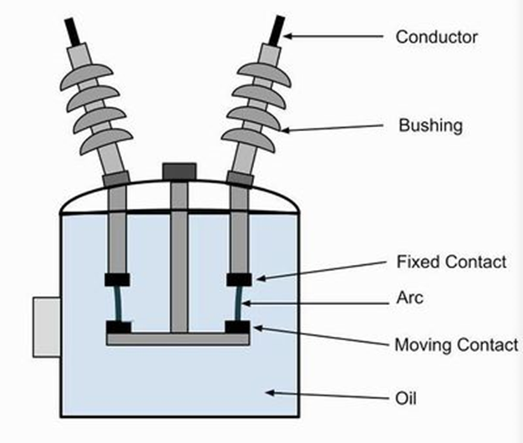
Ans7) UNDERSTANDING COLD WATER SYSTEMS IN THE
HOME
This advice guide is part of a series of free guides produced by the Association of Plumbing &
Heating Contractors Ltd. which provide consumers with essential basic information on a range
of plumbing and heating matters including installations, repairs and maintenance.
We don’t often see the pipework that carries cold water around the home, for example, a cold tap on a
bath, a cold feed to an electric shower or washing machine or an outside tap for using a garden hose.
Understanding how cold water is distributed around the home will allow you to identify what has gone
wrong in the unfortunate event of a leak or ensure you have the most suitable system installed to meet
your needs.
Getting cold water to the home
A water supplier will provide water to a home, through a water main, then branch off. At this point, older
systems may have one branch that connects up to four homes. New properties will have an installation
similar to that shown in the diagram below.
It is vital that people living in a property know where and how to turn off the water supply to their home,
in the event of a leak or for maintenance.
WATER SUPPLY DESIGN
Supply System
• Primary types: upfeed and down feed
- Based on height of building & pressure required to operate fixtures
• Upfeed: uses pressure in water main to directly supply fixtures
- Limit: 40’ – 60’
- Supply from city main is 50psi
- Pressure must be sufficient to overcome friction in pipes, fittings, meter and static head & still
have enough pressure to operate fixtures
- Flush valve: 10 – 20 psi
- Shower head: 12psi
- Toilet: 15pas
- Faucet: 7-8psi
- Hose bibb: 30psi
- Static head: pressure required to push water vertically or the pressure caused at the bottom of
a column of water
- .433 psi to lift water 1’-0” or
- 1psi will lift water 2.3’
- When converting from pressure (psi) to lift (ft), use 2.3 ft per psi
- When converting height or lift (ft) to pressure (psi) use 1/23 or .433 psi
- Example I: A 10 story building has a floor to floor height of 12’, a pressure of 15psi is needed
to flush toilet. What is the required water pressure at the base of the building?
Total lift = 10story x 12’
= 120
= 120/2.3psi
= 52.2 psi
Therefore 52.2psi + 15psi (toilet) = 67.2psi
- Example II: If additional pressure drop of 12psi due to friction @ meter, what is required
pressure at base?
PTOTAL = 52.2psi + 15psi + 12psi
= 79.2psi(min)
- Example III: How much pressure is lost in static head at a fixture 40’ above a water main w/
pressure of 45psi (ignoring friction loss)
40’(.434 lbf/in2
/ft) = 17.36psi
The remaining pressure at the 40’ level is:
45psi – 17.36psi = 27.64psi
- If water supply insufficient, a downfeed system or pneumatic tank must be used
• Downfeed system: when building is too tall for upfeed, water is pumped to storage tanks near top
of building or zone served & flows by gravity to fixtures
- Pressure at any point is determined by distance from outlet of tank
- Height of zone served is determined by max allowable pressure on the fixtures at the bottom
- Max pressure approx. 45 – 60psi
- Max height of zone is 60’ ÷ .434psi or about 138ft
- Beyond max height, pressure-reducing valve needed
- Fixtures at top of zone must have min pressure to make work properly
- Example: flush toilet needs 15psi then water tank must be min of 15/.434 or 35’ above
the fixture
- Actual distance slightly greater to overcome friction
• Lower floors of high rise = upfeed
• Upper floors of high rise = downfeed
• Direct upfeed pumping system or tankless system: several pumps controlled by pressure sensor
which responds to demand
Hot Water Supply
• By tank type or boilers (water heated by gas, oil, elec or steam)
• In small buildings, single supply pipe from heater to fixt minimizes cost but long waits for hot water
- Solved with a two pipe circulating system where all fixtures needing hot water are connected
with supply and return pipes
- Convection keeps water moving: hot water rises to upper fixtures, cools falls to heater
- In long low bldgs convection may not provide enough circulation & pumps are needed
• Size of hot water heater is based on peak demands
- Peak hourly demands:
- .4gal per person for an office
- 12gal per unit for small apartment building
- For large buildings, separate storage tanks required to meet demand while a smaller
boiler heads the water
- Recovery rate: gal per hour of cold water that heater can rise to desired temp
• Size of hot water piping is determined similar to cold water piping except only fixtures requiring hot
water are used. Value multiplied by .75 (75%)
• Recommended point-of-use temps: 95° for therapeutic baths (110° hot to touch) to 180° for
commercial laundries
- 105° hand washing
- 110° for showers
- 140° for residential dish washers
• Types of heaters:
- Direct: water in direct contact with heat source
- Indirect: used intermediate transfer medium to heat water
- Example: commercial applications where steam is available, it can be piped to tubes
within a tank containing domestic hot water
- Storage tank system: tank is used to both heat and store
- Tankless system: quick heated and sent to where needed
- “Insti-hot” at water coolers
- Circulating system: water heated in one place and stored in a separate tank until needed
- Commonly used in solar powered water heating

Block diagram of evaporater
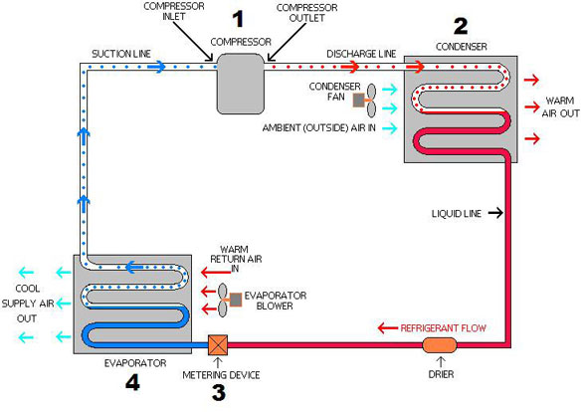
The solution containing the desired product is fed into the evaporator and passes across a heat source. The applied heat converts the water in the solution into vapor. The vapor is removed from the rest of the solution and is condensed while the now-concentrated solution is either fed into a second evaporator or is removed. The evaporator, as a machine, generally consists of four sections. The heating section contains the heating medium, which can vary. Steam is fed into this section. The most common medium consists of parallel tubes but others have plates or coils typically made from copper or aluminium. The concentrating and separating section removes the vapor being produced from the solution. The condenser condenses the separated vapor, then the vacuum or pump provides pressure to increase circulation.
Block Daigram of Compressor
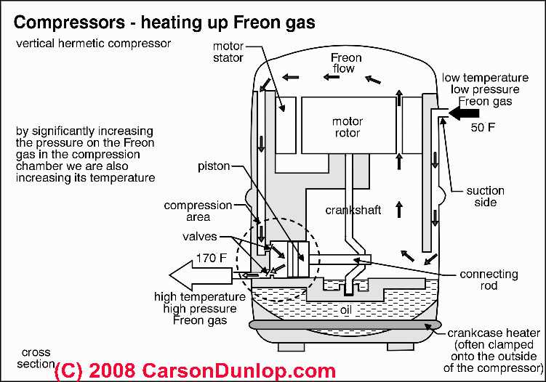
In a nutshell, the air conditioner compressor, condenser, fan unit is the "outdoor" half of an air conditioning or heat pump installation that uses a compressor motor (below right) to compress refrigerant gas to high pressure, sending the pressurized gas through cooling coils (condensing coils) where aided by air movement drawn by the condenser unit fan, the gas is returned to a liquid refrigerant state
The process of compressing and then condensing the refrigerant back from a gas to a liquid also moves heat out of the refrigerant and into outdoor air. We explain this process in detail below.
The outdoor half of a typical air conditioning system (shown at below left) is a unit containing the refrigerant compressor and condensing coil and a cooling fan.
In our photo the gray screened area covering one side of the condensing coil of the first compressor in this row is easily visible. The compressor motor itself (below-right) is not visible unless the covers of this unit are removed.

Block Diagram of Boiler

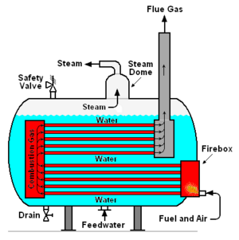
Water-tube boilers with longitudinal steam drums, as were developed to allow increases in generated steam pressure and increased capacity. The water-tube boilers, in which water flowed through inclined tubes and the combustion product gases flowed outside the tubes, put the desired higher steam pressures in the small diameter tubes which could withstand the tensile stress of higher pressures without requiring excessively thick tube walls.
The relatively smaller steam drums (in comparison with the fire-tube shells) were also capable of withstanding the tensile stress of the desired higher pressures without needing excessively thick drum walls.

Ans 12) Direct/Indirect Lighting
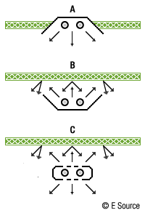
Direct lighting Indirect Lighting
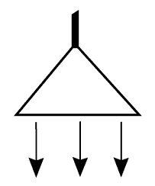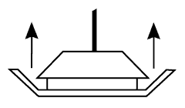
(Term of lighting design)
Lighting that is mixed from direct sources and indirect reflection. In daylighting this means that some part of the light of the sky or the sun is bounced off some surface, while at least part of the sky is still visible from the point in question. In electrical lighting, it says that luminaires of different types are installed, or there are luminaires that emit light both up to the ceiling and down to the workspace.
Advantages:
Good balance between ambient illumination of the room and accent lighting.
Relatively good energy efficiency even in large spaces.
The smaller direct component required makes it easier to control reflective glare in computer screens.
Renders three dimensional objects well without harsh shadows.
Disadvantages:
Relatively high installation and maintenance costs.
Users often need instruction on how to use the system effectively.
Alternative lighting patterns are direct lighting and indirect lighting.
Direct Lighting
(Term of lighting design)
Lighting provided from a source without reflection from other surfaces. In daylighting, this means that the light has travelled on a straight path from the sky (or the sun) to the point of interest. In electrical lighting it usually describes an installation of ceiling mounted or suspended luminaires with mostly downward light distribution characteristics.
Advantages:
Very energy effective lighting.
Plastic display of three dimensional objects, eg. sculptures.
Well suited for zonal or accent lighting.
Can create a vivid environment with attractive light and shadow patterns eg. on wall surfaces.
Disadvantages:
The ceiling is relatively dark, which can cause a "cave like" environment.
Luminaires with wide opening angle that are badly positioned can cause reflected glare on computer screens, dark "executive style" desk surfaces or glossy paper.
Harsh shadows can be unflattering when cast on human faces.
Alternative lighting patterns are indirect lighting and mixed direct/indirect lighting.
Indirect Lighting
(Term of lighting design)
Lighting provided by reflection usually from wall or celiling surfaces. In daylighting, this means that the light coming from the sky or the sun is reflected on a surface of high reflectivity like a wall, a window sill or a special redirecting device. In electrical lighting the luminaires are suspended from the ceiling or wall mounted and distribute light mainly upwards so it gets reflected off the ceiling or the walls.
Advantages:
Creates a soft, undisturbing environment suitable for concentrated work or viewing paintings or drawings.
Reflective glare on computer monitors can be controlled more easily.
Displays human faces advantageously for social gatherings.
Can be installed without disturbing the ceiling surface (eg. in historical buildings or a painted ceiling).
Disadvantages:
It can be disturbing if the ceiling is the brightest surface in a room.
Makes it difficult to recognise details on three dimensional objects.
There is very little contrast in the room which can be boring.
Not very energy effective.
Alternative lighting patterns are direct lighting and mixed direct/indirect lighting.
Ans 14)Diffenence between fuse and circuit breaker
Both the fuse and the circuit breaker (CB) are intended to open a circuit for excessive current.
The traditional fuse is a circuit element that is a one time use element. That is, excessive current will cause it to open and to restore the circuit the fuse must be replaced with a like element. They are often cylindrical and come in holders for somewhat easy replacement but sometimes are soldered in place. They usually use a fusing element that is metal with a low temperature melting point that literally melts under overcurrent conditions. The cylinder is often made of glass to allow inspection of the fuse element to see it it is blown.
There are some self-resetting fuses that will heal after a certain amount of time. These are called PTC fuses and have a high resistance state when hot. If the heat was caused by overcurrent then removing the overload will restore the fuse to operation mode.
A circuit breaker is a multiple use device. It is usually permanently installed in equipment. It generally has two mechanisms for breaking the current: a magnetic portion which opens with a large current and a thermal part that also opens under overcurrent... the thermal part has a lag so these typically go slower than a fuse but with very high currents the magnetic part will open quickly. The circuit breaker usually has a button or handle to reset it after it has cooled down.
Circuit breakers are usually more costly and larger than fuses. Fuses are more likely to be abused because if blown and the user wants to return the equipment to operation AND there is not a spare fuse then he will substitute a fuse of higher value or short out the fuseholder in frustration and defeat the saftey of the fuse.
Ans15)Equipment Maintenance Plans
The Equipment Maintenance Plan, or EMP as it is commonly called, is a
document, in table format, that is used when developing the tasks needed to
properly maintain facility, plant or process equipment. The EMP helps lead the
person or persons developing the required maintenance tasks by ensuring that
the development is done consistently for all equipment. Each EMP should
include one or more maintenance tasks designed to ensure the continued
operation and maintenance of an equipment item, process or system. Each of
these tasks has the following characteristics:
• A descriptive title for each maintenance task to be performed
• A frequency assigned for performing of each task
• Assignment of a specific craft or workgroup and the number of each craft
or workgroup required to perform the task
• Equipment condition required for performance of the task (i.e. running or
shut down)
• Type of Work – Preventive Maintenance (PM), Predictive Maintenance
(PdM), Corrective Maintenance (CM), Situational Maintenance (SIT), etc.
• Procedure number – Unique identifier for the task, or file name if linked to
another document that gives the individual task instructions
• Estimated time to perform the task
• Special tools, materials and equipment required to perform the task
The EMP can also provide the following additional planning and budgeting
information if set up properly in a spreadsheet format:
• Annualized hours for performing the task
• Annualized hours for shut down of the equipment during performance
of the task
• Annualized hours for performance of the task by craft
Each EMP consists of the following defined sections that contain specific
Information
Refferences:
ihmhotelengineeringnotes.blogspot.com
ihmhotelengineeringnotes.blogspot.com
https://lecturenotes.in/m/21160-note-of-hotel-engineering-by-victor-agughasi
ihmkolkata.blogspot.com/2013/04/ihm-kolkata.html
Hotel Engineering - IHM PUSA
ihmpusa.net › wp-content › uploads › 2016/12 › Hotel-Engineering-0
https://www.newtondesk.com/refrigeration-and-air-conditioning-study-notes-hand-written/
en.wikipedia.org/wiki/
encyclopedia2.thefreedictionary.com
www.kopykitab.com/Engineering
www.faadooengineers.com/forums/112-Engineering-Ebooks.
Hotel Engineering Robert F eilliot
Hotel Engineering Tarun Bansal

