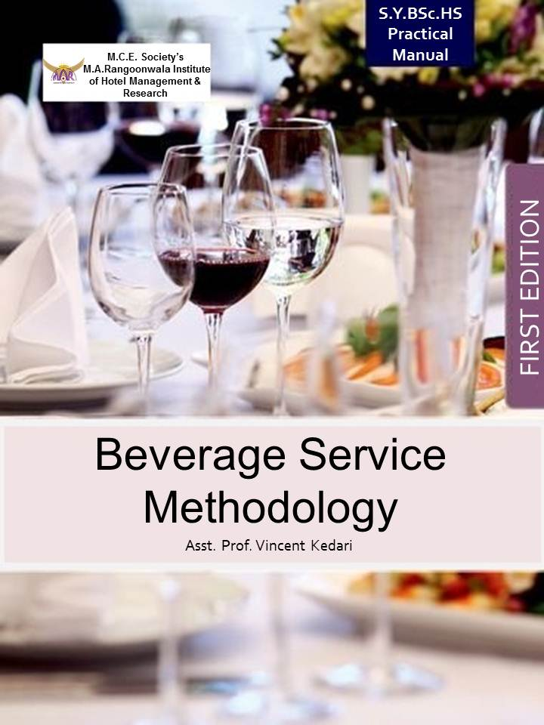

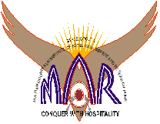
M. C. E. Society’s
M. A. RANGOONWALA INSTITUTE OF HOTEL MANAGEMENT & RESEARCH
2390 – B, K. B. Hidayatullah Road, Azam Campus, Camp, Pune – 411001
www.marhotelmanagement.com Phone no: 020-26442261/62

Certificate

This is to certify that Mr. / Ms. ________________________________________________ studying in F.Y. / S.Y. / T.Y. B.Sc. (HS), Bachelor of Science in Hospitality Studies has completed the course of practical in the subject _________________________________________________________________________________________ satisfactorily during the year 20____ - 20____

His/hers attendance and Performance is as follows:
Total no. of Practicals Conducted | No. of Practicals attended | Grade

Prof. Anita Frantz
Principal Lecturer In-charge Examiner

INDEX

Subject: Beverage Service Methodology
Subject Code: HS 208

Practicals:
1. Conducting Briefing/De-briefing for F & B operations.
2. Taking order for Beverages. (2 practicals)
3. Identification of glasses, equipment required for service.
4. Reading a Wine Label – French.
5. Food & Wine Harmony.
6. Service of Still wines, Sparkling wine, Fortified wines.
7. Menu planning with wines.
8. Service of Spirits (Whisky, Brandy, Rum, Gin, Vodka, Tequila)
9. Preparation of classic and innovative cocktails, glassware and Garnish.
10. Service of Liqueurs.
11. Service of Cigars and Cigarettes

Practical No. 1 Date: ___________
Title - Conducting Briefing/De-briefing for F & B operations.
Aim/Objective - To understand the procedure to conduct the briefing/de-briefing for the F&B Operations
Materials Required - Serviette, KOT Pad, Pen, Wine opener and a note pad.
Procedure:
Briefing can be defined as a two way communication process between the management and staff before the actual process of operation starts.
Following points need to be considered at the time of briefing –
- Attendance – The attendance of the staff right from banquet in-charge to clearance boys is taken. Casual boys are also considered. If any staff is absent without any intimation, and then the reason is found out.
- Grooming –
- Uniform should be neat.
- Shoes should be well polished.
- Nails must be clean and trimmed.
- Hair should be well combed and maintained.
- Girls should tie their hair with simple band, no fancy ribbons.
- Service kit is a must and should include –

- Pen
- Note pad
- Bottle and Wine opener
- Serviette
- Name Tag
- Lighter

- Service – Check table set up for errors, suggest changes if necessary. When staff comes on duty first briefing is done, how to be done and for how many people. The entire function prospectus is read out to give them required details such as –
- Name of the host (Banquet)
- Number of guaranteed and expected guests
- Menu for the day
- VIP’s if booked
- Once the service policies discussed, duty allocation should be done accordingly to table set up.
- Special instructions if given at this stage.
- Doubts if any are exchanged and cleared.
- Tentative time of the host and the guest arrival is given during briefing.
- Lead time is given to be absolutely ready with complete set up and pick up time for food.
- Information, recipes, details of menu should be discussed.
- De-Briefing – De-Briefing is done, once the service of the day is over. Entire restaurant team gathers once again for de-briefing. Following points are discussed in the de-briefing –
- Restaurant Manager / Captain usually conduct the de-briefing session.
- Good and bad points during the event are discussed.
- Common mistakes done are pointed out in the de-briefing and solution and remedy is discussed
- If the staff has done overall good work, then they are congratulated, appreciated motivated to do more better work in the future.
- If service personnel have done extremely good work then he is pointed out and appreciated in front of everyone.
- The common suggestion given by the host before leaving is told and discussed. Any major incidents good or bad are told and discussed during de-briefing.
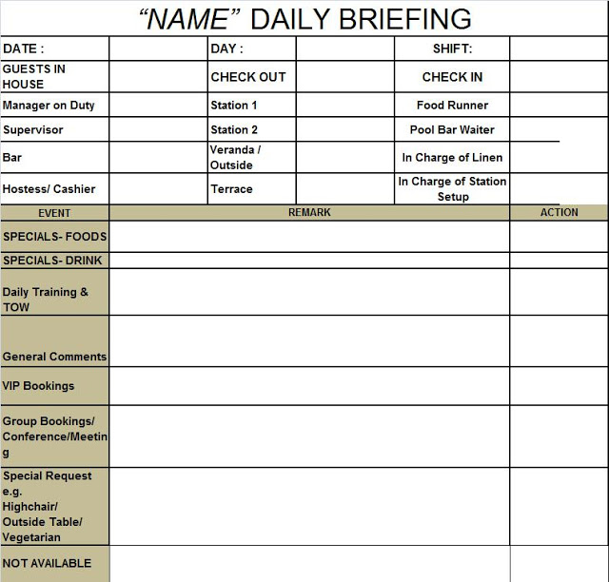
Daily Briefing Sheet Sample

Learning Outcome - ______________________________________________________________________________________________________________________________________________________________________________________________________________________________________________________________________________________________________________________________________________________________

Evaluation/Marks - ___________

Student Signature Faculty Signature
Date:

Practical No. 2 Date: ___________
Title - Taking order for Beverages (2 Practical)
Aim/Objective - To understand the procedure to take order for beverages.
Materials Required - Serviette, BOT Pad, Pen, Wine opener and a note pad.
Procedure for Beverage Orders:
For beverage orders an efficient system must operate here to ensure that:
- the correct wine and other drinks are served at the right table
- the service rendered is charged to the correct bill
- a record is kept of all wine and other drinks issued from the bar
- Management is able to assess sales over a financial period and make comparisons.
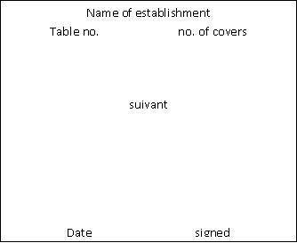
The various order taking processes are similar to those for foods. Sometimes a duplicate check pad is used. The colour of the wine check pad may be pink or white, but is generally pink or some other colour to distinguish it from a food check (see Figure 2.1).

2 sweet sheeries @1.20 2.40
1 Pale Ale @ 1.00 1.00
½ x 16 @ 6.50 6.50
1 x 40 @ 11.75 11.75

$21.65

Figure 2.1 Wine Check
Taking the beverage order:
When the beverage order is taken the service staff must remember to fill in the four items of information required, one in each corner of the check. These are as follows:
- table umber or room number
- number of covers
- date
- signature
Abbreviations are allowed when writing the order as long as they are understood by the bar staff and the cashier. When wines are ordered only the bin numbers, together with the number of bottles required, should be written down. The bin number is an aid to the bar staff and cellar staff in finding the wine quickly. Each wine in the wine list will have a bin number printed against it.
On taking the order staff should hand both copies to the bar staff who retain the top copy, put up the order and leave the duplicate copy with the order. This enables the staff to see which their order is when they come to collect their wines and drinks. After serving the wines and drinks the duplicate copy is handed to the cashier.
Learning Outcome - ______________________________________________________________________________________________________________________________________________________________________________________________________________________________________________________________________________________________________________________________________________________________

Evaluation/Marks - ___________

Student Signature Faculty Signature
Date :

Practical No. 3 Date: ___________
Title - Identification of glasses, equipment required for service
Aim/Objective - To study and identify the different types of glassware and service equipment.
Materials Required - Various types of glassware and service equipment.
Procedure:
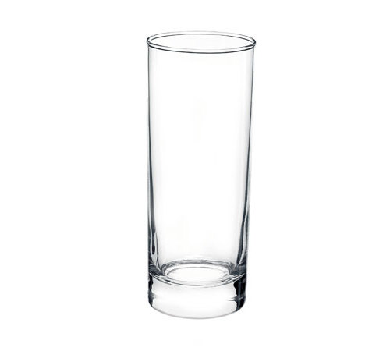
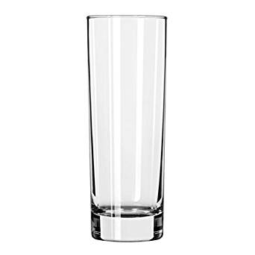
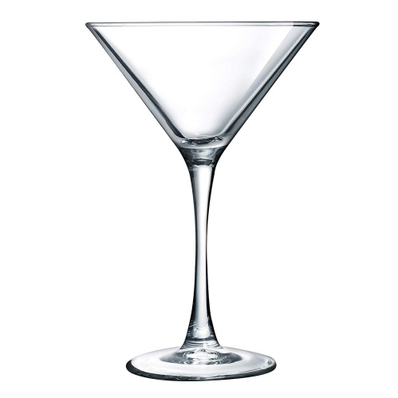

Tom Collins
8oz. – 16oz
( 230 ml - 473 ml)
Cocktail Glass
4oz. – 8oz.
(118ml - 236ml)
Highball
8oz. – 16oz
( 230 ml - 473 ml)

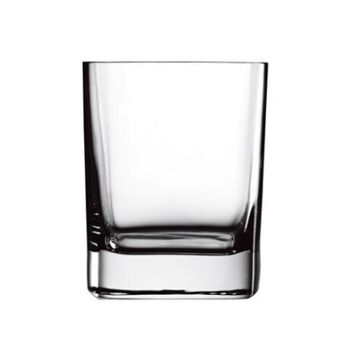
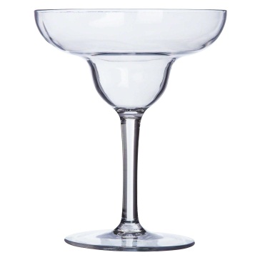
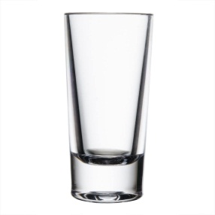

Margarita
6oz. – 10oz.
(177ml - 295ml)
Shot Glass
1oz. – 2oz.
(29ml - 59ml)
Old Fashioned/Rock Glass
6oz. - 10oz.
(177ml - 295ml)

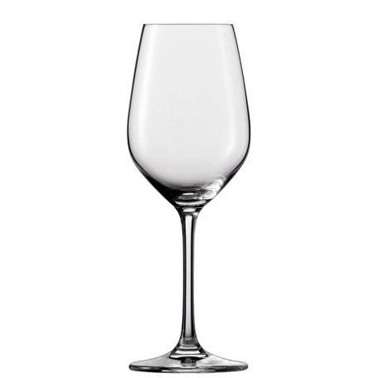
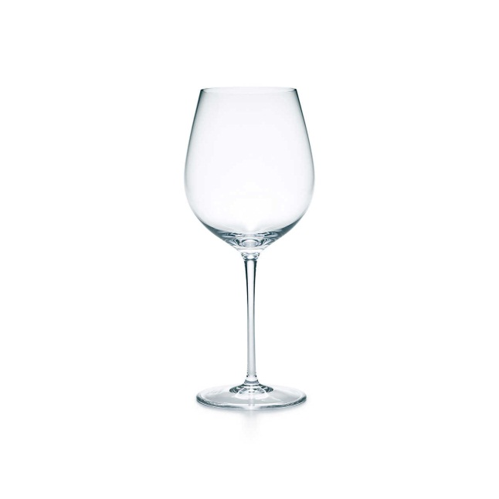

White Wine Glass
8oz. – 14oz.
(236ml - 414ml)
Red Wine Glass
8oz. – 14oz.
(236ml - 414ml)
Champagne Tulip
6oz. – 8oz.
(177ml - 230ml)

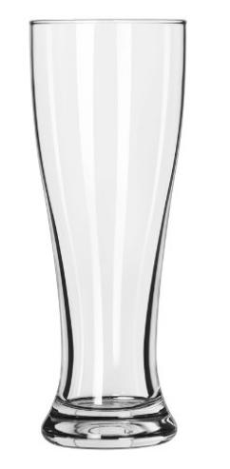
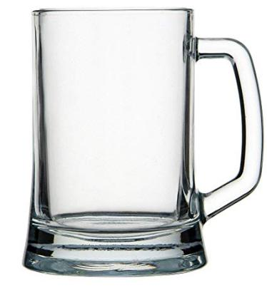
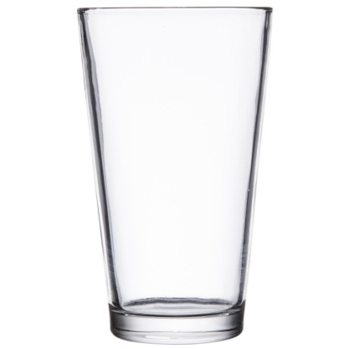

Beer Mug
12oz. – 14oz.
(354ml - 414ml)
Pilsner
12oz. – 14oz.
(354ml - 414ml)
Pint Glass
1 Pint
(473ml)
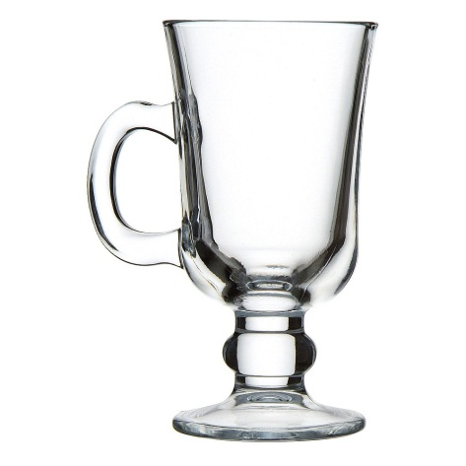
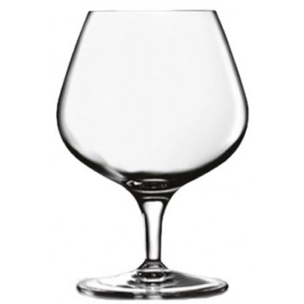
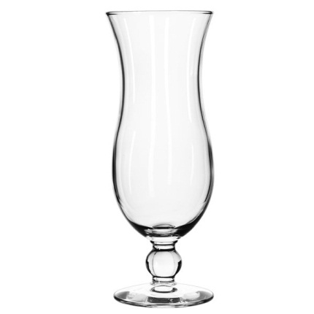

Brandy Snifter
8oz. – 14oz.
(236ml - 414ml)
Hurricane
10oz. – 16oz.
(295ml - 473ml)
Irish Coffee Glass
9oz - 10oz
( 280 ml)

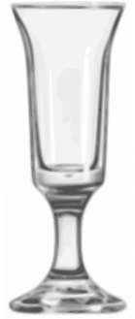
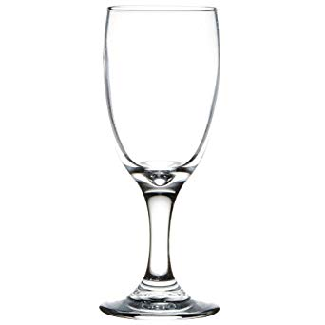

Genever Tulip Glass
1oz. – 3oz.
(29ml - 88ml)

Cordial Glass
1oz. – 3oz.
(29ml - 88ml)
Sour Glass
4 fl oz
(120 mL)

Learning Outcome - ______________________________________________________________________________________________________________________________________________________________________________________________________________________________________________________________________________________________________________________________________________________________

Evaluation/Marks: ____________

Student Signature Faculty Signature
Date:

Assignment 1 - Write the uses of the above mentioned glasses and stuck the pictures of various service equipment used in the F&B Service department.

Practical No. 4 Date: ___________
Title – Reading a Wine Label - French
Aim/Objective - To learn how to read a wine label.
Materials Required - Wine bottles namely red wine, white wine and sparkling wine.
Procedure:
The EU has strict regulations that govern what is printed on a wine bottle label. These regulations also apply to wine entering the EU. In addition, standard sized bottles of light (or still) wines bottled after 1988, when EU regulations on content came into force, must contain 75 cl, although bottles from previous years, containing 70 cl for example, will still be on sale for some years to come.
The label on a bottle of wine can give a lot of information about that wine. The language used will normally be that of the country of origin. The information always includes:
- the name of the wine
- the country where the wine was made
- alcoholic strength in percentage by volume (% vol)
- contents in litres, cl or ml
- the name and address or trademark of the supplier.
It may also include:
- the varietal(s) (name of the grape (s) used to make the wine)
- the year the grapes were harvested, called the vintage, if the wine is sold as a vintage wine
- the region where the wine was made
- the property where the wine was made
- the quality category of the wine
- details of the bottler and distributor
Examples of the kind of information that is given on various wine labels are shown in the figure below -
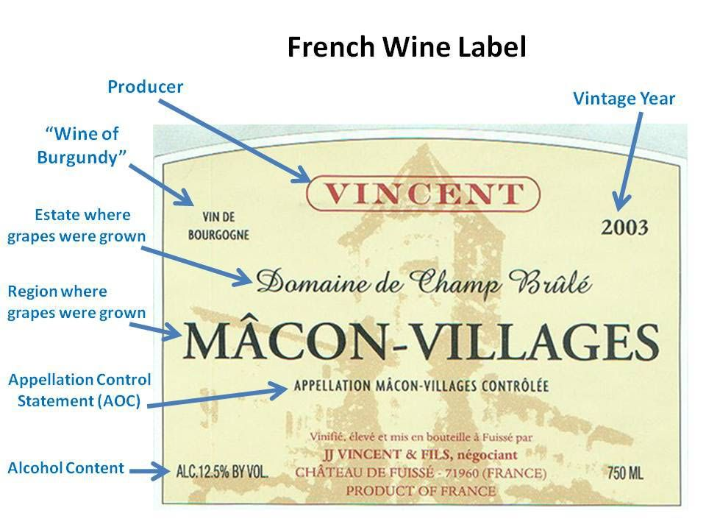

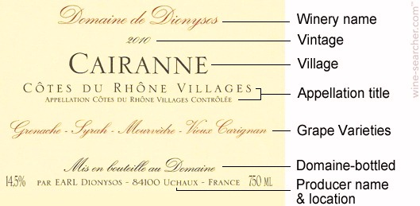

Learning Outcome - ______________________________________________________________________________________________________________________________________________________________________________________________________________________________________________________________________________________________________________________________________________________________

Evaluation/Marks: ____________

Student Signature Faculty Signature
Date:
Assignment 2 - Stick a wine label and identify the information mentioned on the wine label.

Practical No. 5 Date: ___________
Title – Food and Wine Harmony
Aim/Objective - To study how to match food with wine
Procedure:
Matching food with wine and other drinks.
Food and its accompanying wine / drink should harmonize well together, with each other’s performance. However, the combinations that prove most successful are those that please the individual.
When considering possible food and wine partnerships all guidelines have exceptions. For example, although fish is usually served with white wine, some dishes, for example, heavily sauced salmon, red mullet or a fish such as lamprey (which is traditionally cooked in red wine) can be successfully accompanied by a slightly chilled red Saint – Emilion, Pomerol or Mercury, The key issue in not having red wine with fish comes from the reaction of oily fish, such as mackerel, with red wine to produce a metal taste in the mouth. The general guidelines on matching wine and food are summarized in Table 5.1.

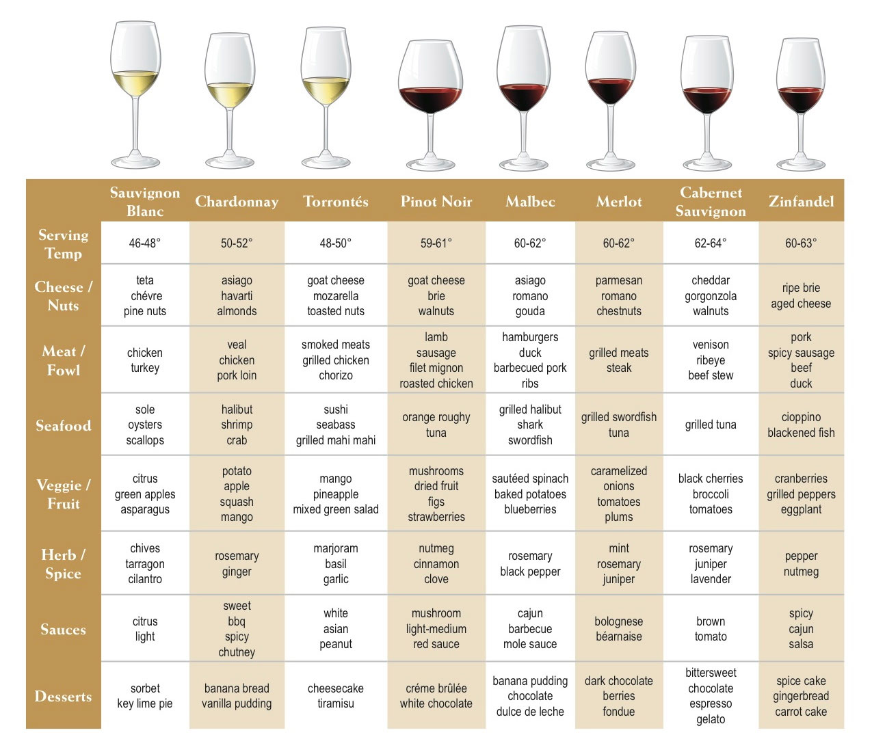

Some general guidelines when selecting and serving wines are given below:
- Dry wines should be served before sweeter wines
- White wines should be served before red wines
- Lighter wines should be served before heavier wines
- Good wines should be served before great wines
- Wines should be at their correct temperature before serving
- Wine should always be served to customers before their food.
When making recommendations, it is useful to be able to identify the type and style of the wine required and the extent to which the wine should be light or full. The below chart sets out a range of wine and food pairing guide.
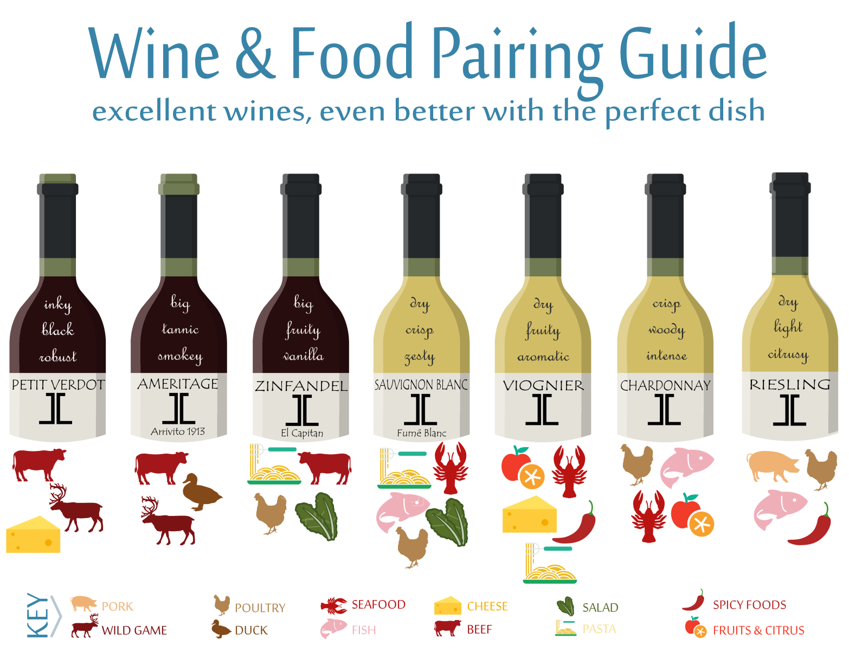

Beers and food:
Recently there has been an increasing trend to offer beers with food, either alongside or as an alternative to wines. As with wines, it is a question of trial and error to achieve harmony between particular beers and food. Generally, the considerations for the pairing of beers and foods are similar to those for matching wines with foods, and in particular, taking account of acidity, sweetness / dryness, bitterness, tannin, weight and the complexity of the taste.

Making recommendations to customers:
A few general pointers are set out below that may be followed when advising the customer on which beverage to choose to accompany a meal. However, it must be stressed that customers should at all times be given freedom in their selection of wines and other drinks.
- Aperitifs are alcoholic beverages that are drunk before the meal. If wine will be consumed with the meal, then the aperitif selected should be a grape (wine-based) rather than a grain (spirit-based) aperitif, since the latter can potentially spoil or dull the palate.

- The aperitif is usually a wine –based beverage. It is meant to stimulate the appetite and therefore should not be sweet. Dry and medium dry sherries, dry vermouths and Sercial or Verdelho Madeira are all good examples of aperitifs.

- Starter courses are often best accompanied by a dry white or dry rose wine.

- National dishes should normally be complemented by the national wines of that country, for example, Italian red wine with pasta dishes.

- Fish and shellfish dishes are often more suited to well -chilled dry white wines.

- Red meats such as beef and lamb blend and harmonize well with red wine.

- White meats such as veal and pork are acceptable with medium white wines.

- Game dishes require the heavier and more robust red wines to complement their full flavour.

- Sweets and desserts are served at the end of the meal and here it is acceptable to offer well-chilled sweet white wines that may come from the Loire, Sauternes, Barsac or Hungary. These wines harmonize best with dishes containing fruits.

- The majority of cheeses blend well with port and other dry robust red wines. Port is the traditional wine harmonizing best with Stilton cheese.

- The grain-and fruit-based spirits and liqueurs all harmonise well with coffee.

Learning Outcome - ______________________________________________________________________________________________________________________________________________________________________________________________________________________________________________________________________________________________________________________________________________________________

Evaluation/Marks: ____________

Student Signature Faculty Signature
Date:
Practical No. 6 Date: ___________
Title – Service of Still wines, Sparkling wine, Fortified wines
Aim/Objective - To study how to serve still wines, Sparkling wine and fortified wines.
Material Required: White wine bottle, wine opener, serviette, ice bucket and white wine glasses.
Procedure: Service of White Wine
- Obtain the wine from the bar or storage area. Check that the order is correct and that the wine is clear and at the correct service temperature.
- Take to the table in an ice bucket and place the ice bucket in a stand.
- Present the bottle to the host with the label showing – this allows him or her to check that the correct wine is to be served.
- Ensure the correct glasses are placed on the table for the wine to be served.
- Make sure a clean napkin is tied to the handle of the ice bucket – this is used to wipe away condensation and water from outside of the bottle before pouring the wine.
- Using a wine knife, cut the foil all the way round, below or above the bottle rim at the top of the bottle (some bottles have small caps rather than foils.) The top of the foil only then is removed and the top of the cork is wiped with the napkin.
- Remove the cork using a wine knife. Smell the cork in case the wine is ‘corked’.
- Place the cork in the ice bucket. If the wine is a high quality vintage wine the cork would be generally be placed on a side plate at the head of the host’s cover. This cork should have the name and year of the wine printed on it.
- Wipe the inside of the neck of the bottle with the napkin.
- Wipe the bottle dry.
- Hold the bottle for pouring so that the label may be seen. Use the waiter’s cloth in the other hand, folded to catch any drips from the neck of the bottle.
- Give a taste of the wine to the host, pouring from the right hand side. He or she should acknowledge that the wine is suitable i.e that it has the correct taste, bouquet and temperature.
- Serve ladies first, then gentlemen and the host last, always commencing from the host’s right. However, nowadays service often follows from one customer to the next, anti – clockwise.
- Fill each glass two-thirds full or to the widest part of the bowl – whichever is the lower. This leaves room for an appreciation of the bouquet.
- Replace the remaining wine in the wine bucket and refill the glasses when necessary.
- If a fresh bottle is required, then fresh glasses should be placed upon the table, and the host asked to taste the new wine before it is served.
- On finishing pouring a glass of wine, twist the neck of the bottle and raise it at the same time to prevent drops from falling on the table cloth.

Service of Red wine:
Materials requires: Red wine bottle, red wine glass, decanter, candle, strainer if required, serviette and wine opener.
The basic procedure for the opening and serving of red wines is the same as for white wines described above. If the red wine to be opened is young, the bottle may stand on an under plate or coaster on the table and be opened from this position. This adds to the overall presentation of the bottle and may prevent drips of red wine from staining the table cloth. Although there is no technical reason why red wine should be served with the bottle in a wine basket or wine cradle, these are used in a number of establishments for display / presentation purposes. They also assist in retaining the sediment, found in some older red wines, in the base of the bottle.
The cork should be removed from the bottle of red wine as early as possible so that the wine may attain room temperature naturally. If the wine is of age and / or is likely to have sediment, then it should be decanted. It should be placed in a wine basket and first presented to the customer. Placing the bottle in a wine basket helps to keep the bottle as horizontal as possible, comparable to its storage position in the cellar, in order to prevent the sediment from being shaken up. The wine should then be decanted. Alternatively, if the wine is ordered in advance it can be left standing for a few days before being opened for service.
There is a trend nowadays to decant younger red wines and also some white wines simply because exposure to air improves the bouquet and softens and mellows the wine. Decanting also enhances the appearance of the wine, especially when presented in a fine wine decanter. However, the permission of the host should always be sought before decanting a wine in the restaurant.
Decanting is the movement of wine from its original container to a fresh glass receptacle, leaving the sediment behind.
- Extract the cork carefully. The cork may disintegrate because of long contact with alcohol, so be careful.
- Place a single point light behind the shoulder of the bottle, a candle if you are decanting in front of the customers, but a torch, light bulb or any light source will do.
- Carefully pour the wine into an absolutely clean decanter. The light will reveal the first sign of sediment entering the neck of the bottle.
- As soon as sediment is seen, stop pouring into the decanter but continue pouring into a glass. The latter wine, when it settles, can be used as a taster or for sauces in the kitchen.
- The wine should always be checked to make sure that it is clear before being presented at the table for service.
- If the wine is not clear after decanting then it should be decanted again into a fresh decanter, but this time using funnel which has a piece of fine muslin in the mouth of the funnel. If the wine is still not clear it should not be served and a new bottle of the wine selected. It is more common now for a wine funnel to be used as part of the decanting process generally.
Very old red wine can break up with too much of exposure to air. Such wines can be left to stand for a few days to allow the sediment to settle in the bottom of the bottle. The bottle is then opened before the meal is served and the wine is poured very carefully straight into the glass, with the bottle held in the pouring position as each glass is approached. This prevents the wine slopping back to disturb the sediment. Sufficient glasses should be available to finish the bottle, thereby ensuring that the wine does not re-mingle with its sediment during the pouring process.

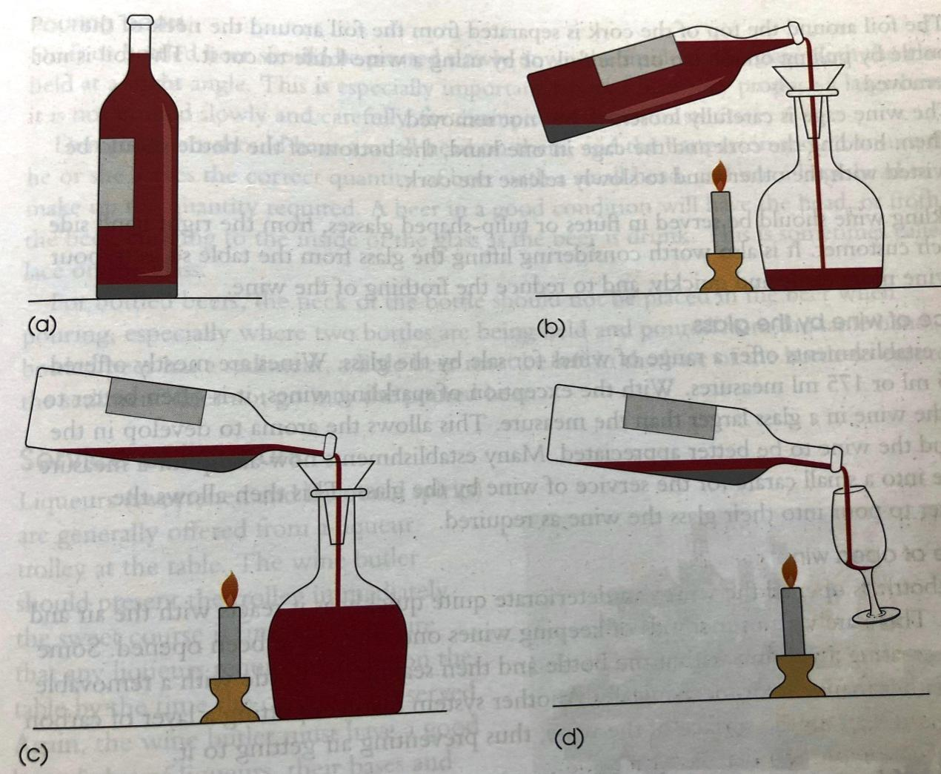

Service of Sparkling wine:
Materials Required: Sparkling wine bottle, champagne tulip or flute, serviette and ice bucket
The same method is used for opening all sparkling wines. The wine should be served well chilled in order to obtain the full effect of the secondary fermentation in the bottle, namely, effervescence and bouquet.
- After presenting the bottle to the host, for agreement of the wine chosen, the wine is ready for opening.

- The neck of the bottle should be kept pointed towards a safe area in the restaurant during the opening process. This is to avoid any accidents to customers should the cork be released suddenly.

- The thumb should be held over the cork with the remainder of the hand holding the neck of the bottle.

- The foil around the top of the cork is separated from the foil around the neck of the bottle by pulling on the tab on the foil. Alternatively, a wine knife may be used to cut the foil. The foil is not removed.

- The wine cage is untwisted and is carefully loosened but not removed.

- Then holding the cork and the cage in one hand, with the thumb still over the top of the cork, the bottom of the bottle should be twisted with the other hand to slowly release the cork.

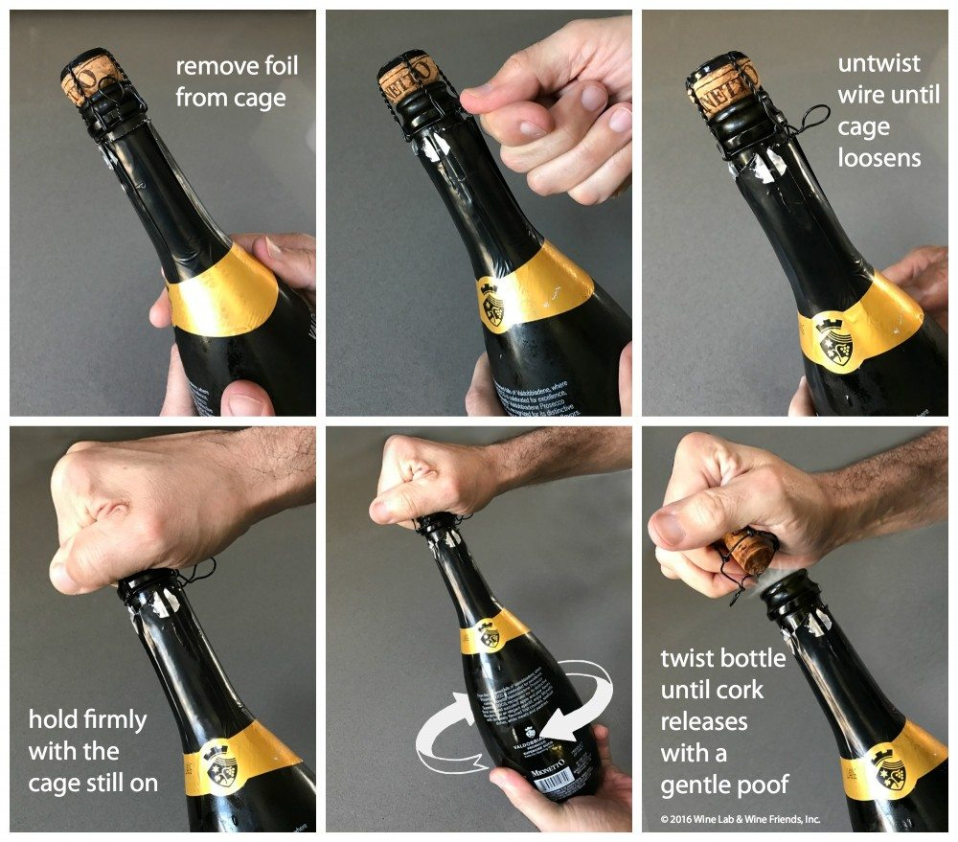

Learning Outcome - ______________________________________________________________________________________________________________________________________________________________________________________________________________________________________________________________________________________________________________________________________________________________

Evaluation/Marks: ____________

Student Signature Faculty Signature
Date:
Practical No. 7 Date: ___________
Title – Menu Planning with Wines
Aim/Objective - To study how to plan various menus with different type of wines.
Material Required: List of wines and French classical menu
Procedure:
Wine needs the dimension of food to bring out its true flavour. The partnership of wines and food depends principally on 4 types -
- The style of wine
- The style of food
- The personal preference of the diner
- The financial constraints
Complications set in when -
- Other people’s tastes have to be considered.
- The choice has to be appreciated to suit a particular occasion
A further complication arises from the knowledge that some foods are the enemies of wines. However, most wine and foods have a beneficial effect on each other. The general principles still broadly valid are that -
- White wine should be served with white meat
- Red wine should be served with red meat, game and cheese
- Sweet white wine should be served with sweets, puddings and desserts.
There are exceptions. Red wine because of its tanin content makes most fish taste metallic, yet it accompanies string flavoured fishes such as salmon, red mullet. There should be compatibility and balance of flavours. Here are some guidelines -
- Most food can be successfully accompanied by several style of wines.
- White and rose are more versatile than red wine.
- Regional pairings are very successful.
- The simpler food, the more wine shines.
- The finer food, the more it is likely to show up inferior wine.
- Look at the complete dish and not just at the main food component. Often the sauce will decide the wine.
- The weight and body of the wine should match the character and flavour intensity of the food.
- Serve light wine with delicate food.
- Medium wine with medium flavoured food.
- Serve full bodied wine with full flavoured wine.
- High acid food with high acid wine.
- Match dry to dry and rich to rich.
- Spiced food with aromatic wines.

Reference guide to match wine with food.
Sr. No. | Food | Wine Style | Examples
1. | Hors-d’oeuvre | Clean, Sharp, white and fortified | Muscadet  Fine Manzanila
 | Asparagus | Soft flavoured white wines | Cotes de Gascogne  Chardonnay
 | Avacado | Dry to medium, white or rosé | Australian Chardonnay  Tavel Rosé
 | Caviar | Sparkling | Champagne  Cuveé Napa
 | Melon | Sweet Fortified | Port  Madeira  Oloroso Sherry
 | Oyster | Sparkling/Dry White | Champagne  Muscadet
 | Prawn Cocktail | Medium White | Chardonnay  Riesling
 | Smoked Salmon | Oaky White | New world Chardonnay  Rioja Bianco
 | Snails | Spicy wines | Cotes de Provence
2. | Soups | Generally no wines are served. Certain exceptions are as follows -
 | Bisque | Full bodied dry white | Rioja Bianco  Pinot Gris
 | Consommé | Medium dry, fortified | Verdelho  Polo Cartado
3. | Egg dishes | Difficult perhaps sparkling | Cava  Cremant de Alsace
4. | Pasta
 | With cream sauce | Mild white | Frascati  Orvieto
 | With tomato sauce | Light red | Santa Maddelena  Beajoulais
5. | Fish
 | Haddock | Mild acidic white | New World Chardonnay  Soave Meursault
 | Scampi | Mild whites | Frascati  Moselle
 | Trout | Dry white | Chablis  Seyssel
 | Turbol | Dry to medium fine white | German Riesling  Chateau Grillet
6. | Meat
 | Beef (Boiled ) | Young light red | Pinot age  Zinfandel
 | Beef (Roast) | Fine red | Margoux  Brunello
 | Lamb (Roast) | Soft red | St. Emillion  Pomerol
 | Pork (Roast) | Alcoholic red | Hermitage  Chateau neuf du pape
 | Ham | Light red | Beajoulais  Mercury
 | Veal (Roast) | Medium bodied red or rosé | Fitou  Cabiereo Rosé d’anjou
7. | Poultry
 | Chicken (Roast) | White/Red/Rosé | Graves  Cote de Beaune
 | Duck (Roast) | Strong red | Rioja  Barberra
 | Goose (Roast) | Full Flavoured red | Barola  Gigondas
8. | Cheese
 | Soft Creamy | Light to full red | Beajoulais
 | English | Light red, fortified | Claret  Port
 | Semi hard | Full bodied red | Burgundy  St. Emillion
 | Hard | Dry white/rosé | Alsace Riesling
 | Blue veined | Full red, port/sweet wine | Sauternes/ Port  Chateau neuf du pape
9. | Sweet
 | Xmas Pudding | Sparkling | Asti Spumante
 | Fruit Salad | Golden White | Barsac
 | Zabaglione | Fortified | Marsala
 | Truffle | Fortified | Sherry/Madeira
 | Savouries | Sweet fortified | Sherry  Port
 | Desserts/Fresh Fruits | Sparkling or Sweet white | Asti Spumante  Sauternes
 | Dry fruits/Nuts | Sweet fortified | Port  Madeira

Learning Outcome - ______________________________________________________________________________________________________________________________________________________________________________________________________________________________________________________________________________________________________________________________________________________________

Evaluation/Marks: ___________

Student Signature Faculty Signature
Date:

Assignment 3 - Plan a 5 course and 7 course menu along with wines

.

Practical No. 8 Date: ___________
Title – Service of Spirits (Whisky, Brandy, Rum, Gin, Vodka, Tequila)
Aim/Objective - To study the service of spirits
Procedure for Service of Spirits:
Sr. No. | Spirit | Service | Modifier | Glassware
1. | Whisky | Neat, on the rocks, with water, soda, cola , juice |  | Old fashion glass, hi-ball glass, collin glass
2. | Brandy | Neat, with water, soda, cola, juice | Warm water, honey | Brandy ballon, hi-ball, collin glass
3. | Rum | With water, soda, soft drink, juice | Lemonade, cola, pineapple juice | Hi-ball, collin glass
4. | Vodka | Shots with water, soda, soft drinks, juice | With lime and salt, orange juice, cranberry juice | Shot glass, hi-ball, collin glass
5. | Gin | With water, soda, soft drink, tonic water, juice | Orange juice, Angustra bitters, water | HI-ball glass with slice of lime, collin glass
6. | Tequila | Shots, juice | Orange juice | Shot glass, lime slice, salt, hi-ball

Learning Outcome - ______________________________________________________________________________________________________________________________________________________________________________________________________________________________________________________________________________________________________________________________________________________________

Evaluation/Marks: __________

Student Signature Faculty Signature
Date:

Practical No. 9 Date: ___________
Title – Preparation of classic and innovative cocktails, glassware and Garnish
Aim/Objective – To study and learn the different preparations of cocktails
Material Required: Bar equipment, spirits, liqueurs, ice and garnishees.
Procedure: Service of Cocktails
Cocktails should always be served well chilled in an appropriately sized glass with the correct garnish, straw and umbrella, according to the policy of the establishment. Many cocktails are served in the traditional V shaped cocktail glass but, if the cocktail is a long drink, then a larger glass such as Slim Jim will be better suited. The key consideration here should be the total presentation of the cocktail as seen visually by the customer.
Points to note in making cocktails
      - Ice should be always clear and clean.
      - Do not overfill the cocktail shaker.
      - Effervescent drinks should never be shaken.
      - To avoid spillage, do not fill glasses to the brim.
      - When egg white or yolk is an ingredient, first break the egg into separate containers.
      - Serve cocktails in chilled glasses.
      - To shake use short and snappy actions.
      - Always place ice in the shaker or mixing glass first, followed by non-alcoholic and then alcoholic beverages.
      - To stir, stir briskly until blend is cold.
      - As a general rule the mixing glass is used for those cocktails based on liqueurs or wines.
      - Shakers are used for cocktails which might include fruit juices, cream, sugar and similar ingredients.
      - When egg white or yolk is an ingredient then the Boston shaker should always be used.
      - Always add the garnish after the cocktail has been made and add it to the glass.
      - Always measure out ingredients; inaccurate amounts spoil the balance of the blend and taste.
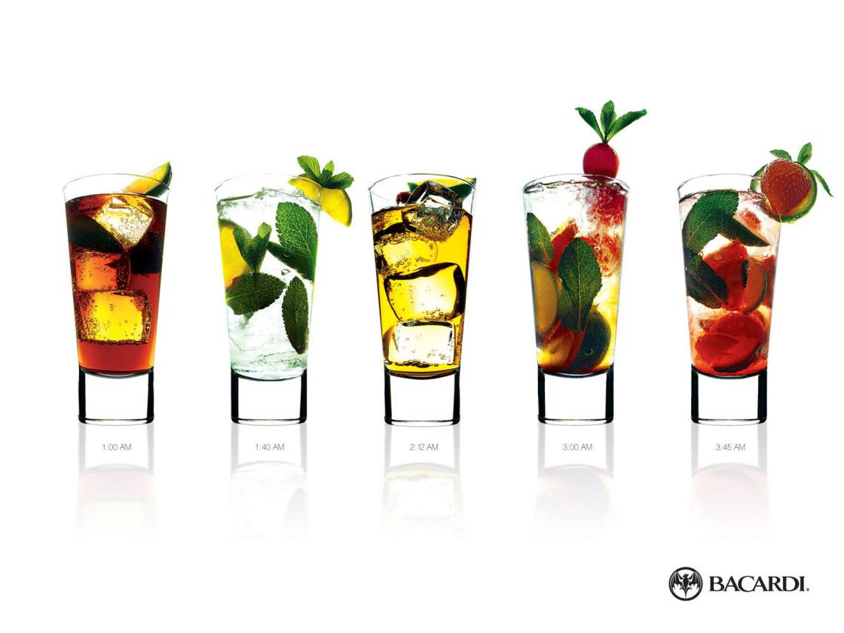
      - Never use the same ice twice.

Learning Outcome - ________________________________________________________________________________________________________________________________________________________________________________________________________________________________________________________________________________________________________________________
Evaluation/Marks: ___________

Student Signature Faculty Signature
Date :
Assignment 4 - Write a report on the visit to Iron Bar and write down the type of cocktail and mocktail demonstrated along with its recipe.

Practical No. 10 Date: ___________
Title – Service of Liqueurs
Aim/Objective - To learn how to do the service of liqueurs
Material Required: Liqueur tolley, elgin shaped glass, salver and serviette.
Procedure:
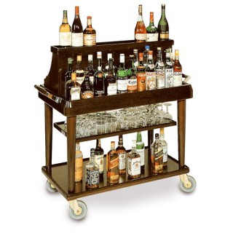
Liqueurs are sweetened and flavoured spirits generally offered from a liqueur trolley at the table. The wine butler should present the trolley immediately the sweet course is finished to ensure that any liqueurs required will be on the table by the time the coffee/tea is served. Again the wine butler must have a good knowledge of the liqueurs, their bases and flavours, and their correct mode of service. Traditionally all liqueurs were served in an Elgin-shaped liqueur glass but many alternatives are now used.
Basic equipment required on the liqueur trolley –
            - Assorted liqueurs
            - Assorted glasses – liqueur/brandy/port
            - Draining stand
            - 25 and 50 ml measures
            - Service salver
            - Jug of double cream
            - Teaspoons
            - Drinking straws (short stemmed)
            - Cigars
            - Matches
            - Cigar cutter
            - Wine list and check pad.
Other items served from the liqueur trolley include brandies and fortified wines such as Port or Madeira.
Learning Outcome - ______________________________________________________________________________________________________________________________________________________________________________________________________________________________________________________________________________________________________________________________________________________________

Evaluation/Marks: __________

Student Signature Faculty Signature
Date:

Assignment 5 - List down the different types of liqueurs along with its colour, flavour and country of origin.

Practical No. 11 Date: ___________
Title – Service of Cigars and Cigarettes
Aim/Objective - To study the service of cigars and cigarettes.
Material Required: A pack of cigars or cigarettes, cigar cutter, lighter and quarter plate
Procedure for Service of cigars:
      - Cigar boxes should be opened carefully with a blunt instrument.
      - To extract a cigar, press the rounded head and the cigar will tilt upwards for easy extraction.
      - Customers should not be allowed to handle cigars before selection. In particular, they should not be allowed to roll a cigar near their ear (sometimes called listening to the band). This tells nothing at all about the cigar and simply damages it.
      - The appearance of a cigar should be smooth, firm and even to the touch. It should always be the same size and colour as its partners in the box. The wrapper (outer leaf) should have a healthy glow to it and the open or cut end should be smooth and even.
      - The band or identification tag should only be removed if the customer requests it. If it is to be removed it should be done carefully as moving it up and down can damage the cigar. Even if peeled off gently, it can still rip the tobacco leaves.
      - When cigars are not pre-cut a V-shaped cigar cutter if required to cut the end, thereby facilitating maximum free draught and ease of smoking. Do not make a small hole with a match or cocktail stick, as this will leave a moist tar concentrate, which imparts a very bitter flavour as the end of the smoke is approached.

Learning Outcome - ______________________________________________________________________________________________________________________________________________________________________________________________________________________________________________________________________________________________________________________________________________________________

Evaluation/Marks: ___________

Student Signature Faculty Signature
Date:

