MAHARASHTRA COSMOPOLITAN EDUCATION SOCIETY
Azam Campus, Pune – 411 001

E-Content Description
Name of School / College: M A Rangoonwala Institute of Hotel Management and Research
Name and Designation of content creator /Producer | Assoc. Prof Imran Sayyed
Title of E content | Absorption refrigerator
Theory/practical | Theory
Title and No of Module | Absorption refrigerator
Title and code of Paper | The Science of Hotel Engineering  Subject Code : HS 206
Broad Subject | Hotel Engineering
Course | BScHS
Class | SY
Semester | Third Semester
University /Board | SPPU
Date of Content Creation | 2 Jan 2020
Name of Reviewer  HOD/Principal | Imran Sayyed

Absorption refrigerator
An absorption refrigerator is a refrigerator that uses a heat source (e.g., solar energy, a fossil-fueled flame, waste heat from factories, or district heating systems) to provide the energy needed to drive the cooling process.
Absorption refrigerators are often used for food storage in recreational vehicles. The principle can also be used to air-condition buildings using the waste heat from a gas turbine or water heater. Using waste heat from a gas turbine makes the turbine very efficient because it first produces electricity, then hot water, and finally, air-conditioning

Absorption cooling process
Both absorption and compressor refrigerators use a refrigerant with a very low boiling point (less than −18 °C (0 °F)). In both types, when this refrigerant evaporates (boils), it takes some heat away with it, providing the cooling effect. The main difference between the two systems is the way the refrigerant is changed from a gas back into a liquid so that the cycle can repeat. An absorption refrigerator changes the gas back into a liquid using a method that needs only heat, and has no moving parts other than the refrigerant itself.
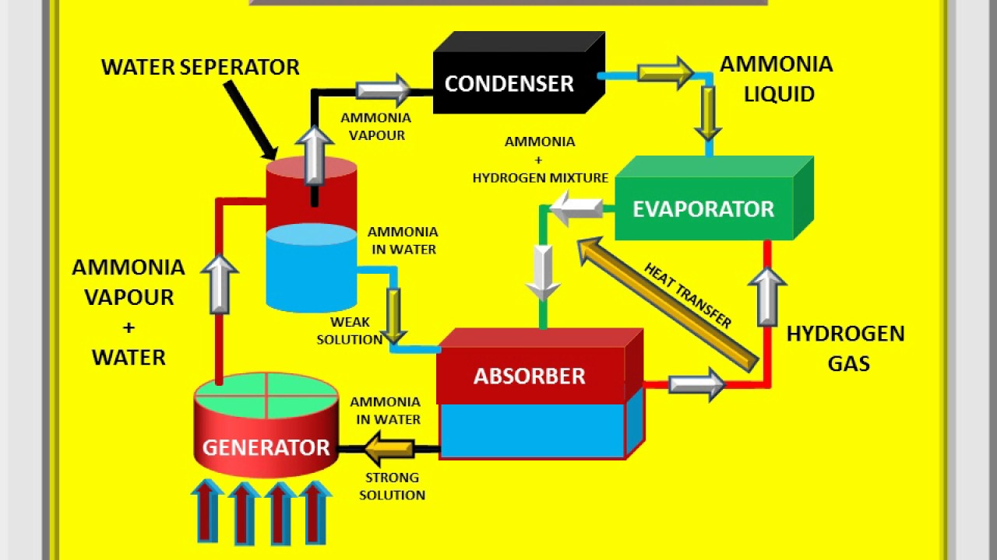
The absorption cooling cycle can be described in three phases:
Evaporation: A liquid refrigerant evaporates in a low partial pressure environment, thus extracting heat from its surroundings (e.g. the refrigerator's compartment). Because of the low partial pressure, the temperature needed for evaporation is also low.
Absorption: The now gaseous refrigerant is absorbed by another liquid (e.g. a salt solution).
Regeneration: The refrigerant-saturated liquid is heated, causing the refrigerant to evaporate out. The hot gaseous refrigerant passes through a heat exchanger, transferring its heat outside the system (such as to surrounding ambient-temperature air), and condenses. The condensed (liquid) refrigerant supplies the evaporation phase.
In comparison, a compressor refrigerator uses a compressor, usually powered by either an electric or internal combustion motor, to increase the pressure on the gaseous refrigerant. The resulting hot, high-pressure gas is condensed to a liquid form by cooling in a heat exchanger ("condenser") that is exposed to the external environment (usually air in the room). The condensed refrigerant, now at a temperature near to that of the external environment, then passes through an orifice or a throttle valve into the evaporator section. The orifice or throttle valve creates a pressure drop between the high pressure condenser section and the low pressure evaporator section. The lower pressure in the evaporator section allows the liquid refrigerant to evaporate, which absorbs heat from the refrigerator food compartment. The now-vaporized refrigerant then goes back into the compressor to repeat the cycle.
Another difference between the two types is the refrigerant used. Compressor refrigerators typically use an HCFC or HFC, while absorption refrigerators typically use ammonia or water.
Refferences:
ihmhotelengineeringnotes.blogspot.com
ihmhotelengineeringnotes.blogspot.com
https://lecturenotes.in/m/21160-note-of-hotel-engineering-by-victor-agughasi
ihmkolkata.blogspot.com/2013/04/ihm-kolkata.html
Hotel Engineering - IHM PUSA
ihmpusa.net › wp-content › uploads › 2016/12 › Hotel-Engineering-0
https://www.newtondesk.com/refrigeration-and-air-conditioning-study-notes-hand-written/
en.wikipedia.org/wiki/
encyclopedia2.thefreedictionary.com
www.kopykitab.com/Engineering
www.faadooengineers.com/forums/112-Engineering-Ebooks.
Hotel Engineering Robert F eilliot
Hotel Engineering Tarun Bansal

