MAHARASHTRA COSMOPOLITAN EDUCATION SOCIETY
Azam Campus, Pune – 411 001

E-content Description
Name of School/College: M. A. Rangoonwala Institute of Hotel Management & Research
Name and Designation of Content Creator / Producer | Kunal Sodhi – Assistant Professor
Title of the e-content | Control Methods
Type of Content  (i.e.Text, Audio-Visual) | Text
Theory/Practical | Theory
Title and No. of Module / Unit | 04
Title and Code of Paper | Food and Beverage Service II HS 206
Broad Subject | Food and Beverage Service
Course | B. Sc. (HS)
Class | I Year
Semester | II Semester
University/Board | Savitribai Phule Pune University
Date of Content Creation | 18/09/2019
Name of Reviewer  (HoD/Principal) | Prof. Dr. Anita Frantz

UNIT
5
Food and Beverage Controls
Structure
  - Introduction
  - Objective of food and beverage control
  - Methods of order taking
  - F&B revenue control methods
  - Special checks
  - Billing
  - Modes of Payment
Learning Objectives
At the end of the unit, the student will be able to
- Explain the importance of the F&B control systems
- List the salient features of the Triplicate check system
. Understand and explain the procedure of the triplicate check system.
5.0 Introduction
Food & Beverage controls are the systems that have to be followed for
tracking the orders and also to check if the operations are in the right direction.

Controls are an important tool for the management to understand the pulse of the market, take managerial decisions about budgets, finance, menu analysis of items that are listed – to check the popularity of one dish against the other, understanding the fast moving & slow moving items, costing of dishes and the profitability of operations. Control systems are also put in place to check on instances of pilferage or stealing etc… Every restaurant with a standardized work pattern follows control systems for keeping a check on operations. These checks are created from placing of an order onwards. Checks are filled in to document every single transaction. These checks are then collected at the end of the day to consolidate the revenue earnings and movement of food from the kitchen.

Chapter Preview
This unit deals with the basic checks that are used for control measures, for the steward to follow. Every order is taken by the steward and filled in a K.O.T, which is then taken to the kitchen for placing of the order and execution of the order placed. Only the dishes listed on the KOT are produced for consumption in the quantities specified. The most prevalent system in use for controls is the triplicate check system.
5.1 Objective of Food & Beverage Control
The main objective of the F&B control is the
- Analysis of income and expenditure
- Establishment and maintenance of standards.
- Pricing
- Prevention of waste
- Prevention of fraud
- Management information
    - Salient Points of Control Systems
The control system is an important stage of the operating cycle. It has to perform a lot of tasks all through the operating cycle. Being the last stage of the operating control cycle (i.e. service), it needs to take into consideration the following points:
      - A checking system- this is necessary to keep control of the no. of covers sold and of the items sold.

      - Control of cost- it is necessary that all the items sold have been paid for and to ensure that money is received or credit has been authorized.
      - Clerical procedure- these would be necessary to control items sold and money received or the credit entitled, would often include the restaurant checking system, meal and sales analysis etc.
      - A checking system in hotel and restaurant is an essential part of the organization.
      - Control which implies checking at every stage enables food and drink to be co-ordinate with the aim of presentation a correct bill to each guest without delay.
      - All the F&B items are only obtained by a waiter on presenting a check for items required.
      - A check is a written proof that a guest has been served with the items he has ordered
5.2 Methods of Order Taking
There are different methods of order taking. Every method has its advantages & disadvantages. The most effective method that has evolved over a period of time is the triplicate check system.

Method | Description
- Triplicate | Order is taken; top copy goes to the supply point (Kitchen); second copy sent to cashier for billing; third copy retained by server as a means of reference during service.
Duplicate | Order is taken; top copy goes to supply point (kitchen); second copy retained for service and  billing purpose.
Service with order | Order is taken; customer is served and payment received according to that order, for example, bar service or take away methods
Pre-ordered | - Individually, for example, room service breakfast  - Hospital tray system  - Functions

5.2.1 Triplicate Checking System

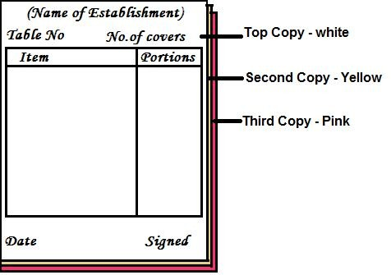

Each copy is color coded for control & ease of identification and use.
This control system is used in majority of the catering establishments. As the name implies the food check or KOT (kitchen order ticket) consists of three copies. To ensure a efficient control at the waiter must fill in the information required in four corners of the check, this being:
      - Table no, no.of covers, date and signature of waiters taking the orders.
      - On taking the food order the KOT/check is written from top to bottom.
      - Where only a table d’hôte menu is in operation, the guest would initially order their first and main courses. The set price charged for this menu would be entered on the food check and circled. A second new food check is written out for the sweet (desert) course, this being taken after the main course is finished. A third new check will be completed if any beverage such as coffee.
      - The operation for an a la carte menu is similar, although the guest may order course by course according to their requirement. It must always be remembered that all checks should be legible and that, when a ‘a la carte’ menu is in operation, the price of the dishes must be put on the check.

      - Abbreviations may be used when taking the order as long as their understood by everyone and not miss interpreted by the kitchen causing the wrong order to be put up and therefore a delay in the service to the guest.
      - The top copy of the food order goes to the kitchen and is handed to the aboyeur at the hotplate, the duplicate goes to the cashier who makes out the guest bill, the flimsy or the third copy is retained by the waiter at his or her sideboard as a means of reference. Any check or bill which has to be cancelled should have the headwaiters or supervisors signature on it.
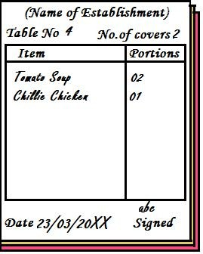
A sample filled in KOT
5.3 F&B Revenue Control Methods
There are severalcontrol systems used on the basis of size, type of operations etc... The main control methods in use in food service establishments are:
Order taking methods Billing methods
Sales summary sheets & Operational statistics

5.3.1 Revenue Control Process
The process of F&B revenue control is summarized in the chart. It is based on the triplicate method for food and duplicate method for dispense bar. The chart indicates that all top copies go to the dispense points (bar, kitchen) and follows the flow of information through until top & second copies are matched up by controls.
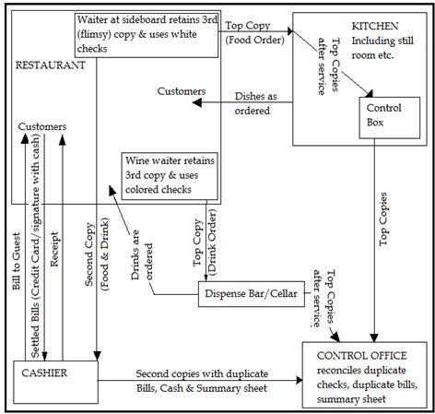
Procedure involved in the Triplicate Checking System
5.4 Special Checks
In certain instances it is necessary to write out special checks. This would
be as follows:

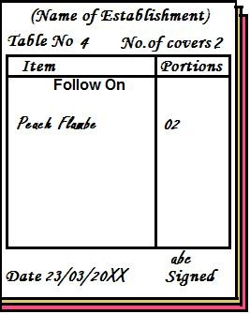

To Follow (Suivant)
This KOT is written out where it is necessary to write out more than one food. Check for a meal e.g. where a sweet check is written out after the first and main course have been served. At the head of this check should be written the word ‘to follow’ or ‘suivant’.
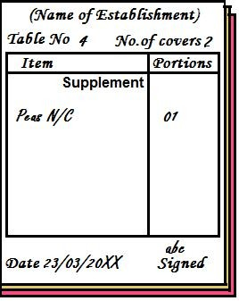

Supplement
When an extra portion of food is required because sufficient has not been sent fromthe kitchen, a special check must be written out headed “supplement”.
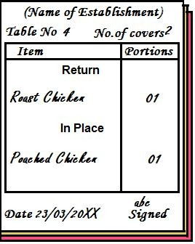

Return (retour)
Where a wrong dish has been ordered and has to be sent back to the kitchen and replaced, a special must again to be made out. Two main headings are used on this check, “return” and the name of the dish going back to the kitchen and ‘in place’ and the name of the new dish to be served.
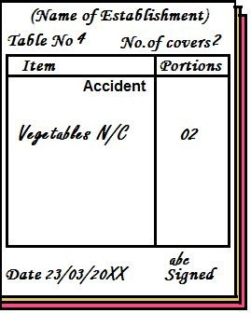

Accident
Sometimes it happens that the waiter may have an accident in during service and some or the complete dish may fall. These must be replaced without any extra charge to the guest. Here a check must be written headed “accident”.
5.5 Billing

Method | Description
Bill as check Separate bill  Bill with order Pre paid Voucher  No Charge Deferred | Second copy of order used as bill  Bill made up from duplicate check and presented to the guest  Service to order and billing at same time, for example, bar or take away service methods  Customer purchases ticket or card in advance, either for specific meal or specific value  Customer has credit issued by third party for either specific meal or specific value, for example, a luncheon voucher or tourist agency voucher  Customer not paying – credit transaction  Refers to, for example, function catering where the bill is to be paid by the organiser, or customers who have an account.

5.6 Modes of Payment
      - In cash
      - Credit cards/debit cards/charge cards
      - Cheque payment
      - Deferred payment (by special arrangements)
      - Travelers cheques
      - Vouchers & tokens

Every system has to be well regarded before implementation; a few operations may still use the duplicate check system effectively, whereas a few may need to use the triplicate check system. What need to be kept in mind is that the systems should yield the desired results, those being effective control of revenue earnings and problem free operations. The control systems being used for beverage controlare slightly different, though the purpose ofhaving the system is beverage control.
Key Terms
Conclusion
Duplicate check system Accident KOT
Return KOT Supplement KOT
Triplicate check system Mode of payment
Summary
This unit has discussed the importance and the objectives of the control
systems, and the main features required in an effective control system. There are various methods oforder taking out ofwhich the most widelyused and maintained system is the triplicate checking system. There has to be a proper channel for flow of information from the table of the guest to the kitchen for the preparation of dishes and finally for billing to the cashier. This information is later consolidated and used by the Controls department for managerial information systems. This information is used by the restaurant managers and owners for understanding the trends in food ordering, fast & slow moving dishes and if the pricing is proper or not. The control system is also meant to keep an eye on the revenue and check for any form of cheating by the employees at any point. It also takes into account the need to have supplemental KOTs for various reasons such as extra portion requirement by the guest or to return an order; where a guest has been wrongly served an item etc… The different methods of payment are touched upon in the chapter.
Questions
- F&B controlis a means ofprevention of fraud, give examples to support your answer.
- What are the salient features of control systems?
- Explain the methods of order taking
  - Service with order

  - Pre-ordered
- Why are the checks color coded? How are they used during service?
- Draw a KOT and list 4 items of ‘a la carte breakfast’.
- What are the different special checks used and why?
- Explain the methods of payment
  - Pre-paid
  - Voucher
  - Deferred
- List the different methods of payment.
- What are the main objectives of the control systems
- Explain
  - Prevention of frauds
  - Pricing
  - Maintenance of standards
- What are the main points of consideration for control systems?
- Explain the different methods of order taking.
- Explain the triplicate checking system.
- Draw a neat format of a KOT and explain the entries to be made on it.
- Draw and explain the flow of information in the triplicate checking system.
- What are the uses of special check?
- Draw and explain
  - Accident KOT
  - Return KOT
  - Supplement KOT

