MAHARASHTRA COSMOPOLITAN EDUCATION SOCIETY
Azam Campus, Pune – 411 001
E-Content Description
Name of School / College: M A Rangoonwala Institute of Hotel Management and Research
Name and Designation of content creator /Producer | Assoc. Prof Imran Sayyed
Title of E content | Biscuits and cookies
Theory/practical | Theory
Title and No of Module | Appetizer
Title and code of Paper | ADVANCEDFOOD PRODUCTION SYSTEMS  301
Broad Subject | Food Production
Course | BScHS
Class | TY
Semister | Fifth
University /Board | SPPU
Date of Content Creation | 21 March 2020
Name of Reviewer  HOD/Principal | Imran Sayyed

Cookie

Cookie
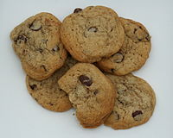
Chocolate chip cookies
In the United States and Canada, a cookie is a small, flat, baked treat, usually containing fat, flour, eggs and sugar. In most English-speaking countries outside North America, the most common word for this is biscuit; in many regions both terms are used, while in others the two words have different meanings. A cookie is a plain bun in Scotland,^{[2]} while in the United States a biscuit is a kind of quick bread similar to a scone. In the United Kingdom, a cookie is referred to as a biscuit, although some types of cookies maintain this name, such as the American-inspired Maryland Cookies, which are also sold there. In South Africa they are called biscuits, and the word cookie refers to cupcakes.
Its American name derives from the Dutch word koekje or (informal) koekie which means little cake, and arrived in American English through the Dutch in North America.
According to the Scottish National Dictionary, its Scottish name derives from the diminutive form (+ suffix -ie) of the word cook, giving the Middle Scots cookie, cooky or cu(c)kie. It also gives an alternative etymology, from the Dutch word koekje, the diminutive of koek, a cake. There was much trade and cultural contact across the North Sea between the Low Countries and Scotland during the Middle Ages, which can also be seen in the history of curling and, perhaps, golf.

Description
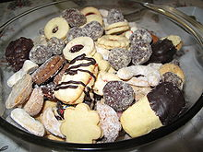

A dish full of cookies
Cookies are most commonly baked until crisp or just long enough that they remain soft, but some kinds of cookies are not baked at all. Cookies are made in a wide variety of styles, using an array of ingredients including sugars, spices, chocolate, butter, peanut butter, nuts or dried fruits. The softness of the cookie may depend on how long it is baked.
A general theory of cookies may be formulated this way. Despite its descent from cakes and other sweetened breads, the cookie in almost all its forms has abandoned water as a medium for cohesion. Water in cakes serves to make the base (in the case of cakes called "batter" as thin as possible, which allows the bubbles – responsible for a cake's fluffiness – to better form. In the cookie, the agent of cohesion has become some form of oil. Oils, whether they be in the form of butter, egg yolks, vegetable oils or lard are much more viscous than water and evaporate freely at a much higher temperature than water. Thus a cake made with butter or eggs instead of water is far denser after removal from the oven.
Oils in baked cakes do not behave as soda tends to in the finished result. Rather than evaporating and thickening the mixture, they remain, saturating the bubbles of escaped gases from what little water there might have been in the eggs, if added, and the carbon dioxide released by heating the baking powder. This saturation produces the most texturally attractive feature of the cookie, and indeed all fried foods: crispness saturated with a moisture (namely oil) that does not sink into it.

History
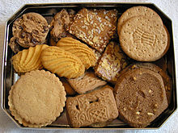

Cookies packed in a tin for shipment
Cookie-like hard wafers have existed for as long as baking is documented, in part because they deal with travel very well, but they were usually not sweet enough to be considered cookies by modern standards.
Cookies appear to have their origins in 7th century Persia, shortly after the use of sugar became relatively common in the region. They spread to Europe through the Muslim conquest of Spain. By the 14th century, they were common in all levels of society, throughout Europe, from royal cuisine to street vendors.
With global travel becoming widespread at that time, cookies made a natural travel companion, a modernized equivalent of the travel cakes used throughout history. One of the most popular early cookies, which traveled especially well and became known on every continent by similar names, was the jumble, a relatively hard cookie made largely from nuts, sweetener, and water.
Cookies came to America in the early English settlement (the 17th century), although the name "koekje" arrived with the Dutch. This became Anglicized to "cookie" or cooky. Among the popular early American cookies were the macaroon, gingerbread cookies, and of course jumbles of various types.
The most common modern cookie, given its style by the creaming of butter and sugar, was not common until the 18th century.^{[5]}

Classification of cookies
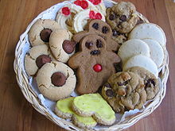

A variety of cookies, including gingerbread men and drop and molded cookies
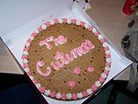
A cookie cake is a large cookie that can be decorated with icing like a cake.
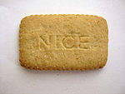
A Nice biscuit from Britain
Cookies are broadly classified according to how they are formed, including at least these categories:
- Bar cookies consist of batter or other ingredients that are poured or pressed into a pan (sometimes in multiple layers), and cut into cookie-sized pieces after baking. In British English, bar cookies are known as "tray bakes". Examples include brownies, fruit squares, and bars such as date squares.
- Drop cookies are made from a relatively soft dough that is dropped by spoonfuls onto the baking sheet. During baking, the mounds of dough spread and flatten. Chocolate chip cookies (Toll House cookies), oatmeal (or oatmeal raisin) cookies and rock cakes are popular examples of drop cookies.
- Molded cookies are also made from a stiffer dough that is molded into balls or cookie shapes by hand before baking. Snickerdoodles and peanut butter cookies are examples of molded cookies.
- Pressed cookies are made from a soft dough that is extruded from a cookie press into various decorative shapes before baking. Spritzgebäck are an example of a pressed cookie.
- Refrigerator cookies (also known as icebox cookies) are made from a stiff dough that is refrigerated to become even stiffer. The dough is typically shaped into cylinders which are sliced into round cookies before baking. Pinwheel cookies are representative.
- Rolled cookies are made from a stiffer dough that is rolled out and cut into shapes with a cookie cutter. Gingerbread men are an example.
- Sandwich cookies are rolled or pressed cookies that are assembled as a sandwich with a sweet filling. Fillings include marshmallow, jam, and icing. The Oreo cookie, made of two chocolate cookies with a vanilla icing filling, is an example.
Cookies also may be decorated with an icing, especially chocolate, and closely resemble a type of confectionery.

Biscuits (cookies) in the United Kingdom
A basic biscuit (cookie) recipe includes flour, shortening (often lard), baking powder or soda, milk (buttermilk or sweet milk) and sugar. Common savory variations involve substituting sugar with an ingredient such as cheese or other dairy products. Shortbread is a popular biscuit in the UK.
This term was then adapted into English in the 14th century during the Middle Ages, in the Middle English word bisquite, to represent a hard, twice-baked product.^{[3]}
However, the Dutch language from around 1703 had adopted the word koekje, a language diminutive of cake, to have a similar meaning for a similar hard, baked product.^{[4]} This may be related to the Russian or Ukrainian translation, where "biscuit" has come to mean "sponge cake".
The difference between the secondary Dutch word and that of Latin origin is that, whereas the koekje is a cake that rises during baking, the biscuit, which has no raising agent, in general does not (see gingerbread/ginger biscuit), except for the expansion of heated air during baking
When peoples from Europe began to emigrate to the United States, the two words and their "same but different" meanings began to clash. After the American War of Independence against the British, the word cookie became the word of choice to mean a hard, twice-baked product.
Further confusion has been added by the adoption of the word biscuit for a small leavened bread popular in the United States.
Today, according to American English dictionary Merriam-Webster:
- A cookie is a "small flat or slightly raised cake"
- A biscuit is "any of various hard or crisp dry baked product" similar to the American English terms cracker or cookie.^{[3]}
- A biscuit can also mean "a small quick bread made from dough that has been rolled out and cut or dropped from a spoon".^{[3]}
In modern Italian usage, the term biscotto is used to refer to any type of hard twice-baked biscuit, and not only to the cantuccini as in the past.

Biscuits for travel
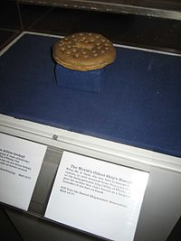
Ship's biscuit display in Kronborg, Denmark
The need for nutritious, easy-to-store, easy-to-carry, and long-lasting foods on long journeys, in particular at sea, was initially solved by taking live food along with a butcher/cook. However, this took up additional space on what were either horse-powered treks or small ships, reducing the time of travel before additional food was required. This resulted in early armies' adopting the style of hunter-foraging.
The introduction of the baking of processed cereals including the creation of flour provided a more reliable source of food. Egyptian sailors carried a flat, brittle loaf of millet bread called dhourra cake, while the Romans had a biscuit called buccellum.^{[5]} Roman cookbook Apicius describes: "a thick paste of fine wheat flour was boiled and spread out on a plate. When it had dried and hardened, it was cut up and then fried until crisp, then served with honey and pepper."
Many early physicians believed that most medicinal problems were associated with digestion. Hence, for both sustenance and avoidance of illness, a daily consumption of a biscuit was considered good for health.
Hard biscuits soften as they age. To solve this problem, early bakers attempted to create the hardest biscuit possible. Because it is so hard and dry, if properly stored and transported, navies' hardtack will survive rough handling and high temperature. Baked hard, it can be kept without spoiling for years as long as it is kept dry. For long voyages, hardtack was baked four times, rather than the more common two, and prepared six months before sailing.^{[6]} To soften hardtack for eating, it was often dunked in brine, coffee, or some other liquid or cooked into a skillet meal.
The more refined captain's biscuit was made with finer flour.
At the time of the Spanish Armada in 1588, the daily allowance on board a Royal Navy ship was one pound of biscuit plus one gallon of beer. Samuel Pepys in 1667 first regularised naval victualling with varied and nutritious rations. Royal Navy hardtack during Queen Victoria's reign was made by machine at the Royal Clarence Victualling Yard at Gosport, Hampshire, stamped with the Queen's mark and the number of the oven in which they were baked. Biscuits remained an important part of the Royal Navy sailor's diet until the introduction of canned foods. Canned meat was first marketed in 1814; preserved beef in tins was officially added to Royal Navy rations in 1847.

Confectionery biscuits
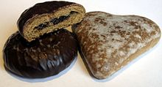
Traditional Polish toruń gingerbread
Early biscuits were hard, dry, and unsweetened. They were most often cooked after bread, in a cooling bakers' oven; they were a cheap form of sustenance for the poor.
By the seventh century AD, cooks of the Persian empire had learnt from their forebears the secrets of lightening and enriching bread-based mixtures with eggs, butter, and cream, and sweetening them with fruit and honey.^{[7]} One of the earliest spiced biscuits was gingerbread, in French pain d'épices, meaning "spice bread", brought to Europe in 992 by the Armenian monk Grégoire de Nicopolis. He left Nicopolis Pompeii, in Lesser Armenia to live in Bondaroy, France, near the town of Pithiviers. He stayed there for seven years, and taught French priests and Christians how to cook gingerbread.[This was originally a dense, treaclely (molasses-based) spice cake or bread. As it was so expensive to make, early ginger biscuits were a cheap form of using up the leftover bread mix.
With the combination of the Muslim invasion of the Iberian Peninsula, and then the Crusades developing the spice trade, the cooking techniques and ingredients of Arabia spread into Northern Europe.^{[7]} By mediaeval times, biscuits were made from a sweetened, spiced paste of breadcrumbs and then baked (e.g., gingerbread), or from cooked bread enriched with sugar and spices and then baked again.^{[11]} King Richard I of England (aka Richard the Lionheart) left for the Third Crusade (1189–92) with "biskit of muslin", which was a mixed corn compound of barley, rye, and bean flour.^{[5]}
As the making and quality of bread had been controlled to this point, so were the skills of biscuit making through the Craft Guilds.^{[7]} As the supply of sugar began, and the refinement and supply of flour increased, so did the ability to sample more leisurely foodstuffs, including sweet biscuits. Early references from the Vadstena monastery show how the Swedish nuns were baking gingerbread to ease digestion in 1444. The first documented trade of gingerbread biscuits dates to the 16th century, where they were sold in monastery pharmacies and town square farmers markets. Gingerbread became widely available in the 18th century. The British biscuit firms of Carrs, Huntley & Palmer, and Crawfords were all established by 1850.
Hence it is no surprise that, often together with local farm produce of meat and cheese, many regions of the world have their own distinct style of biscuit, so old is this form of food.

Biscuits today
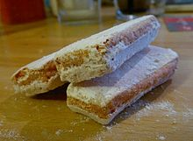
Biscuit rose de Reims
Most modern biscuits can trace their origins back to either the hardtack ship's biscuit, or the creative art of the baker:
- Ship's biscuit derived: Digestive, rich tea, Abernethy, cracker^{[citation needed]}
- Baker's art: Biscuit rose de Reims
Biscuits today can be savoury or sweet, but most are small at around 2 inches (5.1 cm) in diameter, and flat. The term biscuit also applies to sandwich-type biscuits, wherein a layer of cream or icing is sandwiched between two biscuits, such as the custard cream, or a layer of jam (as in biscuits which, in the United Kingdom, are known as "Jammy Dodgers")
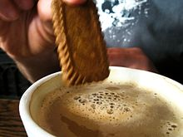
Dunking a biscuit
Sweet biscuits are commonly eaten as a snack food, and are, in general, made with wheat flour or oats, and sweetened with sugar or honey. Varieties may contain chocolate, fruit, jam, nuts, or even be used to sandwich other fillings. There is usually a dedicated section for sweet biscuits in most European supermarkets.
In Britain, the digestive biscuit and rich tea have a strong cultural identity as the traditional accompaniment to a cup of tea, and are regularly eaten as such. Many tea drinkers "dunk" their biscuits in tea, allowing them to absorb liquid and soften slightly before consumption.
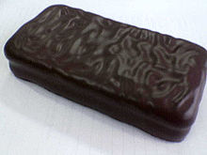
A dark chocolate Tim Tam
Savoury biscuits or crackers (such as cream crackers, water biscuits, oatcakes, or crisp breads) are usually plainer and commonly eaten with cheese following a meal. Also among the savoury biscuit we may include the Jewish biscuits known as Matzos. A large variety of savoury biscuits also contain additional ingredients for flavour or texture, such as poppy seeds, onion or onion seeds, cheese (such as cheese melts), and olives. Savoury biscuits also usually have a dedicated section in most European supermarkets, often in the same aisle as sweet biscuits. The exception to savoury biscuits is the sweetmeal digestive known as the "Hovis biscuit", which, although slightly sweet, is still classified as a cheese biscuit. Savoury biscuits sold in supermarkets are sometimes associated with a certain geographical area, such as Scottish oatcakes or Cornish wafer biscuits.
In general, Australians, South Africans, New Zealanders, Kenyans, Indians, Pakistanis, Sri Lankans, Singaporeans, and the Irish use the British meaning of "biscuit" for the sweet biscuit. In both Canada and Australasia, the terms biscuit and cookie are used interchangeably, depending on the region and the speaker, with biscuits usually referring to hard, sweet biscuits (such as digestives, Nice, Bourbon creams, etc.) and cookies for soft baked goods (i.e. chocolate chip cookies). Two famous Australasian biscuit varieties are the ANZAC biscuit and the Tim Tam. This sense is at the root of the name of the United States' most prominent maker of cookies and crackers, the National Biscuit Company, now called Nabisco.
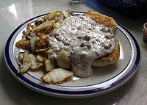

A serving of biscuits and gravy, accompanied by home fries
Biscuits and gravy is a popular breakfast dish in much of North America, especially in the Southern United States.
It consists of soft unsweetened dough biscuits covered in thick "country" or "white" gravy, made from the drippings of cooked pork sausage, white flour, milk, and often (but not always) bits of sausage, bacon, ground beef, or other meat. The gravy is often flavored with black pepper. In some parts of the southern United States this is also called sawmill gravy
HOME RECIPES FEATURED COOKBOOKS TIPS & TOOLS
Baking Tips Conversion Calculators Interesting Websites
NEWSLETTER ARCHIVES FORUM ABOUT DIANA
SEARCH

Tips for Cookies
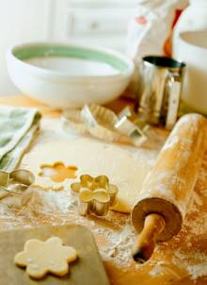

Cookies

Helpful Hints for Perfect Shortbread
Shortbread is so easy to make, and so utterly delicious. The simplicity of the butter, sugar, flour recipe can’t, in my opinion, be beat. To make yours come out perfectly every time, there are just a few simple directives to follow:
Bake your shortbread in the top third of your oven. This way you won’t get too much bottom heat that will cause the bottom of the shortbread to overcook before the top is done.
To make sure that your shortbread releases from the pan cleanly, be sure it is completely cooked in the middle before you remove the pan from the oven. Directions for shortbread baked on a cookie sheet often tell you to cook the shortbread only until the top of the cookies just barely begin to color. This is not the case with shortbread made in one of the Brown Bag Cookie Art Shortbread Pans.
Since you will be cooking your shortbread in the top third of the oven, you will get some top browning as the cookie bakes. The surface of the shortbread should be a toasty light brown when it is cooked. It should never appear raw or slightly opaque in the middle. If it is under-baked in the middle, it will probably stick in the pan when you go to unmold it.
Be sure to let the shortbread cool in the pan for 10 minutes before you flip the pan over to unmold it. This gives the delicate cookie a chance to firm up a bit. After cooling for 10 minutes, hold the pan parallel to and 1” above a wooden or plastic cutting board, face down, and unceremoniously drop it. This jars the shortbread, and it drops right out of the pan.
Slice the shortbread into serving pieces using a thin, sharp knife, while it is still hot. If you wait until it cools, it will become flakey and too fragile to cut cleanly.

Secret Tips for Successful Cookies
Making the perfect cookie involves more than just having the perfect recipe. You need to know the secrets to having your cookies turn out perfect every time.
* * *
While you don't have to follow a recipe exactly, neglecting some important details can make a finished product less than desired.
In her book Cookies and Brownies (1999, Warner Book, A Time Warner Company, New York) Alice Medrich states that "inaccurate measurements do not always spoil the cookies." You can toss in extra raisins, nuts, chocolate chips, coconut, or even vanilla. You can substitute dried fruits for nuts or vice versa and experiment with extracts and flavors. But if your flour measurement is inaccurate, your cookies may be tough, dry, doughy, or leaden.
Always measure the baking soda, baking powder, salt, and especially flour accurately. Before measuring the flour, stir it with a spoon if it is compacted. Then lightly spoon flour into your measuring cup until it is heaped above the rim. Do NOT shake or tap the cup to settle the flour, or you will have more flour than you need. Slide a spatula or knife across the top to level.
When measuring liquid ingredients, use a clear plastic or glass container with lines up the sides. Set the container on the counter and pour the liquid up to the appropriate mark. Lower your head to read the measurement at eye level.
When you mix the flour to the moist ingredients, stir just until blended. Be careful not to over mix or beat your cookie dough, unless you like tough cookies! One helpful hint is to mix the dry ingredients thoroughly first. You want the dry ingredients to be fluffed up rather than compacted so it blends easily with the dough. You can use a wire whisk to mix the dry ingredients.
Another helpful hint in making any recipe is to get the necessary ingredients ready in advance. Some ingredients, such as butter, may need to be at room temperature. If you're mixing with an electric mixer, use butter at room temperature, but if you're mixing by hand, you will want to soften the butter to the consistency of mayonnaise. (You can soften the butter in the microwave at 30 percent power for a few seconds at a time.)
When baking cookies, choose light-colored, dull-finished, heavy-gauge cookie sheets. Old cookie sheets that are dark can make the bottom of the cookies overly brown. Shiny sheets work best for cookies that should not brown too much on the bottom. Do not use insulated sheets for cookies high in butter, shaped cookies, and some drop cookies. The butter may start to melt and leak out before the dough sets. If this happens, the cookies may have thin edges.
Non-stick cookie sheets are easier to clean and help ensure even baking; however, the dough may not spread as much and you may end up with a thicker cookie. On the other hand, rich cookies can spread if baked on a greased sheet. Note the directions in the recipe, and only grease the cookie sheets if specified. When you do grease a pan, use a light coating or your cookies can flatten or spread too much. (If you'd rather not grease, you can line the pan with parchment paper.)
Except for bar cookies, don't use cookie sheets with high sides which can deflect heat and also make it difficult for you to remove your cookies. Your sheets should be two inches narrower and shorter than the oven to allow for even baking. If you don't have enough cookie sheets, you can invert a jelly roll pan or use heavy duty foil. Put the foil on the cookie sheet as it comes out of the oven and bake immediately.
For any dough that needs to be rolled out, refrigerate the dough for a couple hours (or overnight). Use a rolling pin and lightly flour your work surface. If you use too much flour, the dough will absorb it and become tough and dry. You can also roll the dough between sheets of wax paper (or a cut-apart plastic bag). Since the dough softens quickly, only work with part at a time. Keep the rest cooled until ready to use. The thinner the dough, the crispier the cookie.
If you're cutting out cookie designs, dip your cookie cutters in flour to prevent sticking or tearing of the cookies. Cut the cookie shapes as close as possible to lessen scraps. Save the scraps until the end. Press together gently and roll. (Don't handle the scraps too much or they will become tough.)
When making sliced cookies, finely chop any nuts or fruit that you add to the dough to make it easier to slice. Chill the dough and cut with a think sharp knife. Wipe the knife occasionally with a clean paper towel. Occasionally turn the roll of dough while you slice it to get nice round slices.
For drop cookies, make your cookies about the same size so they bake evenly. A cookie scoop helps form equal-size lumps. Space all cookies evenly and leave enough space between each cookie to allow for spreading while baking.
Preheat the oven which takes about fifteen to twenty minutes, depending on your oven. Use the upper and lower thirds of the oven, reversing sheets from upper to lower and front to back about halfway through the baking period to ensure even baking. If you use only one sheet, position the rack in the center, and change from back to front halfway through the baking cycle.
Always cool the pan before baking another batch. A warm pan causes the dough to melt which can cause overspreading, deformed cookies, or altered baking times. If you place cookies on parchment paper of foil pan liner, you may slide the cookies onto the warm cookie sheet, as long as you place it directly in the oven. (Baking times may be a bit shorter.)
To check cookies for doneness, press down lightly in the middle to see if it bounces back. Bake sliced cookies until the edges are firm and the bottoms are just lightly browned. Generally, cookies are done when the edges begin to brown, or when they are golden. Every pan bakes differently, depending on the material, thickness, weight, and surface reflection.
To fine-tune the baking of cookies, test bake a couple cookies. If your cookies spread too much (and you didn't over grease the pan), then you may need to add a tablespoon or two of flour. If you're not certain of the time for baking, you can test bake four cookies, and remove two of them a minute or two earlier than the others. Let them cool before tasting them.
Place cookies on wire racks to cool evenly, so the bottoms don't get soggy. You can transfer some cookies immediately to the wire racks, while others need a couple minutes to cool. If the cookie bends or breaks when transferring, wait another minute before trying.
Thoroughly cool cookies before storing them to prevent them from become soggy. Store cookies in air-tight containers such as tins, cookie jars with tight-fitting lids or zipper-type bags. Clear plastic containers are the best since the plastic preserves freshness, and the clarity lets you see what's inside. For delicate or frosted cookies, use a wide container and put parchment paper between the layers. Separate the hard and soft cookies and cookies with different flavors. If you store them together, the soft cookies will cause the crisp ones to go limp, and the flavors often mix.
Source: Rachel Keller
Adapted from: AllHomemadeCookies.com

Preparing Cookie Baking Sheets:
Prepare cookie sheets and baking pans as directed before you begin to mix the recipe. If light greasing is suggested, use vegetable oil spray or a small amount of solid vegetable shortening. Do not use butter or margarine as it may burn on cookie sheets. You might want to use baker's parchment paper (available in many supermarkets and specialty stores) instead of greasing cookie sheets, it will also save on clean-up time.

Cutting Bar Cookies:
To prevent the jagged edges that often occur when cutting cooled cookie bars: 1. Use a sharp knife to score the bars as soon as the pan comes out of the oven. 2. Then cut the cooled bars along the scored lines.

Cooling Cookies:
Allow cookies to cool slightly before removing them from the baking sheet. As soon as they are firm enough to move without breaking, transfer them to a wire rack to cool completely. Do not leave cookies on the hot baking sheet, they will continue to cook.

Freezing Cookies and Cookie Dough

Freezing unbaked cookie dough
Most cookie doughs freeze extremely well and can be kept frozen for up to 4 or 6 weeks. The most important thing to keep in mind is that the dough will absorb any odd odors present in your freezer if it's not properly wrapped and sealed. To prevent this smell-sponge effect-as well as freezer burn-wrap the dough securely twice. It's also a very good idea to write the type of cookie dough and the date it was frozen on the outside of the package. When you are ready to bake simply let the dough defrost in the refrigerator. This will take several hours, so plan ahead. The cookie doughs that freeze best are shortbreads, chocolate chip, peanut butter, refrigerator, sugar, and brownies, just to name a few. The types of cookie doughs that do not freeze well are cake-like cookies and cookies that have a very liquidy batter, such as madeleines and tuiles.

Freezing already baked cookies
Freezing baked cookies is a great way to preserve their freshness. Baked cookies will keep in the freezer for up to 3 or 4 weeks. As with freezing cookie dough, the most important thing to keep in mind is that you don't want your cookies to absorb any odors. Double-wrap the cookies securely and write the date and the type of cookie on the outside of the package. When you are ready to eat your frozen cookies, just let them come to room temperature, or, for you impatient types, pop them in the microwave on high for about 30 seconds. (Times will differ depending on the size of cookie you're defrosting.) We still haven't come across a baked cookie that doesn't freeze well. So feel free to freeze loads of assorted cookies to keep yourself supplied with yummy goodies, any time.
Source: allrecipes.com

Creative Cookie Decorating With Royal Icing
Decorating transforms the simplest cut-out cookies into sensational miniature sweets. Both children and adults can enjoy creating edible masterpieces and any occasion can provide the inspiration—you'll quickly discover that the design possibilities are endless!
Perhaps the best thing about this craft is its simplicity. Our Bloomin' Sugar Cookies (see recipe and instructions below) are decorated with Royal Icing, a simple mixture of confectioners' sugar, water and egg white or meringue powder. Decorating with royal icing is a skill often used by professional bakers, but with a little practice and our easy instructions, you can achieve the same fanciful results. So turn your kitchen into an art studio with some simple equipment, straightforward techniques and lots of imagination.

It's Time To Decorate
Allow plenty of time and space for a decorating session. Cover surfaces with waxed paper to keep counters clean and create plenty of space for cookies to dry before storing. When working with several colors at once, disposable pastry bags are handy. Or, make your own decorating cones with several layers of waxed or parchment paper.
You can also turn small, zipper-top plastic bags into pastry bags by cutting a tiny snip off the corner. Stand bags in juice glasses for easy filling. Fill the bags no more than half full.

Icing 101
To color the icing, divide small amounts of icing into custard cups. Reserve one cup as white icing. Add food coloring, a tiny bit at a time, to remaining icings. Mix with a spoon or toothpick until well blended, gradually adding more coloring until desired color is attained.
To ice a cookie, stir a few drops of water or flavoring into a small amount of icing until it reaches spreading consistency. (Set aside remaining thick icing for piping.) Using a small, flexible spatula, spread baked, cooled cookies with a base coat of thinned icing. Dip spatula in warm water as needed to achieve a smooth finish. Let the base dry completely before applying piping. (Note: This thinned icing dries out quickly so cover any unused portions.)
Use a pastry bag filled with thick icing to pipe designs on top of cookies. If you're a beginner, use no more than two colors and practice making decorations on a sheet of waxed paper before getting started.

Tricks of the Trade
USEFUL EQUIPMENT
Flexible metal spatulas, writing tips, plenty of custard cups, toothpicks, brushes, waxed paper and disposable pastry bags.
Let icing dry completely before storing cookies or piping one color onto another.
To dry iced cookies faster, place in a 200F oven with the door ajar for 5 minutes.
If you make more icing than you use, cover it with plastic wrap and refrigerate for a few days. Stir gently if mixture separates.

Recipe For Bloomin’ Sugar Cookies
Looking for a way to make someone’s day? Give them this delicious bouquet of colorful cookie flowers!
Ingredients:
1/2 cup (1 stick) butter or margarine, softened
1/3 cup granulated sugar
1 large egg
2 cups all-purpose flour
1 teaspoon baking powder
1/4 teaspoon salt
1 cup white chocolate chips, melted
Wooden skewers
Assorted food colorings
1 box (16 ounces) confectioners' sugar
6 tablespoons water
2 tablespoons meringue powder
Preparation Time: 45 minutes plus chilling
Baking Time: 6-8 minutes per batch
Makes: 3 dozen cookies
Instructions:
1. In a large bowl, using mixer set on high, beat butter and granulated sugar until light and fluffy; on medium speed, beat in egg. In a medium bowl, combine flour, baking powder and salt; add to butter mixture. Beat in melted white chocolate until thoroughly combined, about 1 minute. Form dough into a disk; wrap in plastic. Chill until slightly firm, about 15 minutes.
2. Spread wooden skewers in a large pan; cover with water. Add green food coloring to water in pan. While wearing gloves, gently toss skewers around the pan. Transfer skewers to wire rack; let dry completely.
3. Preheat oven to 350 degrees F (180 C). Roll dough to a 1/4-inch thickness. Using flower cookie cutters, cut out shapes; place on ungreased baking sheets. Place a tinted skewer underneath bottom end of each shape. Gently press dough into skewers. (This will ensure that the cookies will bake around the skewers and help prevent them from falling off.)
4. Bake cookies until lightly golden, 6–8 minutes. Let cookies cool completely.
5. In a large bowl, using a mixer set on medium, beat confectioners’ sugar, water and meringue powder until fluffy, about 4 minutes. Divide icing among small bowls; tint icing with food colorings as desired.
6. Using a small paintbrush, spread tinted icing over base of cookies; let dry.
7. Fill separate pastry bags fitted with medium writing tips with remaining tinted icings. Working with 1 cookie at a time, pipe an outline onto cookies; pipe lines and dots in contrasting colors. Let cookies dry completely.
Makes 3 dozen cookies
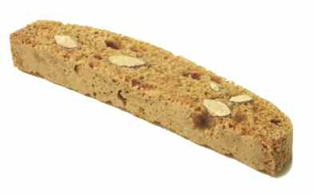 | biscotti Pronunciation: biss-COT-tee : Biscotti are cookies that are hard, dry, and intensely flavored--think of them as teething biscuits for adults. They're made by baking a loaf of cookie dough, slicing it, and then baking the slices a second time. They come in several flavors, including almond, chocolate, anise, and hazelnut. They can be stored for a long time in a dry, airtight container. Substitutes: mandlebrot OR amaretti

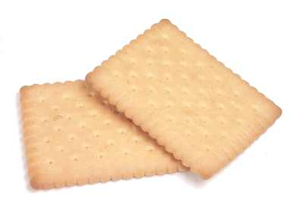 | butter cookie = petit beurre : These crisp cookies are made with butter. They're sometimes crushed and use to make pie crusts. Substitutes: shortbread (not as crisp)

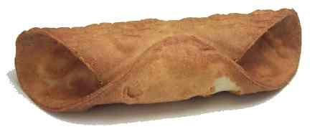 | cannoli shell : Italians stuff these with a sweet filling that's usually based on ricotta cheese. Substitutes: omit (Italians sometimes serve cannoli filling by itself as a pudding.)

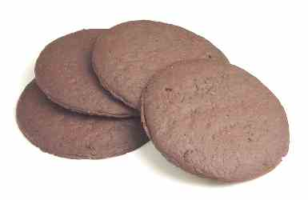 | chocolate wafer : These are crisp chocolate cookies that are often crushed and used to make pie crusts. Substitutes: gingersnaps

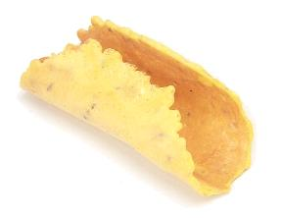 | cialde Pronunciation: chee-AL-day : These crisp, finger-length Italian cookies are flavored with anise. They're often stuffed with fruit or other fillings.

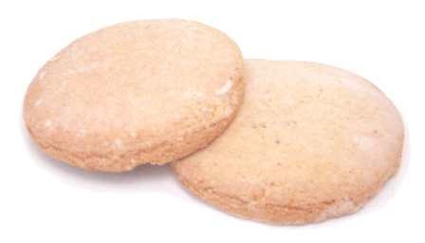 | corico : These lightly sweetened cookies are made with cornmeal. Look for them in Hispanic markets.
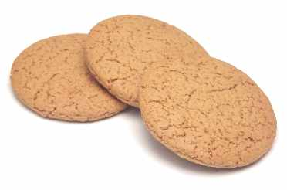 | ginger nut : These addictive British cookies are similar to ginger snaps, but harder. They're often crushed into crumbs for pie crusts. Substitutes: ginger snaps

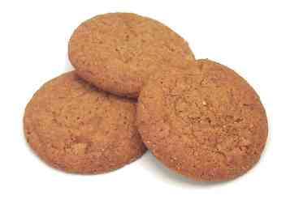 | gingersnap = ginger biscuit : These hard cookies are flavored with ginger and molasses. They're sometimes added to sauerbraten or beef stews, or they're crushed into crumbs for pie crusts. The British version of this is the ginger nut, which is similar but very hard. Substitutes: graham crackers (for pie crusts) OR chocolate wafers (for pie crusts) OR vanilla wafers (for pie crusts) OR gingerroot (for sauerbraten) OR ground ginger (for sauerbraten)

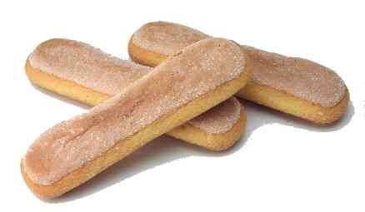 | ladyfingers = savoiardi = savoiardi cookies = savoiardi biscuits = sponge fingers : These are tongue depressor-sized sponge cakes that are used to make charlottes, tiramisu and other desserts. American ladyfingers are smaller and moister than their Italian counterparts. If substituting them for Italian savoiardi, use more and toast them briefly in the oven before using. Substitutes: génoise OR sponge cake OR pound cake (not as absorbent) OR brioche

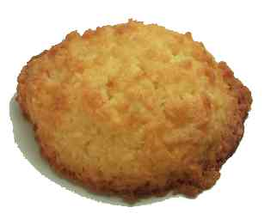 | macaroon : These are soft cookies that are made with either almonds or coconut. Substitutes: amaretti (These aren't as soft as macaroons.)

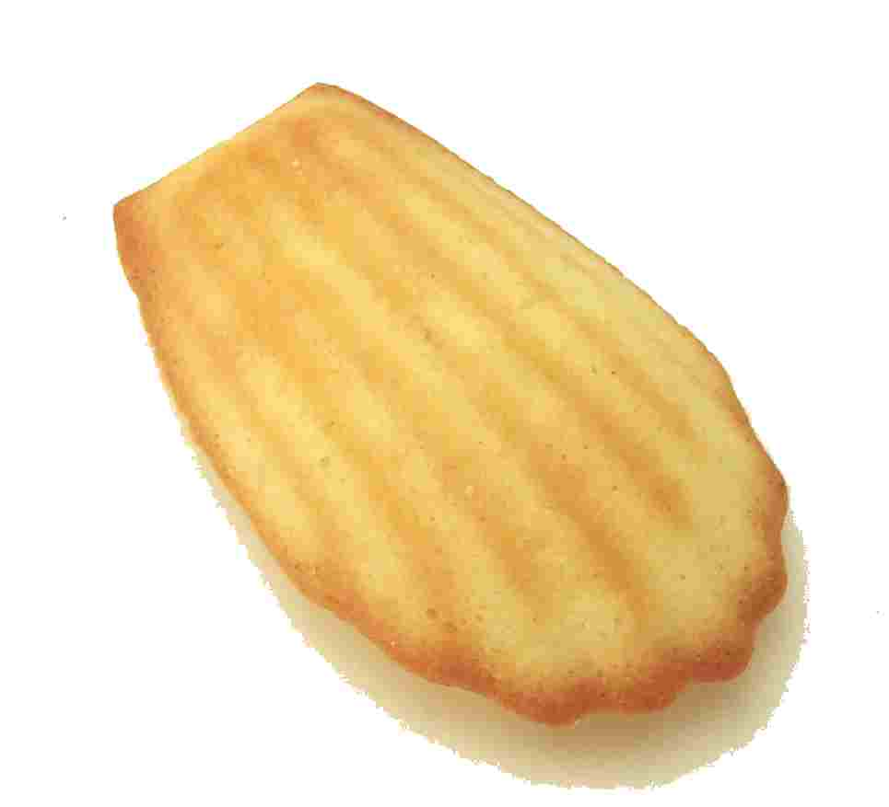 | madeleine : These are rich, cake-like cookies that are shaped like shells. They're often flavored with lemon, orange, chocolate, or almonds.

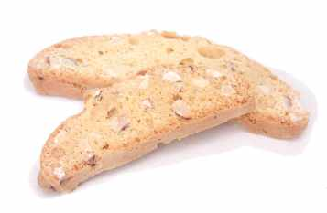 | mandelbrot = mandel bread Pronunciation: This is similar to an almond-flavored biscotti, only smaller and softer. Look for it in Jewish markets. Substitutes: biscotti

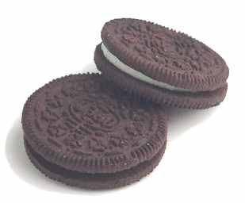 | Oreo® cookie Notes: These cookies have a creamy vanilla filling sandwiched between two chocolate wafers. They're addictive all by themselves, but cooks also crush them and use them to make pie crusts or ice cream toppings. Substitutes: chocolate wafer OR vanilla wafer

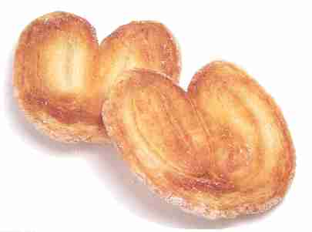 | palm leaf = palmier Notes: These crunchy cookies are made with puff pastry and sugar.

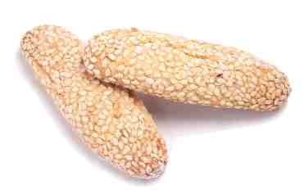 | regina cookies = biscotti de regina Notes: These come with or without a coating of sesame seeds.

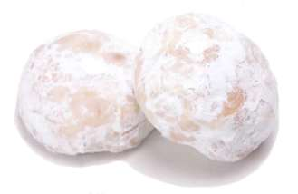 | Russian tea cookie = snowball = Russian tea cake = Russian tea biscuit = Mexican wedding cookie Notes: These are made with flour, nuts, and butter, baked, and then rolled in powdered sugar.

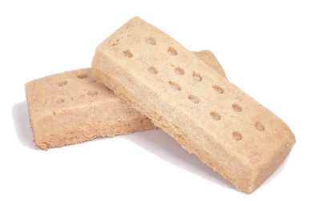 | shortbread Substitutes: These rich cookies are loaded with butter. Substitutes: butter cookie (crisper)

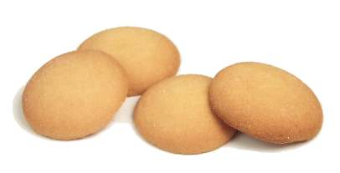 | vanilla wafer Notes: These vanilla cookies can be eaten as they are, but cooks often pound them into crumbs and use them to make pie crusts. Substitutes: chocolate wafers OR gingersnaps

Ref: 1)Wikipedia Google .com
2) www.quara .com

