MAHARASHTRA COSMOPOLITAN EDUCATION SOCIETY
Azam Campus, Pune – 411 001

E-Content Description
Name of School / College: M A Rangoonwala Institute of Hotel Management and Research
Name and Designation of content creator /Producer | Assoc. Prof Imran Sayyed
Title of E content | Audio visual equipments
Theory/practical | Theory
Title and No of Module | Audio visual equipments
Title and code of Paper | The Science of Hotel Engineering  Subject Code : HS 206
Broad Subject | Hotel Engineering
Course | BScHS
Class | SY
Semester | Third Semester
University /Board | SPPU
Date of Content Creation | 5 Jan 2020
Name of Reviewer  HOD/Principal | Imran Sayyed

Chapter 8. Audio visual equipments : 06
8.1. Various audio visual equipment used in hotel
8.2. Care and cleaning of overhead projector, slide projector, LCD and power point presentation units
8.3. Maintenance of computers:
8.4. Care and cleaning of PC, CPU, Modem, UPS, Printer, Laptops
8.5. Sensors – Various sensors used in different locations of a hotel – type, uses and cost effectiveness
9.4 Transport Systems. (Elevators, Escalators)
• Types& Uses of elevators, Passenger service, Freight elevators, Dumbwaiter ,Sidewalk elevators
• Stage lifts , Vehicle elevators , Residential elevator, Paternoster Scissor lift ,
• Rack-and-pinion elevator Material handling belts and belt elevators Passenger elevators, freight
elevators
• Escalators - Design, components, and operation
Chapter8. Audio Visual Equipment
8.1 Various audio visual equipments used in hotels.
Audiovisual (AV) means possessing both a sound and a visual component, such as slide-tape presentations, films, television programs, church services and live theater productions.
Audiovisual service providers frequently offer web streaming, video conferencing and live broadcast services.
Computer-based audiovisual equipment is often used in education, with many schools and universities installing projection equipment and using interactive whiteboard technology.
Another audiovisual expression is the visual presentation of sound (visual music).

Equipment Available:
• Data Projectors
• Wireless Microphones
• Microphone Mixers
• Podium with microphone
• Powered Speakers

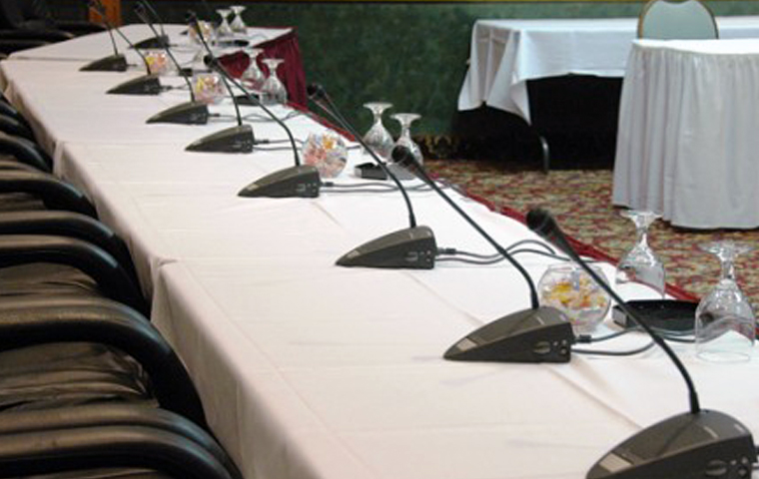
Data projectors
These are used to project an image from:
- Classroom computer
- Document camera
- Laptop
- Any other VGA compatible device
Wireless microphones
These are used for presenters who will be presenting to an audience in larger lecture all or event space. Typically, powered speakers and a microphone mixer are needed as well.
Powered Speakers
Powered speakers are used in conjunction with microphones and microphone mixers to provide audio for a large audience in a lecture hall or event space.
Microphone Mixers
Microphone mixers, or mixers, are used when multiple microphones and/or audio devices are connected to powered speakers.
Podiums
(includes a built-in microphone)
All classrooms already have a metal table-top lectern. Podiums can be requested for larger lecture halls or special events in an event space.
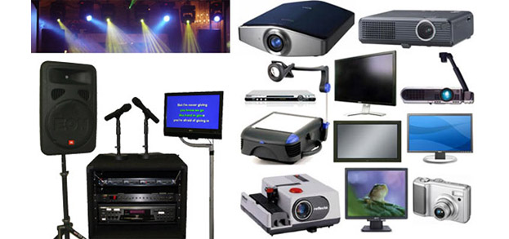

8.2. Care and cleaning of overhead projector, slide projector, LCD and power point presentation units
Overhead Projectors:
a projector having a flat, transparent top on which a sheet like transparency is placed, and an overhead mirror that reflects the image on the transparency to a screen.
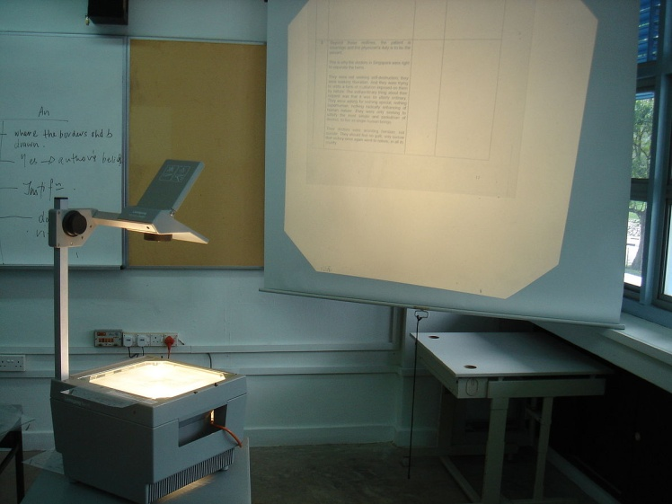
CARE AND MAINTENANCE:
- Remove dust and other debris from the projector’s vents and fan. Use a small handheld vacuum with a crevice tool to get the dust trapped within the vents and the fan blades. Alternatively, use a can of compressed air to blow the dust free. Don’t hold the can too close to the projector and use gentle pressure to avoid damaging the components.
- Wipe the projector stage and base with a soft, dry microfiber cloth to remove dust and other debris.
- Dampen a soft, microfiber cloth with water or a specialized overhead cleaning solution and wipe the stage glass and the projector lens. Use gentle pressure to avoid damaging the equipment and don’t saturate the cloth or allow liquid to pool on the projector because doing so may damage the internal circuitry of the device.
- Clean the projection mirror with a soft brush. This allows you to remove dust and other surface debris from the mirror without leaving streaks or other marks. Don’t wipe the projection mirror to clean it because doing so may result in damage.

SLIDE PROJECTOR
A slide projector is an opto-mechanical device for showing photographic slides.
35 mm slide projectors, direct descendants of the larger-format magic lantern, first came into widespread use during the 1950s as a form of occasional home entertainment; family members and friends would gather to view slide shows, which typically consisted of slides snapped during vacations and at family events. Slide projectors were also widely used in educational and other institutional settings.
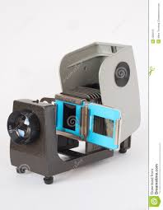
CARE AND MAINTENANCE
- The following items are required:
- ‘3-In-One’ lubrication oil and grease
- Oil free air compressor or compressed air cans
- Lint free tissue, anti-static brush
TWICE A WEEK AND WEEKLY MAINTENANCE
• The lamp inside the projector needs to be changed twice a week. It is important that this is done before the lamp fails. A schedule can be set up based on the average 40 hours life expectation of the lamp. It is necessary to wear gloves when changing the lamp as grease spots on the lamp reduces its life and cause them to blow prematurely. • The slide projector needs to be cleaned once a week by a trained AV technician. This includes dusting the outer body of the projector as well as the lens and optical path (there are 4 lenses and filters inside the projector). The cleaning of the projectors optics, such as the lens, condenser and heat filter should be carried out using a soft lint e cloth or an anti-static brush. If the projector begins to make a squeaky noise, this is usually caused by the ventilation wheel inside being dusty and/or that the bearings may need lubrication.
MONTHLY BASIS
• Once a month a deep clean needs to be carried out on the slide projector. Dirt and dust can have adverse effects on the lubricants used on the rotating parts inside the slide projector and thus may lead to malfunctioning. See detailed maintenance instructions at the end of the report. This will take circa 40 minutes for each.
LCD PRJECTOR
An LCD projector is a type of video projector for displaying video, images or computer data on a screen or other flat surface. It is a modern equivalent of the slide projector or overhead projector. To display images, LCD (liquid-crystal display) projectors typically send light from a metal-halide lamp through a prism or series of dichroic filters that separates light to three polysilicon panels – one each for the red, green and blue components of the video signal. As polarized light passes through the panels (combination of polarizer, LCD panel and analyzer), individual pixels can be opened to allow light to pass or closed to block the light. The combination of open and closed pixels can produce a wide range of colors and shades in the projected image.
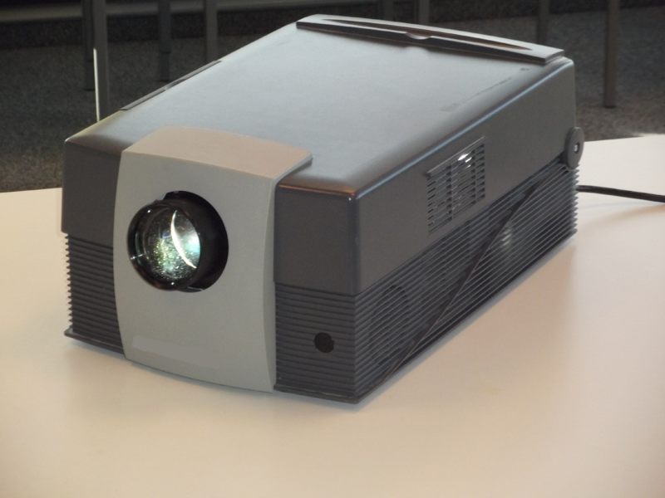
CARE AND MAINTENANCE:
One of the most expensive components of a computer system or laptop is the LCD monitor or screen. Liquid Crystal Display (LCD) screens are easily susceptible to damage and scratches, so it's a good idea to make sure that you don’t touch the display surface and that you clean the screen correctly.
Not all types of cleaning solutions are acceptable for LCD screens. Using alcohol or ammonia - based cleaners repeatedly may cause permanent damage to the LCD. Over time, using these types of cleaners could cause the surface of the screen to yellow. It can also make the screen brittle and eventually cause cracking on the screen surface.
The following cleaners should NOT be used:
- Acetone
- Ethyl alcohol
- Ethyl acid
- Ammonia
- Methyl chloride
The following types of cleaners are acceptable:
- Water
- Vinegar (mixed with water)
- Isopropyl Alcohol
- Petroleum Benzene
Some basic supplies needed to clean an LCD screen include:
- A soft cotton cloth. When cleaning the LCD screen it is important to use a soft cotton cloth, rather than an old rag. Some materials, such as paper towels, could cause scratches and damage the LCD screen.
- Solution of water and isopropyl alcohol. This solution can be used along with the soft cotton cloth.
- Computer wipes. Only use these if they specifically state on the package they are designed for LCD laptop screens. Computer wipes can come in handy for fast clean-ups or when you want to avoid mixing up a cleaning solution yourself.
To clean the LCD surface properly:
- Do not spray any liquids on the LCD screen directly, and do not use paper towels, this can cause the LCD screen to become scratched.
- Always apply the solution to your cloth first, not directly to the parts you are cleaning. You want to avoid dripping the solution directly into your computer or laptop.
- Stroke the cloth across the display in one direction, moving from the top of the display to the bottom.
8.3. Maintenance of computers:
Occasionally clean your computer as follows:
- Use a soft cloth moistened with non-alkaline detergent to wipe the exterior of the computer.
- Avoid spraying cleaner directly on the display or the keyboard.
- Gently wipe the display with a dry, soft cloth.
- Laptop users: If you see a scratch like mark on your display, it might be a stain transferred from the keyboard, or the TrackPoint (R) pointer, when the cover was pressed from the outside. Wipe or dust the stain gently with a soft, dry cloth. If the stain remains, moisten a soft, lint-free cloth with water that does not contain impurities, wring out as much of the water as you can, and then gently wipe the display again. Be sure to dry the display before closing the laptop.
Prior to the use of any chemical agents, be sure to read and understand the manufacturer label for warnings, toxicity, handling, and directions for proper use.

Components

Keyboard
The crumbs, dust, and other particulate that fall between the keys and build up underneath are loosened by spraying pressurized air into the keyboard, then removed with a low-pressure vacuum cleaner. A plastic-cleaning agent applied to the surface of the keys with a cloth is used to remove the accumulation of oil and dirt from repeated contact with a user's fingertips. If this is not sufficient for a more severely dirty keyboard, keys are physically removed for more focused individual cleaning, or for better access to the area beneath. Finally, the surface is wiped with a disinfectant.

Monitor
Fingerprints, water spots, and dust are removed from the screen with a cleaning wipe specialized for the screen type (CRT, LCD, etc.). A general plastic-cleaning agent is used on the outer casing, which requires a less gentle cleanser but may need more focused attention to unusual buildups of dust, grime, pen marks, etc. idiosyncratic to the user and environment.

Mouse
The top surface of the mouse is wiped with a plastic cleanser to remove the dirt that accumulates from contact with the hand, as on the keyboard. The bottom surface is also cleaned to ensure that it can slide freely. If it is a mechanical mouse, the trackball is taken out, not only to clean the ball itself, but to scrape dirt from the runners that sense the ball's movement and can become jittery or stuck if impeded by grime.

Tower/desktop unit
The case is opened to expose the internal components, which accumulate dust brought in by the airflow maintained by fans to keep the PC from overheating. A soft brush is used throughout the case and components to remove as much loose dirt as possible; the remainder is dislodged with compressed air and removed with a low-pressure vacuum. The case is wiped down with a cleaning agent.
Aside from brushing you can also use pressurize blower or air blower that can easily removed all dust that cannot be reach with a brush this would require opening up your computer case, if proper computer maintenance is not followed then you should not be surprised if it gets hotter than it usually does or suffers a system failure.^{[1]}

Data

Backups
Important data stored on computers may be copied and archived securely so that, in the event of failure, the data and systems may be reconstructed. When major maintenance such as patching is performed, a backup is recommended as the first step in case the update fails and reversion is required.
Disk cleanup may be performed as regular maintenance to remove these. Files may become fragmented and so slow the performance of the computer. Disk defragmentation may be performed to combine these fragments and so improve performance.

Legal issues[
In the United States of America, the Digital Millennium Copyright Act specifically exempts computer-maintenance activities, so copies of copyright files may be made in the course of maintenance provided that they are destroyed afterwards.^{[2]}

Software

Operating system
Operating-system files such as the Windows registry may require maintenance. A utility such as a registry cleaner may be used for this. Also inbuilt Disk defragmenter will also help.

Software updates
Software packages and operating systems may require regular updates to correct software bugs and to address security weakness..

Printer
General Printer Maintenance Tips...
Just like brushing your teeth or taking your car to the garage for an oil change, there are simple everyday things you can do to maintain and prolong the useable life of your inkjet or laser printer.
(Be sure to turn off the power and unplug the printer before you start.)
Outside. Clean the outside of your printer at least once a week. Use a damp, lint-free cloth dipped in water or rubbing alcohol to wipe away dust, dirt, animal hair, and other contaminants. Beware: Stronger cleaners can damage the printer case.
Inside. Pop the hood and remove the toner cartridge. Clean the gears and rollers along the paper path. To clean the rollers, use rubbing alcohol or Bestine (a solvent usually available at art stores).
Vacuum. It is not recommended to use a compressed air blower to clean out the inside of your laser or inkjet printer, because dirt and dust are blasted back into the printer. For better results, buy a small portable vacuum that you also can use to clean your keyboard.
Rock the toner. Before replacing the toner cartridge, rock it gently from side to side. This prolongs the life of the toner. It also redistributes the toner so that your printer prints evenly across the page.
Printer Maintenance Tips
Print a blank page. Run a clean page through your printer. This will pick up lint, dust, and stray toner. In some printers, you'll have to take the printer offline and then press the Form Feed button. OR... open your word processor to a blank page and press the Print command. If it won't print a blank page, type any character and then press Print.
There are several inkjet and laser cleaning products that claim to remove dust, dried ink, and paper debris from the feed rollers, toner drum, and thermal head. Save your money.
Cover up. When not in use, protect your printer with a printer cover. They're available at computer and office supply stores. A cover keeps your printer safe and clean when not in use.
If it isn’t broke. Unlike cars, there's no set time to have a printer checked out by a professional. For the most part, inkjet and laser printers work tirelessly. The only thing you'll replace is the toner or ink cartridge, which is why you should always have an extra on hand. Faulty, damaged, or bad toner or ink cartridges are responsible for the majority of printer problems—especially image output defects such as fuzzy or dropped-out words, staining, and uneven or fading ink.
Before you call tech support, lug your printer into an authorized repair facility, or request in-house service, you should try to change the cartridge first and see if that clears up the problem.

Different Types Of Sensors With Their Applications
Typical applications of different types of sensors such as application of Speed sensor for synchronizing the speed of multiple motors, Temperature sensor application for industrial temperature control, application of the PIR sensor for automatic-door-opening system, Ultrasonic sensor application for distance measurement, etc., are discussed below with their block diagrams.

Speed Sensor
Sensors used for detecting speed of an object or vehicle is called as Speed sensor. There are different types of sensors to detect the speed such as Wheel speed sensors, speedometers, LIDAR, ground speed radar, pitometer logs, doppler radar, air speed indicators, pitot tubes and so on.
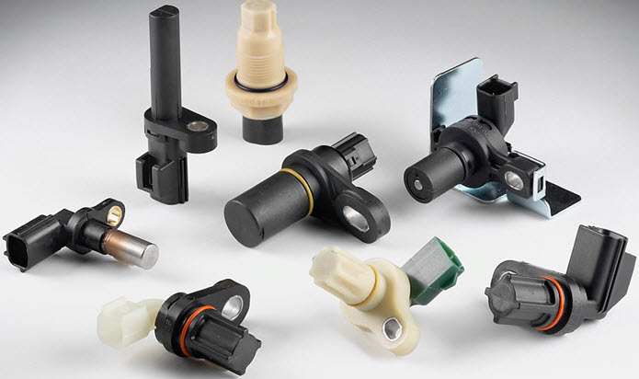
Speed Sensor

Application of Speed Sensor
PIC microcontroller based project for speed synchronization of multiple motors in industries using wireless technology is a typical application of the speed sensor. One of the multiple motors in the industry is considered as a main motor which act as transmitter and remaining motors acting as receivers, will follow the speed of the main motor. The main motor and receiver motors used in this project are BLDC motors that are controlled using PWM control with the radio frequency wireless communication mode.

Application of Speed Sensor by Edgefxkits.com
Reference RPM is given to each motor shaft which has an IR sensor mounted and a closed loop is obtained by feeding this output to controller in the circuit. Full speed will be displayed on display unit and required speed of all motors can be obtained by entering the desired percentage using the keypad. This entered percentage is matched with running RPM by maintaining appropriate DC power to motor with automatic adjustment of pulse width output of microcontroller.
Thus, by varying speed of transmitting motor, we can change the speed of all motors using this technology.

Temperature Sensor
A device which gives temperature measurement as an electrical signal is called as Temperature sensor. This electrical signal will be in the form of electrical voltage and is proportional to the temperature measurement.
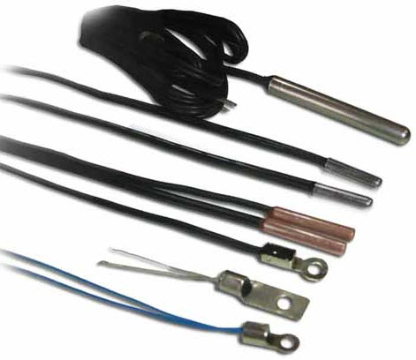
Temperature Sensor
There are different types of sensors used for measuring temperature, such as Contact type temperature sensors, Non-contact type temperature sensors. These are again subdivided as Mechanical temperature sensors like Thermometer and Bimetal. Electrical temperature sensors like Thermistor, Thermocouple, Resistance thermometer and Silicon band gap temperature sensor.

Application of Temperature Sensor
Design of Industrial Temperature Controller for controlling temperature of devices used in industrial applications is one of the frequently used practical applications of the temperature sensor. In this circuit IC DS1621, a digital thermometer is used as a temperature sensor, thermostat, which provides 9-bit temperature readings. The circuit mainly consists of 8051 microcontroller, EEPROM, temperature sensor, LCD display and other components.

Temperature Sensor Application by Edgefxkits.com
LCD is used to display temperature in the range of -55degress to +125degrees. EEPROM is used to store predefined temperature settings by user through the 8051 series microcontroller. The relay whose contact is used for load, is driven by microcontroller using a transistor driver.

PIR Sensor
An electronic sensor used for measuring the infrared light radiation emitted from objects in its field of view is called as a PIR sensor or Pyroelectric sensor. Every object that has a temperature above absolute zero emit heat energy in the form of radiation radiating at infrared wavelengths which is invisible to the human eye, but can be detected by special purpose electronic devices such as PIR motion detectors.
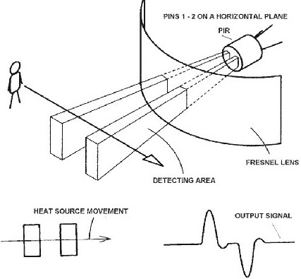
Passive Infrared Sensor
PIR sensor itself is split into two halves, which are sensitive to IR and whenever object comes in the field of view of the sensor, then positive differential change will be produced between two halves with the interception of the first half of the PIR sensor. Similarly, if the object leaves the field of view, then negative differential change will be produced. PIR or Passive Infrared sensor is named as passive because it doesn’t emit any energy or radiation for detecting the radiation. There are different types of sensors used for detecting the motion and these PIR sensors are classified based on angle (wide area) over which they can detect motion of the objects like 110degrees, 180degrees and 360degress angles.

Application of PIR Sensor
Automatic Door Opening System is a typical application of PIR sensors which is intended for automatic door closing and opening operations based on body movement near the door. PIR-sensor-based-automatic-door- opening system circuit mainly consists of a PIR sensor, an 8051 micrcontroller, a driver IC, a door motor.

PIR Sensor Application by Edgefxkits.com
If a body movement is present near the door, then infrared radiation emitted from the body will cause the sensor to produce sensing signal which is fed to microcontroller. The door motor is then controlled and operated by the microcontroller through driver IC. Thus, if anybody comes near to door, then a command will be sent by microcontroller for opening door and a time delay is set for closing door automatically. This project is intended for operating doors of shopping malls, theatres and hotels.

Ultrasonic Sensor
The principle of ultrasonic sensor is similar to sonar or radar in which interpretation of echoes from radio or sound waves to evaluate the attributes of a target by generating the high-frequency-sound waves (around 40kHz). The transducer used for converting energy into ultrasound or sound waves with ranges above human hearing range is called an ultrasonic transducer.
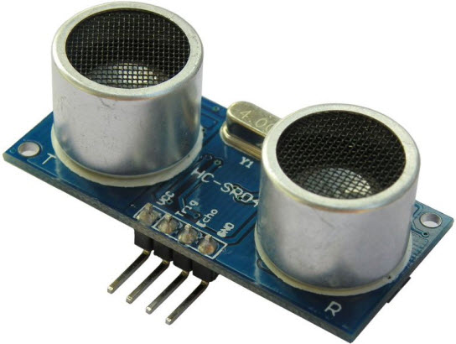

Application of Ultrasonic Sensor
The distance measurement at inaccessible areas is a typical application of ultrasonic sensors. The circuit consists of an ultrasonic module, LCD display and microcontroller. The ultrasonic module is interfaced with the microcontroller and this ultrasonic transducer consists of a transmitter and receiver.

Refferences:
ihmhotelengineeringnotes.blogspot.com
ihmhotelengineeringnotes.blogspot.com
https://lecturenotes.in/m/21160-note-of-hotel-engineering-by-victor-agughasi
ihmkolkata.blogspot.com/2013/04/ihm-kolkata.html
Hotel Engineering - IHM PUSA
ihmpusa.net › wp-content › uploads › 2016/12 › Hotel-Engineering-0
https://www.newtondesk.com/refrigeration-and-air-conditioning-study-notes-hand-written/
en.wikipedia.org/wiki/
encyclopedia2.thefreedictionary.com
www.kopykitab.com/Engineering
www.faadooengineers.com/forums/112-Engineering-Ebooks.
Hotel Engineering Robert F eilliot
Hotel Engineering Tarun Bansal

