MAHARASHTRA COSMOPOLITAN EDUCATION SOCIETY
Azam Campus, Pune – 411 001

E-Content Description
Name of School / College: M A Rangoonwala Institute of Hotel Management and Research
Name and Designation of content creator /Producer | Assoc. Prof Imran Sayyed
Title of E content | Transport Systems. (Elevators and Escalators)
Theory/practical | Theory
Title and No of Module | Transport Systems. (Elevators and Escalators)
Title and code of Paper | The Science of Hotel Engineering  Subject Code : HS 206
Broad Subject | Hotel Engineering
Course | BScHS
Class | SY
Semester | Third Semester
University /Board | SPPU
Date of Content Creation | 1 Jan 2020
Name of Reviewer  HOD/Principal | Imran Sayyed

Chapter9. Safety in Hotels
9.4 Transport Systems. (Elevators and Escalators)
ELEVATORS.
An escalator is a vertical transportation device in the form of a moving staircase – a conveyor which carries people between floors of a building. It consists of a motor-driven chain of individually linked steps. These steps are guided on either side by a pair of tracks which force them to remain horizontal.
Escalators are used around the world in places where elevators would be impractical. Principal areas of usage include department stores ,shopping malls, airports, transit systems (railway/railroad stations), convention centers, hotels, arenas, stadiums, and public buildings.
Escalators have the capacity to move a large number of people, and they can be placed in the same physical space as a staircase. They have no waiting interval (except during very heavy traffic), they can be used to guide people toward main exits or special exhibits, and they may be weatherproofed for outdoor use. A non-functioning escalator can function as a normal staircase, whereas many other conveyances become useless when they break down.

Components
Landing platforms: These two platforms house the curved sections of the tracks, as well as the gears and motors that drive the stairs. The top platform contains the motor assembly and the main drive gear, while the bottom holds the step return idler sprockets. These sections also anchor the ends of the escalator truss. In addition, the platforms contain a floor plate and a comb plate. The floor plate provides a place for the passengers to stand before they step onto the moving stairs. This plate is flush with the finished floor and is either hinged or removable to allow easy access to the machinery below. The comb plate is the piece between the stationary floor plate and the moving step. It is so named because its edge has a series of cleats that resemble the teeth of a comb. The teeth mesh with matching cleats on the edges of the steps. This design is necessary to minimize the gap between the stair and the landing, which helps prevent objects from getting caught in the gap.
Truss: The truss is a hollow metal structure that bridges the lower and upper landings. It is composed of two side sections joined together with cross braces across the bottom and just below the top. The ends of the truss are attached to the top and bottom landing platforms via steel or concrete supports. The truss carries all the straight track sections connecting the upper and lower sections.
Balustrade: Either made of metal, sandwich panel, or glass, it structures the handrails of the escalator. It also provides additional protection for the handrail and passengers. Some escalators have direction arrows on the ends of the balustrade. The button that turns on and off an escalator is also located at the ends of the balustrade. Moving walkways use balustrades in the same way.
Tracks: The track system is built into the truss to guide the step chain, which continuously pulls the steps from the bottom platform and back to the top in an endless loop. There are actually two tracks: one for the front wheels of the steps (called the step-wheel track) and one for the back wheels of the steps (called the trailer-wheel track). The relative positions of these tracks cause the steps to form a staircase as they move out from under the comb plate. Along the straight section of the truss the tracks are at their maximum distance apart. This configuration forces the back of one step to be at a 90-degree angle relative to the step behind it. This right angle bends the steps into a shape resembling a staircase. At the top and bottom of the escalator, the two tracks converge so that the front and back wheels of the steps are almost in a straight line. This causes the stairs to lay in a flat sheetlike arrangement, one after another, so they can easily travel around the bend in the curved section of track. The tracks carry the steps down along the underside of the truss until they reach the bottom landing, where they pass through another curved section of track before exiting the bottom landing. At this point the tracks separate and the steps once again assume a staircase configuration. This cycle is repeated continually as the steps are pulled from bottom to top and back to the bottom again.
Steps: The steps themselves are solid, one piece, die-cast aluminum or steel. Yellow demarcation lines may be added to clearly indicate their edges. In most escalator models manufactured after 1950, both the riser and the tread of each step is cleated (given a ribbed appearance) with comb-like protrusions that mesh with the comb plates on the top and bottom platforms and the succeeding steps in the chain. Seeberger- or "step-type" escalators (see below) featured flat treads and smooth risers; other escalator models have cleated treads and smooth risers. The steps are linked by a continuous metal chain that forms a closed loop. The front and back edges of the steps are each connected to two wheels. The rear wheels are set further apart to fit into the back track and the front wheels have shorter axles to fit into the narrower front track. As described above, the position of the tracks controls the orientation of the steps.
Handrail: The handrail provides a convenient handhold for passengers while they are riding the escalator. In an escalator, the handrail is pulled along its track by a chain that is connected to the main drive gear by a series of pulleys. It is constructed of four distinct sections. At the center of the handrail is a "slider", also known as a "glider ply", which is a layer of a cotton or synthetic textile. The purpose of the slider layer is to allow the handrail to move smoothly along its track. The next layer, known as the "tension member", consists of either steel cable or flat steel tape, and provides the handrail with tensile strength and flexibility. On top of tension member are the inner construction components, which are made of chemically treated rubber designed to prevent the layers from separating. Finally, the outer layer—the only part that passengers actually see—is the cover, which is a blend of synthetic polymers and rubber. This cover is designed to resist degradation from environmental conditions, mechanical wear and tear, and vandalism.

Design and layout considerations
A number of factors affect escalator design. These include physical requirements, location, traffic patterns, safety considerations, and aesthetic preferences. Foremost, physical factors like the vertical and horizontal distance to be spanned must be considered. These factors will determine the length and pitch of the escalator. The building infrastructure must be able to support the heavy components. The escalator should be located where it can be easily seen by the general public. Furthermore, up and down escalator traffic should be physically separated and should not lead into confined spaces.
Traffic patterns must also be anticipated. In some buildings, the objective is simply to move people from one floor to another, but in others, there may be a more specific requirement, such as funneling visitors towards a main exit or exhibit. The escalators must be designed to carry the required number of passengers. For example, a single-width escalator traveling at about 0.5 metres (1.5 ft) per second can move about 2000 people per hour, assuming that passengers ride single file. The carrying capacity of an escalator system must match the expected peak traffic demand. This is crucial if there are sudden increases in the number of riders. For example, escalators at stations must be designed to cater for the peak traffic flow discharged from a train, without causing excessive bunching at the escalator entrance.
In this regard, escalators help in controlling the flow of people. For example, if an exit can only be accessed by an escalator, one cannot use it as an entrance unless one tries to use the escalator in the "wrong" direction. This may reduce security concerns. Escalators are sometimes used as the exit from an airport security checkpoint. Such an egress point would still generally be staffed to prevent its use as an entrance during times of light pedestrian traffic.

For freight, goods & special requirements
For any individual need in the market, Schindler provides an appropriate solution. Not only for passenger elevators, but also for freight and special elevators. Schindler has the right solution for any application.
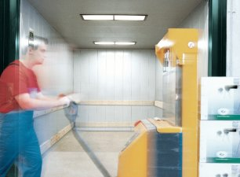

Freight elevators
Do you want to transport heavy freight and goods?
Let us help you find the elevator with the right load-bearing capacity to meet your requirements. We've installed freight elevators in warehouses, shopping centers, industrial plants and more.
We can help solve the complex transportation requirements with simple, flexible, durable, cost-effective products.

Special applications
Schindler offers a selection of standard features and finishes for passenger elevators. But sometimes something special is required.
When that is the case, Schindler can work with you to provide a custom elevator design limited only by your imagination.
Contact your local Schindler office for more information about our custom elevator capabilities.

Description
A dumbwaiter is a small freight elevator or lift intended to carry objects rather than people. Dumbwaiters found within modern structures, including both commercial, public and private buildings, are often connected between multiple floors. When installed in restaurants, schools, kindergartens, hospitals, retirement homes or in private homes, the lifts generally terminate in a kitchen.
A simple dumbwaiter is a movable frame in a shaft, dropped by a rope on a pulley, guided by rails; most dumbwaiters have a shaft, cart, and capacity smaller than those of passenger elevators, usually 45 to 450 kg (100 to 1000 lbs.) Before electric motors were added in the 1920s, dumbwaiters were controlled manually by ropes on pulleys.
STAGE LIFTS
For the world's most influential performers, no act is complete without stage lifts. They are essential for creating exciting effects and dramatic reveals by lifting artists, band gear, and props. Check out the large selection of All Access stage lifts.

5 Different Types Of Vehicle Lifts
Vehicle lifts come in a variety of designs, quality, styles and functionalities. Although they are all designed to lift cars above the ground, choosing the right type and style is of utmost importance. Vehicle lifts are however divided into two different categories, which is mainly centered at how they engage the vehicle. These include frame engaging car lifts and wheel engaging vehicle lifts. These come in additional subcategories based on the specialty e.g. portable lifts, scissor lifts, in-ground lifts or even parking lifts. Outlined below is a brief breakdown of several types of vehicle lifts for both business and home needs.
1. Two-post Car Lift: This is the most common frame engaging auto lift in both home garages and professional automotive shops. This lift uses on two incredibly sturdy posts with supportive stabilization arms that make it possible for the lift to hold and lift a wide variety of cars into position. Most people prefer this vehicle lift as it is not only affordable, but also a space saver providing unobstructed access to all the wheel. These are also available in two varieties; symmetrical and asymmetrical lifts.
2. Four-post Vehicle Lifts: This hydraulic vehicle column lift is specially designed to do all the heavy lifting. It is commonly used to lift vehicles with higher capacities such as trucks and other high-end cars. Most garages and shops use this type of lift because it is very user-friendly as all one needs to do is drive-on, and then park on the mounting. It is typically a wheel-engaging lift. One of the reasons why most homeowners and garages love the four-post vehicle lift is because it doesn’t require or need floor anchor to work. These lifts are also ideal for those who wish to store two vehicles in a limited space (meant for one vehicle only).
Effectiveness of Four-post Vehicle Lifts
3. Scissor Car Lift: Also known as the X-type car lift, this lift works by raising the payload using an accordion-like mechanism placed under the runway. Scissor car lifts engage the vehicle’s frame to lift it up though this may depend on the lift’s mechanism and raising rods. This type of lift can only handle medium capacity vehicles and not as strong as two post or four post vehicle lifts. It is mostly preferred by hobbyists and professional car garage shops.
4. Alignment Vehicle Lifts: These are specially designed car lifts mainly used for both lifting and wheel alignment needs. They can handle higher capacity vehicles ranging from cars to trucks, and were originally designed for dedicated hobbyists and automotive repair shops. This lift also comes with additional built-in features such as slip plates and special turn places on the runway hence providing an ample ground for alignment and turning without resistance.
5. Parking Lifts: This type of lift uses almost the same style and design as four-post lifts, only that it can handle or carry more vehicles. As the name suggests, parking lifts are specially designed for both private and public parking structures. One of the primary benefits of having this type of lift in your garage is that you can park a truck underneath a saloon car, and comes with a full drive-on deck. Although a great lift, it isn’t a viable option for repair and maintenance or automotive service.
Other types of lifts include portable car lifts that come in handy for those dealing with a limited space, as well as in-ground lifts that can be used to keep your car hidden within your garage’s floor. In-ground lifts use a special elevator to lift the car to the surface. This makes it easier for one to de-clutter his/her garage. When shopping and looking for the right company, or buying a new vehicle lift, it would be advisable to take a few of the factors outlined above in consideration before making the order. Usability is of utmost importance here.
PATERNOSTER LIFT
A paternoster or paternoster lift is a passenger elevator which consists of a chain of open compartments (each usually designed for two persons) that move slowly in a loop up and down inside a building without stopping. Passengers can step on or off at any floor they like. The same technique is also used for filing cabinets to store large amounts of (paper) documents or for small spare parts.^{[1]}The much smaller belt manlift which consists of an endless belt with steps and rungs but no compartments is also sometimes called a paternoster.
The construction of new paternosters was stopped in the mid-1970s due to safety concerns, but public sentiment has kept many of the remaining examples open.
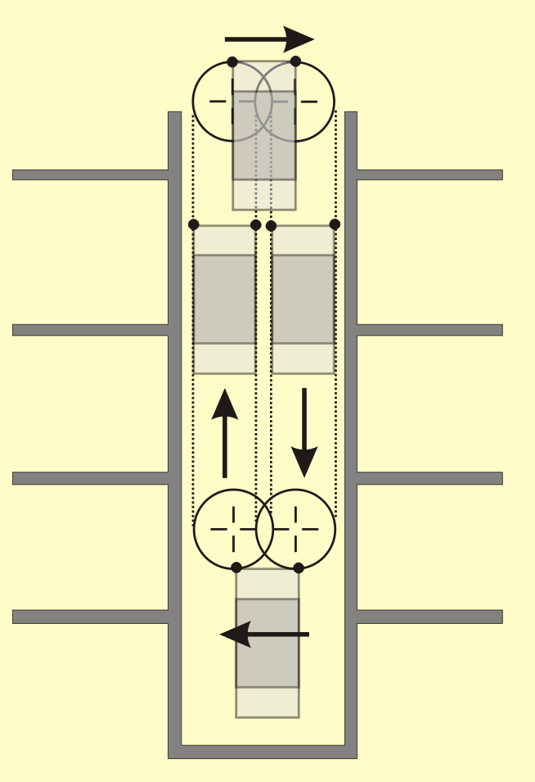

RACK AND PINION ELEVATOR
Our permanent rack and pinion elevators’ rugged construction provides safe, secure vertical transportation of personnel, with capacities ranging from 650 lbs. to 25,000 lbs. Flexible configurations provide customization to meet virtually any application requirement, while providing full safety features. Century Elevators’ rack and pinion lifts are used in all industries, including commercial construction, oil and gas, petro-chemical, shipyards, mining and tunnels, bridges and power generation industries.
The team of industry experts have the knowledge to design a safe, effective, economical lifting solution to move personnel. We specialize in rack and pinion lifts that are safe, easy to install and provide maximum operational effectiveness. Rack and pinion elevators are self-contained and install directly in an existing or emerging structure, making them ideal for industrial applications.
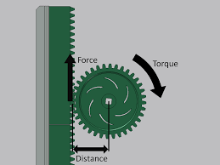
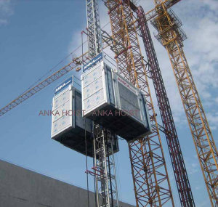

CONVEYER BELTS
It is easier, safer, faster, more efficient and cheaper to transport materials from one processing stage to another with the aid of material handling equipment devoid of manual handling. Handling of materials which is an important factor in manufacturing is an integral part of facilities design and the efficiency of material handling equipment add to the performance level of a firm . Conveyor systems are durable and reliable in materials transportation and warehousing. Based on different principles of operation, there are different conveyor systems namely: gravity, belt, screw, bucket, vibrating, pneumatic/hydraulic [2], chain, spiral, grain conveyor systems etc. The choice however depends on the volume to be transported, speed of transportation, size and weight of materials to be transported, height or distance of transportation, nature of material, method of production employed. Material handling equipment ranges from those that are operated manually to semi-automatic systems and to the ones with high degree of automation. The degree of automation however depends on handling requirements.
The design of a belt conveyor system takes into account the
followings:
i. Dimension, capacity and speed
ii. Roller diameter
iii. Belt power and tension
iv. Idler spacing
v. Pulley diameter
vi. Motor
vii. Type of drive unit
viii. Location and arrangement of pulley
ix. Control mode
x. Intended application
xi. Maximum loading capacity
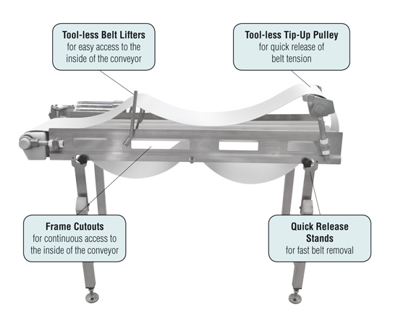
Refferences:
ihmhotelengineeringnotes.blogspot.com
ihmhotelengineeringnotes.blogspot.com
https://lecturenotes.in/m/21160-note-of-hotel-engineering-by-victor-agughasi
ihmkolkata.blogspot.com/2013/04/ihm-kolkata.html
Hotel Engineering - IHM PUSA
ihmpusa.net › wp-content › uploads › 2016/12 › Hotel-Engineering-0
https://www.newtondesk.com/refrigeration-and-air-conditioning-study-notes-hand-written/
en.wikipedia.org/wiki/
encyclopedia2.thefreedictionary.com
www.kopykitab.com/Engineering
www.faadooengineers.com/forums/112-Engineering-Ebooks.
Hotel Engineering Robert F eilliot
Hotel Engineering Tarun Bansal

