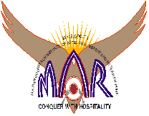
M. C. E. Society’s
M. A. RANGOONWALA INSTITUTE OF HOTEL MANAGEMENT & RESEARCH
2390 – B, K. B. Hidayatullah Road, Azam Campus, Camp, Pune – 411001.

Practical Journal
For
FOOD AND BEVERAGE SERVICE – I
Subject Code: HS 106
I Semester
Name :________________________________________________________________
Class:_______________________ Semester:_____________________________
Batch:_______________________ Year:________________________________
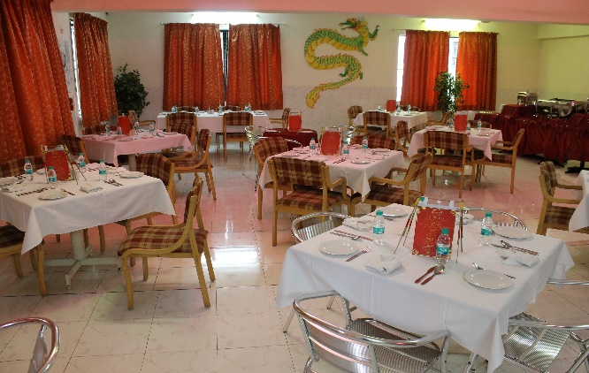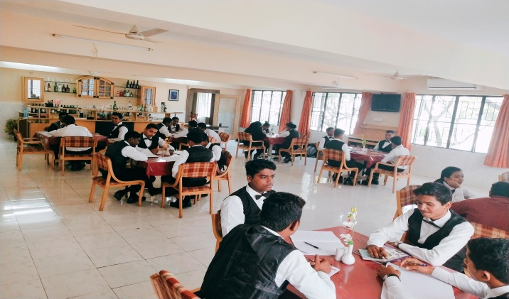
KUNAL SODHI
Assistant Professor
M. C. E. Society’s
M. A. RANGOONWALA INSTITUTE OF HOTEL MANAGEMENT & RESEARCH
2390 – B, K. B. Hidayatullah Road, Azam Campus, Camp, Pune – 411001
www.marhotelmanagement.com Phone no: 020-26442261/62

Certificate

This is to certify that Mr. / Ms. ________________________________________________ studying in F.Y. / S.Y. / T.Y. B.Sc. (HS), Bachelor of Science in Hospitality Studies has completed the course of practical in the subject _________________________________________________________________________________________ satisfactorily during the year 20____ - 20____

His/hers attendance and Performance is as follows:
Total no. of Practicals Conducted | No. of Practicals attended | Grade

Prof. Anita Frantz
Principal Lecturer In-charge Examiner

SUBJECT – FOOD & BEVERAGE SERVICE – I (PRACTICAL)
SUBJECT CODE-HS 106
SEMESTER - 1 BATCH:-________________
PRACTICALS INDEX
SR NO | PARTICULARS | PAGE No. | DATE | REMARKS | SIGNATURE
1 | Food and Beverage Service Attributes, Etiquettes
2 | Restaurant Hygiene Practices
3 | Identification of Equipment – Crockery, Cutlery
4 | Identification of Equipment – Serviceware, Glassware and Miscellaneous
5 | Mis-En-Place & Mis-En-Scene – Organization of Sideboard
6 | Laying & Relaying of Table Cloth
7 | Laying of cover - Table d’hôtel & A La Carte cover
8 | Points to be remembered while setting a cover and during service.
9 | Napkin Folds
10 | Service of Water
11 | Technical Skills - Carrying a Salver /Tray
12 | Carrying Plates, Glasses & Other Equipment
13 | Handling the Service Gear
14 | Clearing, Crumbing, Presenting the Bill
15 | Continental Breakfast – Menu Planning, Setup and Service
16 | American Breakfast – Menu Planning, Setup and Service
17 | English Breakfast – Menu Planning, Setup and Service
18 | Indian Breakfast – Menu Planning, Setup and Service

Practical 1:- Food and Beverage Service Attributes, Etiquettes

Objective:-The increase in demand of guest eating outside the home and to meet this demand there is an increasing diversity in the nature and type of food & beverage on offer. The Food & Beverage service is the essential link between customers and the menu beverages and other services on offer in a hotel/restaurant.

The server is the main point of contact between the customers and the establishment and plays an important role in the profession increasing the level of customer’s satisfaction.

The following are the Basic Etiquettes the Server should adhere to at all times:
- Attend to guests as soon as they enter the restaurant.
- Assist guests to remove warm, heavy coast in winter and help put them when they leave.
- Wish guests the time of the day and welcome them to the restaurant using the correct verbiage.
- Preferably address them by their name, which requires remembering them
- Be polite to guests and escort them to the assigned table
- Help to seat ladies.
- Provide extra cushions or special chairs for children.
- When speaking to guests, do not interrupt him if he is speaking to another guest.
- Do not overhear conversation
- Avoid mannerisms such as touching hair or nose picking.
- Stand erect at all times. A gentle bow at the time of service is permissible.
- Remember a guest's special dish and remind them that you know it ascertain whether he would like to order it again.
- Be attentive to guest calls ,Talk softly
- Strike a match to enable a guest to light his cigarette
- Avoid arguing with service staff and guest in the restaurant.
- Carry pen ,note pad and KOT book in the pockets and not behind ears or clipped in front of the Jacket
- Do not chew gum or beetle nut.
- Pre-set the bill/ check to the host discreetly in order to avoid embarrassing him.
- Avoid soliciting for tips. Remove tips after the guest has left.
- Thank the guest for coming.
- Enter and leave the restaurant through the service door only.

Conclusion:-______________________________________________________________________________________________________________________________________________________

Sign Of Student:_______________ Sign Of Faculty:_________________

Date: ________________________

Practical 2:- Restaurant Hygiene Practices

Objective: Neatness, cleanliness and maintaining hygiene of the space is expected in every hospitality establishment. Each person working with food must maintain a high degree of cleanliness and a tidy external appearance. Personal hygiene in restaurants is extremely important in order to maintain food health standards. Appearance and behavior contribute to the first impression others have of you and are seen as a reflection of the hygiene standards of the standards of the establishment and the quality of service to come.

Professional and hygienic appearance:
- Staff should be clean and should use deodorants.
- Aftershave and perfumes should not be too strong
- Sufficient sleep .an adequate and healthy intake of food and regular exercise is essential for good health and the ability to cope with the pressures and stress of work.
- Particular attention should be paid to the hands. They must always be clean, free of nicotine stains and with clean, well-trimmed nails.
- Teeth should be brushed before coming on duty and the breath should be fresh smelling.
- Men should normally be clean shaven or with any moustache neatly trimmed.
- Women should only wear light make up .if nail varnish is worn then it should be clear.
- Earrings should not be worn with the possible exception of studs.
- Uniform must be clean, starched as appropriate and pressed. All buttons must be present.
- Hair must be clean and well groomed .Long hair must be tied up or back to avoid hair falling into foods and drinks and to avoid repeated handling of the hair.
- Shoes must be comfortable and clean and plain, neat design .Fashion is not as important here as safety and foot comfort.
- Cuts and burns should be covered with waterproof dressings.
- Any colds or other possible infections should be reported immediately,
- Hands should be washed immediately after using the toilet.
- Staff should try to avoid any mannerisms they may have such as running their fingers through their hair, chewing gum or scratching their face.
- Excessive jewellery should not be worn. The establishment policy should be followed.

Conclusion:-_______________________________________________________________________

_______________________________________________________________________

_______________________________________________________________________

Sign Of Student:_______________ Sign Of Faculty:__________________

Date:________________________

Practical 3:-Identification of Equipments – Cutlery and Crockery

Objective: To identify the various equipments used in the Food & Beverage Service Departments according to the classifications and size and purpose of each.

Introduction :-The operating equipments used in hotels / restaurants play an important role in attracting customers. The restaurant operating equipments include Tableware(Cutlery, Flatware, Hollowware ),Crockery, Glassware, Furniture and Linen all of which squarely reflects the standard and style of the restaurant.

TABLEWARE:-

These includes all items of flatware ,cutlery and hollow-ware and are classified as follows:-Cutlery, Flatware, Hollow-ware.
- Cutlery-
- Dinner Knife

Dinner knife is sized between 9 ½ and 10 inches.
- Fish knife
Fish knife is used when fish is served for dinner. Fish knife measures 8 ¾ inches with a wide blade and dull edge. The tip of fish knife aids in separating layers of fish and lift bones.
- Butter knife
Small in size at 5 to 6 inches, butter knife has a rounded point so that it does not scrape the bread while spreading butter.
- Flatware-Denotes all forms of spoon and fork

Spoons: There are different types of spoon for specific tasks.
- Teaspoon: It is meant for stirring coffee, tea, soups and eating.
- Service spoon: A tablespoon is bigger than a teaspoon and is used for serving food from serving bowls.
- Dinner Spoon/All Purpose spoon: It is an all-purpose spoon bigger than a teaspoon but smaller than a tablespoon.
- Soup spoon: A large rounded spoon used for eating soup.
- Dessert spoon: It is used for eating sweet dishes and puddings.
- Sundae spoon: Long spoons to reach the bottom of sundae glass and eat liquid or semi-liquid food like ice-cream toppings, floats, jelly etc.
- Fruit spoon: Fruit spoon has an elongated bowl and a pointed tip that aids in cutting fruit and eating fruits like grapes, oranges and melons.

Forks:

Dinner fork/ All Purpose Fork : Meant for the main course, dinner fork measures around seven inches.
- Dessert fork: It is used for eating cake, pies and pastries. It is more or less similar to salad fork.
- Fish fork: It is used for holding and eating fish. Tines are uniform in width and length.
Picture of Tableware’s:-

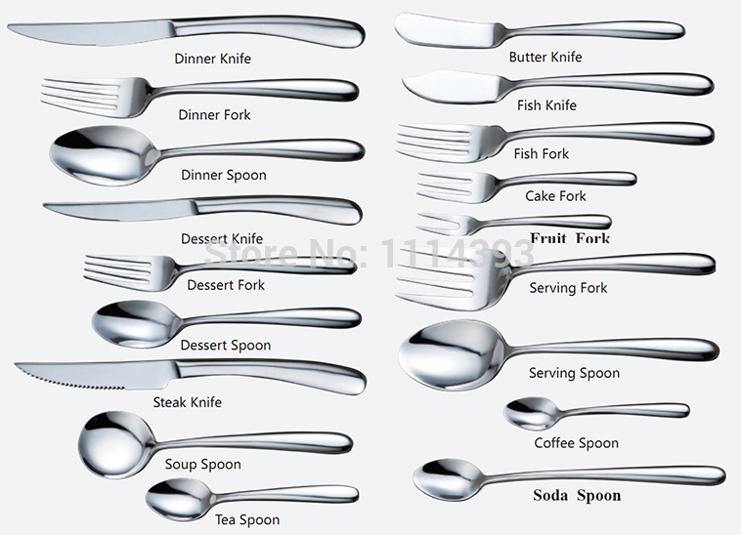

- Hollowware:-

Hollowware (hollowware, or hollow-ware) is metal tableware such as sugar bowls, creamers, coffee pots, teapots, soup tureens, hot food covers, water jugs, platters, butter dishes, and other items that go with the dishware on a table. It does not include cutlery or other metal utensils.

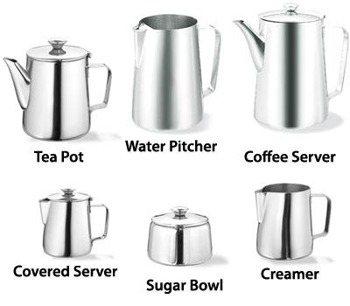
Types Of Hollow-ware:-

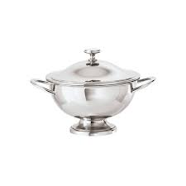

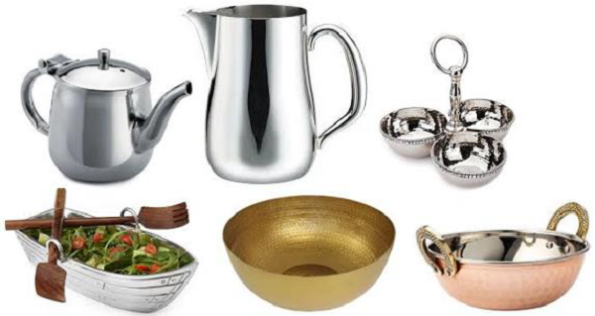
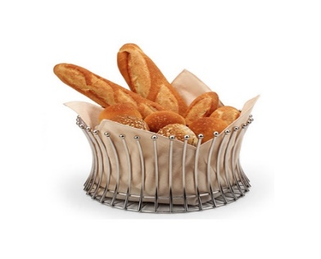

CROCKERY (china ware)

Chinaware is a term used for crockery whether bone china (expensive and fine), earthenware (opaque and cheaper), porcelain or vitrified (metalized), stone ware (vitrified). Most catering crockery used nowadays tends to be vitrified earthenware, which is very durable and have been strengthened. Crockery is also usually given rolled edges to make it more chip resistant

Chinaware is made of silica, soda ash, and china clay, glazed to give a fine finish. Chinaware can be found in different colours and designs which are always coated with glaze. Chinaware is more resistant to heat than glassware. There are various classification of catering china. They are:
Porcelain: Porcelain is a ceramic material made by heating selected and refined materials.
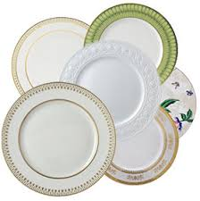
Porcelain Chinaware

Bone China: Bone china is porcelain made of clay mixed with bone ash. This is very fine, hard china that is very expensive. The decorations are to be found under the glaze only. The price of bone china puts it out of reach of the majority of everyday caterers, and only a few of the top class hotels and restaurants would use it. The range of design, pattern and colour is very wide and there is something to suit all occasions and situations.
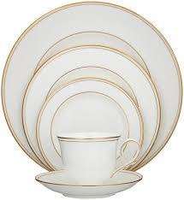
Bone Chinaware

Earthenware: Earthenware may sometimes be as thin as bone china and other porcelains, though it is not translucent and is more easily chipped. Earthenware is also less strong, less tough, and more porous than stoneware.
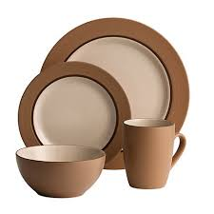
Earthenware

Stoneware: Stoneware is a hard pottery made from siliceous paste, fired at high temperature to vitrify (make glassy) the body. Stoneware is heavier and more opaque than porcelain. The usual color of fired stoneware tends to be grayish, though there may be a wide range of colors, depending on the clay. It has been produced in China since ancient times and is the forerunner of Chinese porcelain.
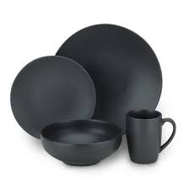
Stoneware

DIFFERENT TYPES OF CROCKERY AND THEIR SIZES
- Soup plate: - 20 cms in diameter and used for the service of thick soups.
- B and B plate (Side plate):- 15 cms in diameter use for the service of bread and butter.
- Fish plate: - 20 cms in diameter used for service of fish items.
- Dessert plate (Sweet plate):- 18 cms in diameter and used for the service of desserts.
- Meat plate (Joint plate / dinner plate / main course plate):- 25 cms in diameter and used for the service of main courses only.
- Cereal Bowl: - 13 cms in diameter used for the service of cereals (cornflakes, wheat flakes, Choco flakes, etc.), puddings, compotes.
- Cheese plate: - 16 cms in diameter used for the service of cheese and biscuits.
- Consommé cup: - Used for the service of thin soups only.
- Coffee cup: - It has a capacity of 10 cl and is used for the service of black coffee only. It is also referred to as a demi – tasse cup. 31/2 oz.
- Tea cup :- 19 cl capacity used for the service of tea and coffee

Conclusion:-____________________________________________________________

______________________________________________________________________

______________________________________________________________________

Sign Of Student:_______________ Sign Of Faculty:__________________

Date: ________________________

PRACTICAL 4:- Identification of Equipment – Serviceware, Glassware and Miscellaneous
1. Pony Tumbler / Juice glass: - This is a small glass used sometimes for the service of small juices. 4 ounce glass
2. High Ball Glass: - It is the most commonly used glass in a bar. They are long and straight sided. They can range from 14 – 30 cl. But 24 cl is the most commonly used.
3. Tom Collins: - They are tall and thin and usually have a capacity of 12 ounce / 36 cl.
4. Old fashioned Glass: - These are used to serve “spirits on the Rocks” ( served on cube ice). They range from 14 – 25 cl and the most commonly used is 17 cl.
5. Liqueur Glass:-They are having a capacity of 2 – 3 cl.
6. Pilsner Glass: - They are glasses which are used to serve Pilsners. It holds approximately 34 cl.
7. Beer Tankard: - These glasses are most commonly used for the service of Draft beers. It has a capacity of around 34 cl.
8. Sherry Glass: - This is a glass to serve sherry ( a fortified wine ) and has a capacity of 7 cl.
9. Brandy Balloon: - Always has the same shape with a short stem so that the hand can heat the glass and allow the brandy / cognac to heat up and release its aroma.
10. Champagne saucer / Champagne tulip /Champagne Flute:- It is the glass which is used for the service of Champagne.
11. Red wine Glass:-It has got the capacity of 22 cl and the red wine is served only half the glass. The tulip shaped glass holds the aroma.
12. White wine Glass: - This is used for the service of white wine and has the capacity of 17 cl.
13. Decanter: - This is used to carry mixes or can be used as a wine carafe.
14. Martini Glass: It has a capacity to serve 22cl used to serve Martini Cocktail.
15. Margarita Glass: It has a capacity to serve 22 cl used to serve Margarita Cocktail.

LINENS:-
BAIZE CLOTH- In fine dining restaurants tables are permanently covered with thick woollen cloth or felt which is termed as “baize”. The purpose of baize is to 1. Deaden the noise of cutlery and crockery while placing them on the table.
2. Protect table top from heat from the dish.
3. Give grip to the table cloth and to prevent it from slipping.
4. Protect the wrist of the customer while dining.
5. Also acts as cushion for customer. Baize should never be exposed to the guest it must always be covered with a clean table cloth.

TABLECLOTHS:-
137 cm X 137 cm (54 in X 54 in) to fit a table 76 cm (2 ft. 6 in) square or a round table 1 m (3 ft.) in diameter
183 cm X 183 cm (72 in X 72 in)to fit a table 1 m (3 ft.) square
183 cm X 244 cm (72 in X 96in)to fit rectangular shaped tables
183 cm X 137 cm (72 in X 54in)to fit rectangular shaped tables

SLIPCLOTH:-
1 m X 1 m (3 ft. X 3 ft.) used to cover a tablecloth

SERVIETTE:-
46-50 cm (16-18 in) square if linen

FURNITURE (TABLES AND CHAIRS):-

TABLES-Normally three types of tables are used. They are round, rectangular and square .
The height of the table irrespective of the shape should be 75 cm from the floor level. The diameter of a round table to seat four people should be approximately 92 cm. The size of a square table to seat two people should 76 cm sq and 92 cm square to seat four people. The size of rectangular table to seat four people should be 137 cm x 76 cm. Commercial table tops come in a variety of materials: wood, metal, stone, tile and melamine.

CHAIRS- The dimension of chairs should be relative to table dimensions. The average height of the chair should be 92 cm. The seat should be 46 cm from the floor and 23 cm from the top of the table. This would enable guests to sit and eat comfortably, without their legs touching the underside of the table.
SIDE STATION / DUMMY WAITER- The side station is also called the dummy waiter or service console. This is a very important piece of furniture in a restaurant. It is used by the service staff for keeping all the service equipment at one place. For the convenience of the service staff, the side station should be strategically located in a restaurant. The side station should be kept clean and presentable as it can be seen by the guests. The following service equipment can be stored in a side Station :-

Salvers
Creamers
Wine chiller and stand
Coffee pots Teapots
Ice buckets and tongs
Finger bowls
Sugar bowl and tongs Soup ladles
Butter dishes
Bread baskets
Toothpick stand

SPECIAL EQUIPMENTS:-
1.Asparagus Holder - The asparagus holder is an utensil for a diner to hold a single stalk of asparagus. It is made of a single strip of metal, bent in the form of U-shaped tongs, with a small square plate at each end to grip the stalk.
2. Pastry Slicer - Pastry slicer is used for serving pastries (portion of gateaux)
3. Oyster Fork- A fork used for picking up shellfish cocktail or oysters. This fork is shaped like a regular fork, but it slightly smaller and the tines are curved outward.
4. Lobster Pick -This long, narrow utensil is used to pull every shred of meat from the hard-to-reach cavities (such as the legs) of lobsters and crabs. The tip of a lobster pick can either be pointed or in the shape of a tiny, two-prong fork.
5. Snail Tong and Snail Fork - Small, spring-operated tongs used to hold hot snail shells while extracting the snail. Unlike most tongs, these open by squeezing the handles. When the pressure is released, the tongs snap securely around the snail shell.
6. Snail Dish- It is a round dish with two ears having six indentations to hold portion of six snails.
7. Nutcracker - It is a tool for cracking hard nutshells, usually consisting of two hinged metal arms between which the nut is squeezed.
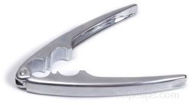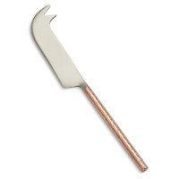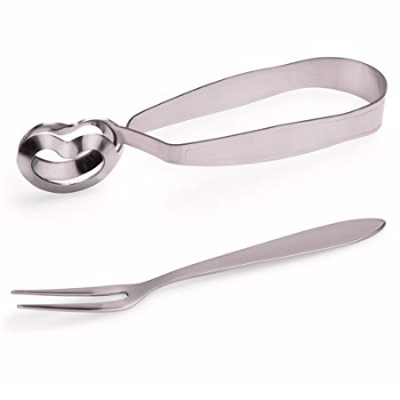

LOBSTER CRACKER CHEESE KNIFE SNAIL TONGS

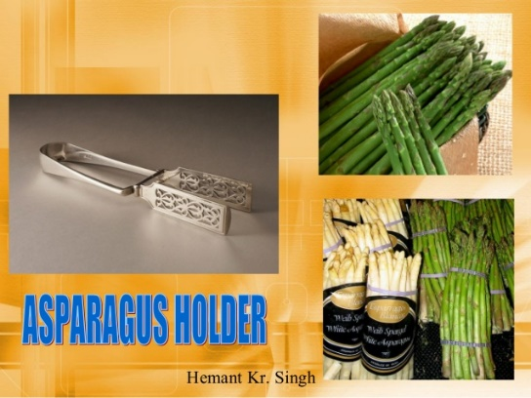

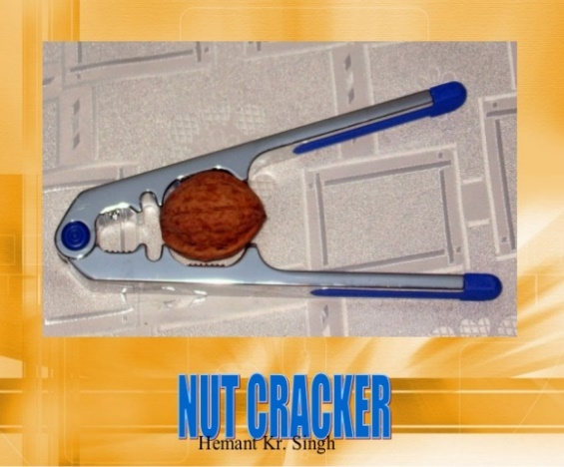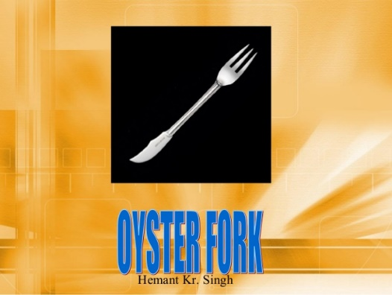

Conclusion:-____________________________________________________________

______________________________________________________________________

______________________________________________________________________

Sign of Student: _______________ Sign Of Faculty: __________________

Date:________________________

Practical 5:-Mis-En-Place & Mis-En-Scene – Organisation of Sideboard

Objective: To understand the importance of both the French terms in relation to the Food & Beverage Service Department.
Definitions:-
Mise-en-scene: Mise-en-scene means prepare the environment of the outlet before service. Mise-en-scene includes preparing the restaurant welcoming, create ambience with regard to cleanliness, furniture setting and temperature.
Mise-en-place: Mise-en-place means “putting in place” and the term denotes to the preparation of a work place for ultimate smooth service. To ensure that the restaurant is ready for service the waiter makes sure that this station has been efficiently prepared for service.

MISE-EN-PLACE:

Mise en place is a French term that literally means, “setting in place.”
Mise-en-Place means preparing the Restaurant prior to service.
Basically, “Mise-en-Place refers to prepare the restaurant or F&B department properly to serve the guest and clients. In order to ensure service and is as smooth as possible”.
This preparation will vary from Restaurant to Restaurant.
Preparing service area is one of the very important parts of Mise-en-Place. To serve any guest, you must have to prepare your service area properly.
However, to prepare your service area you must have to do some work. Like choosing, you service area, cleaning your all equipment, cleaning all useful place, fix table layout etc.

Things to do for Mis-En-Place:-

SERVICE STAFFS AND MISE EN PLACE:
• Prepare the Mise-en-place for chinaware as trained.
• Pick up the washed chinaware from the shelves located at the dish-washing area and deliver them to the polishing area.
• Prepare hot water in a stainless steel pot, and polish every item, using a chinaware towel.
• Deliver the polished chinaware to the service station using trays.

GLASSWARE FOR MISE EN PLACE:
• Pick up the washed glassware from the shelves located at the dish washing area, deliver them to the polishing area by using glass racks.
• Prepare hot water in a stainless steel pot, steam the glasses in/over hot water and polish them using glass towels.
• Check the glasses for chips, scratches, lipstick marks, etc.
• Hold the glass by the stem or base with a polishing towel after it has been polished.
• Deliver the polished gasses to the service station using the appropriate trays.
For flatware polishing, i.e., forks, knives, spoons, etc. :
• Pick up the washed flatware from the dish-washing area, and deliver the items to the polishing area using trays or racks
• Prepare hot water in a stainless steel pot, put the flatware into the hot water before polishing and polish using a silverware towel
• Check the flatware for any damage, bends or scratches.
• Hold with a cleaning towel after polishing, and deliver to the service station suing the appropriate trays.
• Make sure all flatware is stacked neatly in the assigned service station drawers.

CONDIMENTS AND SAUCE BOTTLE FOR MISE EN PLACE:
• Collect all the Sauce bottles and transfer the contents from bottle to bottle until full but do not mix brands.
• Wipe the top with a wet cloth and the entire bottle if dirty.
• Prepare hot water in a stainless steel pot; put all the sauce bottle caps into hot water for about 10 minutes. Take out the caps and wipe them with a clean wet cloth and polish them with a dry towel.
• Deliver the bottles to the service station after cleaning.
Salt and pepper set (cruet set):
• Collect all salt and pepper containers in one place, remove the caps and clean the exterior of the containers.
• Refill with new salt or pepper until 90 % full. No salt or pepper containers shall have less than half of its capacity.
• Wipe and polish the tops and caps (check that holes are clear on the caps), and deliver them to the service station after cleaning.

MISE EN PLACE AND NAPKIN FOLDING:
• Pick up fresh napkins from the linen room during the authorized hours, twice a day.
• Fold the napkins in a designated shape according to the Manager’s or Supervisor’s instructions.
• Deliver to the service station after folding.
MISE EN PLACE and side stations
Fill up the service station and bring the following items according to the established par stock :
1. Water goblets
2. Service trays
3. Coffee cups
4. Ashtrays
5. Salt and pepper sets
6. Toothpick holders
7. Flatware
8. Matches
9. Table cloths
10. Sauce bottles
11. Sugar bowls
12. Water Pitchers
13. Fill up the ice container.

MISE-EN-SCENE
Mise-en-scene, the French term means to prepare the environment of the outlet before service in order to make it pleasant, comfortable, safe and hygienic. Before each service session, the restaurant should be made presentable enough to receive the guests. The supervisor or team of waiters should ensure the following Mise-en-scene:
· Carpets are well brushed or hovered.
· All tables and chairs are serviceable.
· Table lights or wall lights have functioning bulbs.
· Menu cards are presentable and attractive.
· Tent carts or other sales material are presentable.
· Doors and windows are thrown open for some time to air the restaurant. This should be
followed by closing the windows and doors and setting the air-conditioning or heating to a
comfortable temperature.
· Exchange dirty linen for fresh linen.
· Table cloths and mats are laid on the tables.
· Replace wilted flowers with fresh flowers.

Mise-en-scene refers to a restaurant, whether a hotel's restaurant or self-contained, and refers to preparing the environment before service in order to make it aesthetically pleasant, and functional. So, this encompasses making sure all light bulbs work, to the layout of the table and the style of décor.

Conclusion:-____________________________________________________________

______________________________________________________________________

______________________________________________________________________

Sign Of Student:_______________ Sign Of Faculty:__________________

Date:________________________

Practical 6:- Laying and Re-laying of Table Cloth (Square)

Objective: To learn the method of laying a table cloth.

Material Required:-Table Cloth, Duster & Table.

Note:-

1) Make sure that the table cloth is starched and free from stains.

2) It should be as per the shape of the table.

3) Size of Table cloth

183 cm X 183 cm (72 in X 72 in) to fit a table 1 m (3 ft) square

183 cm X 244 cm (72 in X 96 in) to fit rectangular shaped tables

Procedure:-

1. Check that the table is correctly positioned and firm.(not wobbling)

2. Make sure the table is clean and free from dust and dirt (clean if necessary)

3. Ensure that moulton is placed on the table.

4. Choose the correct size of the table cloth as per the table.

5. Stand centrally between two legs of the table

6. Place the folded cloth on the table with the open edges towards you and the main folds facing away from you.

7. Open the cloth across the table so that its woven sides (the shelved edges) and its inside double fold facing away from you .

8. With thumbs uppermost, take the top flap of the cloth into your thumb and first finger and take the central fold between the first and second finger.

9. With the arms stretched out the width of the table move the cloth to the far edge of the table away from you.

10. Release and drop the bottom flat (which is laying loose) over the far edge of the table.

11. Allowing the rest of the cloth to lie on the table release your hold on the centre fold and gently unfold the cloth drawing it across the table towards you until the tablecloth is spread and the table is covered.

12. Inspect to see that drop is even all round and the cloth corners drape the legs.

13. To adjust the cloth, stand squarely between the table legs and arms out stretched.

14. The chairs should then be placed in their correct position.

Re- Laying Of Table Cloth (Square)

Objective:-To learn the method of relaying the table cloth when guest are present at the table.

Material Required: Clean table cloth, Duster, Soiled Table cloth and Table.

Note:-While relaying the table cloth the table should not be shown to the guest.

Method:-
- Select the correct size of the table cloth.
- Stand as for laying a cloth.
- Place the new cloth on the far side of the table in the same way as for laying a cloth.
- Open the new cloth and hold it as previously described.
- Stretching across the table, hold the loose flap of the loose cloth clear of the far edge of the table.
- Release the lower flap and release the double fold held between the thumb and first finger .This allows the cloth to fall lightly(usually on the chair on the far side)
- Without relinquishing hold off the clean one, pinch the soiled cloth at the outer edge of the table between the palm and finger to pick it up.
- Draw the soiled cloth towards you , gently shaking the clean cloth over the table.
- Inspect the clean cloth foe correct drop and alignment.
- Place the soiled cloth away in the dirty linen receptacle.

Conclusion:-____________________________________________________________________________________________________________________________________________________________

Sign Of Student:_______________ Sign Of Faculty:______________________

Date:-________________

Practical 7:- Laying of cover Table d’hôtel & A la Carte Covers (2 covers)

Objective: - To learn the correct method of laying Table d’hôtel covers.

Material Required:-
- Furniture (table and two chairs)
- Linen (table cloth, two serviette ,and a salver)
- Crockery: Side Plates(2),a full plate (for measuring the size of the cover and alignment of the cover )
- Cutlery ;Soup spoons(2),Fish knives/forks(2),Large Knives/forks(2),side knives(2),Dessert spoon/forks(2).
- Glassware :Hi-Ball (2)
- Table Accompaniments: Salt/Pepper (cruet set), flower vase, menu stand/table number.

Note: No ashtray is set on the table.

Method:-
- Place the dinner plate on the table in inverted position right at the centre of the cover to get the size of the cover.
- Place the side plate on the left hand side of the dinner plate.
- All spoons and knives are to the right hand side and forks to the left hand side of the dinner plate.
- All cutleries are now arranged properly and should be kept ½ ̋away from the table edge.
- Sequence of cutlery should start outside towards inside.
- Example starting on the right hand side soup spoon, fish knife and large knife.
- On the left hand side fish fork and large fork followed by side knife on the top left side of the side plate.
- The cutting edges of the knives should face inside or the left hand side of the cover.
- The Dessert indicators i.e. Dessert spoon and Dessert fork is placed on the top of the dinner plate.
- Dessert spoon is on the top with handle towards right and fork below the dessert spoon with handle towards left.
- The Hi-ball is placed on the tip of the first knife or large knife on the right hand side.
- After the cutleries and glass is placed and aligned on the cover, remove the Dinner Plate and place a neatly folded clean serviette in the centre of the cover.

Objective: - To learn the correct method of laying a la carte covers. (2 Covers)

Materials required:-

1. Furniture: Table and 2 chairs.

2. Cutlery: AP knives (2),AP Forks(2),Side knives(2) Dessert Spoon (2).

3. Crockery: Side Plates (2), Full Plate (1).

4. Glassware: Hi-Ball glass (2)

5. Table Accompaniments: Salt & Pepper set (Cruet Set), Flower Vase, menu stand/table number.

Note: No ashtray is set on the table.

There are 4 different ways of laying “a la carte” cover; the type of cover laid in the restaurant depends upon:
- Availability of cutlery
- Exclusiveness of the restaurant
- Availability of time
- The dishes of the menu

Method:-

1. Same as laying a cover for “Table d’hôtel”

a. All knives and spoons are kept on right hand side and fork to the left.

b. All cutleries should be kept ½ ̋ away from the table.

c. Sequence of cutlery should start outside towards inside.

A) The cover consists of:-

1. Soup spoon 2.Fisk Knife 3.Large Knife 4.Side Knife

5. Fish Fork 6.Large fork 7.Hi-Ball glass 8. Table number

9. Cruet Set 10.Flower vase 11.Dessert spoon 12.Dessert Fork.

B) The cover consists of:-

1. Soup Spoon 2.Large knife 3.Large Fork 4.Side Knife

5. Side Plate 6.Dessert Spoon 7.Dessert Fork 8.Hi-Ball glass

9. Table number 10.Cruet set 11.Flower vase

C) The cover consists of:-

1. Large knife 2.Large Fork 3.Side Knife 4.Side plate

5. Dessert spoon 6.Dessert Fork 7.Table number 8.Cruet Set

9. Flower vase.

D) The consists of:-

1. Large Knife 2.Large Fork 3.Side Plate 4.Cruet set

5. Flower vase 6.Hi-Ball

Conclusion:- ________________________________________________________________________________________________________________________________________________

Sign Of Student:_______________ Sign Of Faculty:______________________

Date:-_______________________

Practical 8:- Points to be remembered while setting a cover and during service.
Objective: - To learn how to set up a cover.

Materials required:-

1. Furniture: Table and 2 chairs.

2. Cutlery: AP knife, AP Fork, Side knife, Dessert Spoon.

3. Crockery: Side Plate, Full Plate.

4. Glassware: Hi-Ball glass.

5. Table Accompaniments: Salt & Pepper set (Cruet Set), Flower Vase, menu stand/table number.
Points:-
- Set the table in position and it should not wobble. The table and chairs are clean.
- The table should have a baize cloth, the tablecloth should be placed with the proper procedure and it should have a fall of 9” below the edge of the table from the sides. The height of the table should be 30” and chair should be 18” in height up to seat.
- Place the centre piece ABC (Ashtray, Budvase & Cruet Set) at the centre of the table top.
- Place a full plate in the centre of the edge of the table where the cutleries are to be placed. Place the required cutlery which is polished, the sequence for the soup spoons, forks & knives are from outside to inside from the right hand side, the forks are placed on the left. This is called a Cover which is 24” in length and 18”in breadth. All the cutleries should be ½ “from the edge of the table. The cutting edge of the knife should be facing the left of the cover.
- The Dessert Cutlery Dessert Spoon and Fork is placed on the top of the plate where the dessert spoon is placed on the top with the handle facing on the right side and the dessert fork below the dessert spoon with the handle facing the left side.
- Place the side plate on the left of the cover with the side knife on the top right side of the side plate. The cutting edge of the knife should be facing to the left side.
- The Hi-ball glass must be placed at the tip of the first knife.
- Not more than 3-4 knives, forks are to be lay down at the time on the table.
- Remove the full plate from the cover.
- Place the serviettes in the centre of the cover.

Conclusion:-________________________________________________________________________________________________________________________________________________

Sign Of Student:_______________ Sign Of Faculty:______________________

Date:-_______________________

Practical 9:-Napkin Folds

Objective: -To learn the different Napkins folds.

There are many forms of serviette /napkin fold in use in the food and beverage service area. Some are intricate in detail while others are simpler. The simpler folds are used in everyday service and some of the more complex and difficult folds may only be used on special occasions such as luncheons, dinners and weddings.

There are three main reasons why the simple folds are better than more complex ones.

1. The serviette, if folded correctly can look good and add to the general appearance of the room whether simple or complex fold is.

2. A simpler fold is perhaps more hygienic as the more complex fold involves greater handling to complete. In addition its appearance when unfolded to spread over the guests lap, is poor as it often has many creases.

3. The complex fold takes much more time to complete properly than a very simple fold.

Many of the napkin folds have special names like:

- Cone
- Bishops mitre
- Rose
- Cockscomb/Birds of Paradise
- Triple Wave
- Fan
- Candle

These are simpler folds that may be completed more quickly requiring less handling and are more hygienic.

The Serviettes must be clean and well starched.

Conclusion:-____________________________________________________________________________________________________________________________________________________________

Sign Of Student:_______________ Sign Of Faculty:______________________

Date:-_______________________

Practical 10:- Service of Water
Objective: To learn the technique involved in the service of water .
Method:
1. Fill the water jug with chilled water and one with room temperature.
2. Take the order from the guest for regular water or mineral water.
3. Ask the guest whether the water ordered is required chilled or at room temperature.
4. Take a serviette, place the jug on the serviette and approach the guest from the right hand side, put the right leg forward and pour the water gently into the water glass.
5. Lift the jug when the level of water is 1” below the rim and place the jug back on the serviette and proceed in the similar manner around the table clockwise to the next guest and repeat the procedure in the similar manner around the table clockwise to the next guest and repeat the procedure . Serve the host last.
6. If mineral water or bottled water is ordered then take the sealed bottle on the serviette approach from the right hand side of the guest present the bottle announce the name of the brand of the bottle, open the seal of the bottle and put your right leg forward and pour the water gently into the glass till the water level is 1”below the rim.
7. The types of bottled water are:
a. Packaged drinking water- Bisleri, Aqua fina , Oxyrich.
b. Mineral water –Qua, Evian, Apollinaries.
c. Sparkling mineral water- Perrier, San Pellegrino, Vittel Vichy.
Notes:-
1. Service is always from the right hand side of the guest.
2. While pouring the water wait for the last drop of water to fall before removing the jug/bottle.
3. If the water spills on the table, use the serviette to damp the water from the table cloth.

Conclusion:-____________________________________________________________________________________________________________________________________________________________

______________________________________________________________________________

Sign Of Student:_______________ Sign Of Faculty:______________________

Date:-_______________________
Practical 11:-Carrying a Salver/Tray.
Objective: To learn the correct method and purpose of carrying the tray.
Points to consider: A service tray/salver consists of round silver with a serviette set on it. It may be used in a number of ways during the actual meal service.
- Carrying clean glasses and removing dirty glasses from a table.
- Removing clean cutlery, flatware from the table.
- Placing clean cutlery, flatware on the table.
- Placing coffee services on the table.
- Clearing side plates and side knives.
- Use as an under flat when silver serving vegetables

- When carrying clean glasses they should be placed upside down on the service salver .This reduces the risk of dust etc. getting in the glasses. When being placed on the table the waiter should hold the stem and place the glass at the top right hand corner of the cover and the correct way up. This ensures that the bowl of the wine glass is not touched which is most important when a wine is being served.
- When removing from or placing clean cutlery and flatware on a table they should be carried on a service salver. The blades of the knives to be placed under the arch in the middle of the fork and if carrying dessert spoons and forks the prongs of the fork to go under the arch in the middle of the spoon. The reason for this is to help to hold the items steady on the service salver, bearing in mind that the handles of the cutlery and flatware are generally the heaviest part ant this method prevents them sliding about too much.
- When clearing dirty side plates and side knives after the main course has been consumed by taking a service salver to the table the waiter has a large area on which t stack one upon the other with all the debris in a separate pile and the side knives laid flat upon the service salver. This is much safer and speedier method espeically when large numbers are involved.
- When coffee services to a table the coffee saucers, the demi tasse cup and all coffee spoons laid flat on the service salver. When the waiter is at the table the coffee service is placed down from the right hand side having first set a demitasse cup on a cup from the right hand side.
- When the silver serving vegetables and potatoes at the table an under flat should be used to hold either on large vegetable and potatoes at the table an under flat should be used to hold either one large vegetable dish or a number of smaller ones depending on the guests order giving the dish a good presentation and protecting the server against heat and possible spillage on to the table

Conclusion:-_______________________________________________________________________________________________________________________________________________________________________________________________________________________________________________________________________________________________________________________________________________________________________________________

Sign of Student:_______________ Sign of Faculty:______________________

Date:-_______________________

Practical 12: Carrying Plates, Glasses and Other Equipments.
Objective: To show the procedure of carrying plates for service and clearance, glasses and other equipments.
Points to remember: Service Standard.
If the main course is plated-
- Collect the main course dish on a full plate(hot) from the kitchen and place it from the right hand side(the plate will have mat, potatoes , vegetables arranged in the kitchen)
- Place the plate from the right hand side in such a way that the meat is closer to the guest at 6’o clock position on the plate and the potatoes at 2’o clock position
- Move clockwise to the next guest. Serve the host last.
If the main course is served-
- Carry the pile of plates as per the number of covers on the left palm over a serviette to the table.
- Place the empty(hot) plate from the right hand side using the waiter cloth.
- Move clockwise to the next guest till you place the plate last to the host.
- Serve the main course (meat) from left hand side on the plate at 6’o clock on the plate followed by the potatoes at 2’o clock and vegetables at 12’o clock position. The sauce is served from the left on the meat from the left hand side.
Clearance standard of plates:
- Do use salver or tray to clear the plates. Start clearing the plates from the right hand side of the guest. Pick up the plates from the right hand making sure the cutlery on the plate does not slip from the plate.
- Carry the soiled plate and place the plate between the last finger and thumb supporting the base of the plate with the three fingers (index, middle and ring) on the left hand.
- Place the cutlery holding the fork in the thumb and slide the fork in between the fork.
- Collect the next plate and place it on the cushion of the palm of the left hand where the first plate was carried. Slide the debris into the first plate along with the soiled cutlery.
- Move clockwise and repeat the step till all the plates are cleared.
Standard of carrying the glasses:
- When carrying clean glasses they should be placed upside down on the service salver. This reduces the risk of dust etc. getting in the glasses. When being placed on the table the waiter should hold the stem and place the glass at the top right hand corner of the cover and the correct way up. This ensure that the bowl of the glass not touched which is most important when placing the glasses.

Conclusion:-_______________________________________________________________________________________________________________________________________________________________________________________________________________________________________________________________________________________________________________________________________________________________________________________

Sign of Student:_______________ Sign of Faculty:______________________

Date:-_______________________

Practical 10: Handling the service gear.(service spoon and fork)
Objective: To know the proper technique of handling service gear.
Points to consider: Expertise in this technique can only be achieved with a great deal of practice. The purpose of this service spoon and fork is to enable the service to serve food from a flat or dish onto the guest plate quickly and present it well . Following are the steps to follow:
- The end of the service spoon and fork should be positioned in the Centre of the palms of the service handle as illustrated> this allows more control when serving various food items.
- The service fork should be positioned above or on the top of the service spoon.
- The service spoon is held firmly in the position by the fingers of the serving hand other than the fore finger.
- The finger or index finger is used together with the thumb to hold the handle of the service fork.
- This method will help to pick up food items from the serving dish in between the service spoon and service fork and at the same time turn the fork to mould with the shape of the items being served.

Conclusion:-_______________________________________________________________________________________________________________________________________________________________________________________________________________________________________________________________________________________________________________________________________________________________________________________

Sign of Student:_______________ Sign of Faculty:______________________

Date:-_______________________

Practical 14.Crumbing, Clearing, Presenting the Bill
Objective: To understand the procedure of crumbing down the table.
Crumbing down Points:
1. Crumbing down commences from the left hand side of the guest. The side plate is placed just beneath the edge of the table .Crumbs are brushed towards the plate using a folded napkin.
2. After having been completed the dessert fork is moved from the head of the place setting to the left hand side of the cover.
3. The server now moves to the right hand side of the guest and completes the crumbing down of the place setting.
4. The dessert spoon is then moved from the head of the place setting to the right hand side of the cover.
5. While the dessert spoon and dessert fork are being moved to their correct positions the service cloth is held under the service plate by the fingers of the holding hand.
6. Having completed the crumbing down procedure for one place setting the waiter is now correctly positioned to commence again the crumbing down of the next place setting i.e. to the left of the next customer.
This method of crumbing down ensures that the waiter does not at any time stretch across the front of a customer to complete a place setting in readiness for the sweet course and does not interrupt any conversation between guests.
Clearing Points:-
- Dirties should always be cleared from the right hand side of the guest.
- The server should be positioned himself taking the sideways stance at the table.
Clearing Soup Bowls
- The server will carry a salver and having positioned himself correctly on the right hand side of the guest will then pick up the first dirty soup bowl along with the soup spoon on its under plate and place it on the salver .
- On the salver the server will separate the bowl with the soup spoon and carry on clearing the other soup bowls of the guest from right hand side and arranging the soup bowls and soup spoons on the salver.
Clearing Joint /Dinner Plates
- The server having positioned himself correctly on the right hand side of the guest will then pick up the first dirty dinner plate along with the cutlery which are placed on the dirty plate with the right hand and places the plate on the left hand where the plate is held firmly pushed up to the joint between the thumb and the first and second finger of the servers left hand .
- Note the cutlery is positioned with the fork held firmly wit the thumb over the end of its handle and the blade of the knife placed under the arch in the handle of the fork.
- Any debris or crumbs will be pushed into the triangle formed by the handles of the knife and fork and the rim of the plate. This is nearest the holding hand.
- The other dinner plates are cleared and placed on the palm of the hand in the same manner and the debris of the plates are cleared onto the first plate and the dirty cutleries are placed under the first fork which is held under the thumb of the first cleared plate.
- The side plates are then cleared from the left hand side along with the side knife and placed on the top of the dinner plates and the side knife placed on the first cleared dinner plate.
- All the side plates are cleared placing them on the top of the dinner plates which is held on the left hand of the server.

Bill Presentation
- The bill is presented to the guest in a bill folder from the right hand side.
- Note the bill is checked first for the correct order and the table number and then given to the guest after his request for the bill.
- The guest may settle the bill by cash, credit card or room charge.
- Collect the bill folder from the guest after the mode of payment is done.
- Check the mode of payment and thank the guest and leave. Do not solicit for tips.

Conclusion:-____________________________________________________________________________________________________________________________________________________________

Sign Of Student:_______________ Sign Of Faculty:______________________

Date:________________________

Practical 15, 16 17 & 18 :-Breakfast Table/Tray Lay out & Service (Indian, American, English, Continental)
Objective: To know how to lay a cover for English breakfast in the restaurant (table lay out)
Material required : Side knife ,side plate, serviette ,tea cup/saucer with teaspoon, bread basket preserve dish ,tea/coffee pot ,creamer ,sugar basin ,cruet set ,fish knife ,fork AP knife ,AP fork dessert spoon and fork ,juice glass.
Course /Menu for English/Full Breakfast:-
Courses | Menu
Juices | Orange ,Pineapple, Grapefruit
Fresh /Stewed Fruits | Grapefruit, Apricots, Peaches.
Cereals | Cornflakes, Muesli, Porridge
Yogurt | Natural , Fruit ,Low fat
Fish | Fried or grilled kippers, smoked haddock, smoked salmon ,sardines, tuna, gravlax(marinated fish)
Eggs | Fried, poached, scrambled, boiled
Meats | Bacon ,sausages, gammon, steaks
Potatoes or vegetables | Hash brown, mushrooms, baked beans
Pancakes and waffles | Pancakes or waffles with maple syrup
Cold buffet | Hams, salamis , cheeses
Bread | Toast , croissants, Danish pastries muffins
Preserves | Jam ,honey, marmalade, butter
Beverages | Tea, Coffee, Hot Chocolate
Method:
- The fish knife and fork are placed first on the cover.
- The AP knife and fork are placed next inside the cover.
- A dessert spoon and fork is placed on the top of the cover for the porridge or cereals.
- The side plate and knife with serviette is placed on the left of the cover.
- The tea pot /coffee pot, tea cup and saucer with tea spoon, sugar basin is placed on the right hand side of the cover.
- The bread basket, butter dish and preserves are kept on the left hand side at the top of the side plate.
- The angles of the cup handles and the pot all are at the right angle.
Service Method:
- Greet the guest and escort them to the table.
- Pull out the chair and allow him/her to sit.
- Present the menu
- Pour water in the glass (ask for regular or mineral water)
- Take the customer’s order. The food order is written on KOT and placed in kitchen and the beverage on another KOT.
- Ensure the cover is adjusted as per the guest order. Adjust the cutleries according to the cover .Place the required accompaniments and serve the first course.
- After the first course is cleared serve the beverage and the bread basket (croissant, Danish pastry, cinnamon rolls, muffins, white and brown toast )
- Serve the main course plated plus accompaniments.
- Check any other requirements.
- On clearing the main course, move the tea cup /coffee cup in front of the guest and ask if guest would require more tea /coffee.

Conclusion:-______________________________________________________________________________________________________________________________________________________

Evaluation:-
Menu Planning | Set Up | Introduction of the Menu | Service | Clearance | Total
5 | 5 | 5 | 5 | 5 | 25

Sign Of Student:_______________ Sign Of Faculty:______________________

Date:-_______________________

Objective: To know about Continental breakfast /Indian breakfast and service of the breakfast.
Materials required: Material required: Side knife, side plate, serviette tea cup/saucer with teaspoon, bread basket, preserve dish, tea/coffee pot creamer, sugar basin, juice glass.
Continental Breakfast is:
Courses | Menu
Juices | Orange ,Pineapple, Grapefruit
Bread | Toast , Croissants, Danish Pastries, Cinnamon Rolls, Muffins
Preserves | Jam ,honey, marmalade, butter
Beverages | Tea, Coffee, Hot Chocolate
Materials required: Side plate, side knife, serviette, tea cup/saucer with teaspoon, tea/coffee pot creamer, sugar basin, juice glass.
Points:
Café complet: The term “café complet” means a Continental Breakfast with coffee as beverage.
Thé complet : The term “thé complet” means a Continental Breakfast with tea as beverage.

Indian Breakfast is:
Courses | Menu
Juices | Orange ,Pineapple, Grapefruit
Fresh | Banana, Apples, Peaches.
Mains | Stuffed Parathas ,Idli Sambhar, Poori Bhaji
Accompaniments/Preserves | Chutney ,Pickles , Yogurt
Beverages | Tea, Coffee
Materials required: Side plate, serviette, tea cup/saucer with teaspoon, AP Spoon /Fork, tea/coffee pot creamer, sugar basin, juice glass.

Conclusion:-______________________________________________________________________________________________________________________________________________________

Evaluation:-
Menu Planning | Set Up | Introduction of the Menu | Service | Clearance | Total
5 | 5 | 5 | 5 | 5 | 25

Sign Of Student: _______________ Sign Of Faculty:______________________

Date: ________________________

Objective: To know how to lay a cover for American breakfast in the restaurant (table lay out)
Material required : Side knife ,side plate, serviette ,tea cup/saucer with teaspoon, bread basket preserve dish ,tea/coffee pot ,creamer ,sugar basin ,cruet set, AP knife ,AP fork, AP Spoon, juice glass.
Course /Menu for American Breakfast:-
Courses | Menu
Juices | Orange ,Pineapple, Grapefruit
Fresh /Stewed Fruits | Grapefruit, Apricots, Peaches.
Cereals | Cornflakes, Muesli, Porridge
Eggs | Fried, poached, scrambled, boiled
Bread | Toast , croissants, Danish pastries muffins
Preserves | Jam ,honey, marmalade, butter
Beverages | Tea, Coffee, Hot Chocolate
Method:
- The AP knife and fork are placed first on the cover.
- A dessert spoon is placed on the top of the cover for the porridge or cereals and preserves are placed on the top of the cover .
- The side plate and knife with serviette is placed on the left of the cover.
- The tea pot /coffee pot, tea cup and saucer with tea spoon, sugar basin is placed on the right hand side of the cover.
- The angles of the cup handles and the pot all are at the right angle.
- Once the guest order is taken then the juice is served first followed by the cereals
- The bread basket, butter dish are kept on the left hand side at the top of the side plate.
- The order for the eggs is placed on the centre and the beverages are served upon the request of the guest.

Objective: To know how to lay a cover for American breakfast on the tray/trolley and service of the breakfast. (In Room Dining).
Material required: Side knife ,side plate, serviette ,tea cup/saucer with teaspoon, bread basket ,preserve dish ,tea/coffee pot ,creamer ,sugar basin ,cruet set ,AP knife ,AP fork dessert spoon ,juice glass.
Method:
- Set the tray /trolley according to the order. Collect all the order and check according to the order.
- Carry the tray to the guest room ,knock the door softly three times and address by saying “Room Service”
- Wait for the guest to open the door ,wish the guest and then enter the room.
- Ask the guest where the tray /trolley should be placed ,ask the guest whether he would be liked to serve tea/coffee.
- Take the sign of the guest on the check, thank the guest and leave the room .
- Give the check to the order taker and be ready for the next order.
- The food delivered to the room should be served hot.

Conclusion:-____________________________________________________________________________________________________________________________________________________________

Menu Planning | Set Up | Introduction of the Menu | Service | Clearance | Total
5 | 5 | 5 | 5 | 5 | 25
Evaluation:-

Sign Of Student:_______________ Sign Of Faculty:______________________

Date:-________________________

